SPAN
BRAND PROTECTION SUITE

Complete User Guide
Every feature · Every workflow · Step by step

Version: v22 · 28 June 2026
For Pankaj Monga, CEO — SPAN Consulting

Table of Contents
Part 1 — Getting Started
Part 2 — Case Management
Part 3 — Clients & Contractors
Part 4 — Finance Module (Invoices & Payables)
Part 5 — Escalations
Part 6 — Evidence & Chain of Custody
Part 7 — Intelligence / OSINT
Part 8 — Quality
Part 9 — Field Operations
Part 10 — SPAN Network (Counterfeiter Graph · Counsel · Field Marketplace)
Part 11 — Public-facing Pages (Marketing & Lead Magnets)
Part 12 — Lead Pipeline
Part 13 — Billing & Subscription
Part 14 — Audit Log
Part 15 — Developer Console (API Keys & Webhooks)
Part 16 — Analytics
Part 17 — Notifications & Live Push
Part 18 — Email & Communications
Part 19 — Settings & Admin
Part 20 — REST API & Integrations
Part 21 — Production Ops & Monitoring
Part 22 — Troubleshooting & Deployment
Part 23 — Products & Parties Libraries
Part 24 — Public Web Intake & Email-to-Case
Part 25 — GDPR, i18n & CSV Import Wizard
Part 26 — Milestones & Saved Searches
Part 27 — GIS Map & Ad-hoc Report Builder
Part 28 — PWA: Install, Offline Capture & Web Push
Part 29 — Government Verification Feed (UP-FDA · BD-DGDA · CDSCO)
Part 30 — Polygon Anchoring (Real & Simulated)
Part 31 — WhatsApp Intake & Slack / Teams / Discord Connectors
Part 32 — Demo / Sandbox Tenant
Part 33 — Oversight Dashboard, Contractors & Case Codes (P4)
Part 34 — CEO Strategic Answers (P5): Branding, Portal, Vetting, Multilingual AI, Weekly Digest, Retention, Tap2Verify
Part 35 — P6 One-Shot Sprint (June 2026): 13 of 19 v9-Gap-Analysis items shipped
Part 36 — P7 NFOR Module (June 2026): Routing settings · 3-tab NFOR · Investigation Tracker · Stage progress
Part 37 — P8 Sighting Reports (June 2026): CRUD · Image uploads · Lightbox · Claude cover notes · Draft auto-save
Part 38 — Feb 2026 Roster Ingestion: 22 real employees + 10 distribution aliases · Force-rotation flow
Part 39 — Phase 1 Foundation (Master Build Prompt v1/v2 · Track A): Reporting hierarchy · Team API · /settings/team · /org · Universal SPAN-CODE-CC-NNNN/YYYY ref · NFOR routing pre-populated · Case-detail RM/MD badges · Investigation Tracker RM/MD columns · My Team dashboard widget
Part 40 — Phase 2 BD/Sightings & AI (Track B + E): Video uploads · INT formal ref · McKinsey Word reports · 72h follow-up scheduler · Weekly client digest · BD expenses (21 cat) · Auto-NFOR · Sighting audit log · 12 Claude touchpoints
Part 41 — Phase 3 Finance & HR (Tracks C + D): NFOR RM/MD/COO/CEO stamping · Online/Offline activity tabs · Correlation Engine · 4 McKinsey case templates · Per-diem auto-calc · Saturday payout drill · Invoice cadences · GST/TDS dashboard · BD budgets · Leave + Payroll + Self-service · 72h scheduler on APScheduler
Part 42 — Phase 4 RBAC + Records + Reports (Tracks F + G + H): UI-editable RBAC matrix · Per-user overrides · Preview-as-user · Records index · Jurisdiction retention (IN 7y / BD 6y / SG 5y / AE 5y / GB 7y) · Legal Hold dashboard · Excel/Word/PDF/CSV exports · Report scheduler · Monthly auto-invoice cron
Part 43 — Go-Live Hardening + AI/Comms Platform (Phases 16-26, Feb 2026): McKinsey AI engine · CEO Command Center · Feature toggles · Universal exports · Admin UI completion · Case Lifecycle library · Case Updates · Product Registry · Org Chart editor · Visual System tokens · Drip campaigns · Resend webhook · Unsubscribe + suppression · HTML template editor · Audit-trail dashboard · CEO password reset · Real data import
Appendix A — Test credentials (live SPAN India roster)
Appendix B — Glossary
Appendix C — Roadmap & Pending integrations
Appendix D — Visual Reference (28 screenshots)

PART 1
Getting Started
1.1 What is SPAN Brand Protection Suite?
SPAN is an enterprise-grade case management & investigation platform built for global brand protection. Unlike generic case-tracking software, SPAN is purpose-built around five operational realities: court-admissible evidence, multi-currency dual-track invoicing, autonomous AI-driven OSINT, a 9-department RBAC matrix, and a shared-intel network across brands.
The platform spans six modules — Case Management · Finance · Escalations · Evidence · Quality · Intelligence — and three strategic moats that compound competitive advantage: (1) Provable evidence with a public verifier, (2) AI as an investigator (Agents, Briefs, C&D drafter, Counterfeit detector), and (3) a Network effect via opt-in shared counterfeiter intel, a counsel directory, and a field-officer marketplace.
1.2 How to access the platform
SPAN runs at the URL provided by Emergent. Production deployments live at *.emergent.host; preview builds live at *.preview.emergentagent.com. Open the URL in any modern desktop or mobile browser (Chrome, Safari, Edge, Firefox).
Login methods
- Email + password (JWT-based session). Use the credentials provisioned by your administrator.
- Google OAuth via Emergent. Click 'Continue with Google' on the login screen — a 1-tap login that creates the same JWT session under the hood.
- Brute-force protection is built in: 5 failed attempts → 15-minute lockout for that account.
Workflow — First-time login
- Open https://<your-span-url>/login in a browser.
- Enter your email and password. (For the founder seed: pankaj@span.com / SpanCEO@2026.)
- Optional: Toggle dark mode using the Sun/Moon icon in the top bar — your preference is saved in browser localStorage.
- On success you are redirected to the Dashboard. The session uses Bearer JWT in the Authorization header (no cookies → no CORS friction).
- Log out from the bottom of the left sidebar; this clears the token from localStorage.
1.3 The Operator Console layout
Once logged in, the console is organized as: (a) Left sidebar with all 16 navigation items, (b) Top bar with global search, dark-mode toggle, and notifications bell, (c) Main content area, (d) Bottom-left user identity panel with a 'Sign out' affordance.
Sidebar navigation (21 items)
Each item is gated by your department (see the RBAC table below). Items you don't have permission for are hidden.
Item | Purpose | Departments with access
Dashboard | Executive KPI overview, OSINT map, escalations summary | All authenticated users
Cases | All cases · 13 codes · filters · bulk actions | Ops · Investigations · FieldOps · Quality
Clients | Brand owner directory | Ops · Finance · Investigations
Products | Product library — SKUs, auth marks, indicators | Ops · Investigations · Quality · Legal
Parties | Counterfeiters / distributors / brokers directory | Ops · Investigations · Legal · Intelligence
Invoices | Client invoicing (9 currencies, GST, PDF export) | Finance · Ops
Payables | Contractor payable Kanban (5 stages) | Finance · Ops
Escalations | CEO escalation queue (auto-triggered) | Executive · Ops · Finance
Leads | Inbound brand-health-score leads pipeline | Ops · Marketing
Field Ops | Officer dispatch & evidence collection tasks | FieldOps · Ops · Investigations
Capture | Mobile-first PWA evidence capture (offline-capable) | Ops · Investigations · FieldOps
Map | GIS heatmap — cases, signals, parties on Leaflet | All authenticated users
Intelligence | IntelliProbe OSINT dashboard + AI brand scan | Intelligence · Ops · Investigations
Network | Counterfeiter Graph + Counsel + Field marketplace | Ops · Investigations · Intelligence · Legal
Quality | QA reviews of evidence and investigations | Quality · Ops · Investigations
Gov Verify | Government license verifications (manual / CSV / scrape) | Ops · Investigations · Legal · Quality
Analytics | Time-series Recharts dashboards | All operational departments
Reports | Ad-hoc report builder (filters, group-by, CSV export) | All authenticated users
Billing | 3 plans, Stripe checkout, subscription status | Executive · Finance · Admin
Audit log | Every state change with filters + cursor pagination | Executive · Operations · Admin
Developer | API keys + outbound webhooks | Executive · Admin
Settings | Profile, org info, integrations, GDPR, sandbox | Self-serve
1.4 The 9-department RBAC matrix
Every API route checks the user's department against an allow-list. The CEO role bypasses all checks (super-admin). Departments and their grant scopes:
Department | Scopes
Executive | cases:* · invoices:* · payables:* · escalations:* · users:* · evidence:* · field:* · intel:* · quality:* · notifications:*
Operations | cases:* · invoices:read · payables:read · escalations:read · evidence:read · field:* · intel:read · quality:read · notifications:read
Investigations | cases:* · evidence:* · field:* · intel:read · quality:read · escalations:read · notifications:read
FieldOps | cases:read · evidence:* · field:* · notifications:read
Quality | cases:read · evidence:read · quality:* · notifications:read
Finance | cases:read · invoices:* · payables:* · escalations:read · notifications:read
Legal | cases:read · evidence:read · escalations:read · notifications:read
Intelligence | cases:read · intel:* · evidence:read · notifications:read
Admin | users:* · cases:* · invoices:* · payables:* · evidence:* · field:* · intel:* · quality:* · escalations:* · notifications:*
1.5 Dark mode
Click the Sun/Moon icon in the top right of the topbar. Your preference is saved to localStorage and persists across page navigation. The sidebar always stays dark — that's a deliberate design choice (an 'always on' command-bar aesthetic).
1.5b Language switcher (i18n)
SPAN currently ships translations for English (EN), Hindi (HI), Bengali (BN), and Arabic (AR). Click the language pill in the top bar (next to the theme toggle) and pick your language. Arabic automatically flips the layout to right-to-left (RTL). Your preference is saved in localStorage.
Coverage: Navigation labels, the public /report intake form, and common CTAs are translated. Case content, evidence notes, and AI outputs remain in their source language.
1.6 Global search
Type any 2+ characters in the search bar (top bar). Results appear inline across five indices: Cases (by code/title/client), Clients (by name/code/country), Products (by name/SKU/category), Parties (by name/alias/city/email), and Invoices (by invoice number/PO/description).
Workflow — Finding a case by client name
- Click the global search bar (or press Ctrl/Cmd+K).
- Type the first 4-6 characters of the client name, e.g. 'Mari' for Marico.
- Cases, clients, and invoices matching the query are shown in three separate columns.
- Click any row to jump directly to its detail page.

PART 2
Case Management
2.1 The 13 case codes
Every case is auto-assigned a code in the format CODE-COUNTRY-YEAR-SEQ, e.g. PHA-IN-2026-014. The case code is the universal handle that flows across modules — finance, evidence, escalations, court bundles.
Code | Meaning | Auto-escalates >$10K?
MKT | Marketplace counterfeit | Yes
OSI | OSINT-derived investigation | Yes
FOP | Field operation (raid / sweep / test purchase) | Yes
PHA | Pharmaceutical counterfeit | Yes (sensitive — always escalates)
AUT | Automotive counterfeit | Yes (sensitive — always escalates)
FIN | Financial / banking fraud | Yes (sensitive — always escalates)
NAR | Narcotics-adjacent goods | Yes (sensitive — always escalates)
TRD | Trade mark infringement | Yes
CPR | Copyright infringement | Yes
DSG | Design / pattern infringement | Yes
DOM | Domain squatting / cyber-squatting | Yes
INV | Inbound investigation (from lead conversion) | Conditional
MISC | Miscellaneous brand protection matter | Yes (>$10K only)
2.2 Creating a case
Workflow — Open a new case
- Click 'Cases' in the sidebar.
- Click the '+ New case' button at the top right.
- Pick a Code from the dropdown (the 13 above) — this determines the case_code prefix and escalation rules.
- Select an existing Client from the autocomplete (or create one first under Clients).
- Enter Title (one line, factual — e.g. 'Counterfeit Cardiothrust seizure · Lucknow').
- Enter Description (3-5 sentences — the brief, the suspected violator, the geographic area).
- Enter Value in USD (estimated loss / matter value — drives the escalation rule).
- Pick Priority (low / medium / high / critical).
- Optionally assign to a user from the Assignee dropdown (filtered to your department).
- Click 'Create'. The case_code auto-generates, the case appears in the list, and an activity log entry is recorded.
Note: If the value > $10,000 OR the code is in {PHA, AUT, FIN, NAR}, a CEO escalation is auto-created.
2.3 Case detail page
Click any case row from /cases to open its detail view. The case detail page is composed of:
- Header strip: case_code, client name, country, priority badge, status badge, value (USD + INR equivalent).
- AI Toolbar (top-right): AI Brief · C&D Letter · Court Bundle PDF buttons — see Sections 2.6, 2.7 and 6.5.
- SLA Risk strip (only shown when risk_inr > 0): orange/red strip showing days_open + accumulated exposure in INR.
- Tabs: Overview · Activity · Evidence · Investigations · Client invoices · Contractor payables · Comments · Documents.
Workflow — Update case status
- Open the case detail page.
- On the 'Overview' tab, click the Status badge.
- Pick a new status from the dropdown: open · investigating · field_dispatch · escalated · closed.
- An automatic activity log entry is created with your user_id and a timestamp.
- If status transitions to 'escalated', the case appears in the CEO Escalations queue.
2.4 Bulk case actions
Use bulk actions when you need to update many cases at once (e.g. mass-closing a campaign of resolved counterfeits, or reassigning when a case manager leaves).
Workflow — Bulk close 20 resolved cases
- Filter the cases list to status = 'investigating' and the relevant code/country.
- Tick the checkbox at the left of each row, or tick the header checkbox to select all visible.
- A floating action bar appears at the bottom of the screen showing 'X selected'.
- Click 'Bulk update', then pick the new status (e.g. 'closed') and/or new assignee.
- Confirm. A single API call POST /api/cases/bulk applies the change atomically. Every affected case gets its own activity log entry tagged 'bulk'.
2.5 Filters and saved views
Filter cases by: case_code prefix, country, status, priority, value range, assignee, created date range. Combinations are AND-joined.
Workflow — Save a frequently-used filter
- Apply your filters to the Cases list.
- Click 'Save view' next to the search bar.
- Give the view a name, e.g. 'My open PHA cases over $50K'.
- The view appears under 'Saved views' in the sidebar of the Cases page — one click to re-apply.
- Saved views are per-user (not shared with the team).
2.6 AI Field Officer Brief (Moat 2)
Generate a one-page Markdown operational brief for any case using Claude Sonnet 4.5. The brief covers: Target & Context · Surveillance approach · Applicable statutes · Local precedents · Risk & escalation triggers. Field officers carry a printed copy on the dispatch.
Workflow — Generate an AI brief
- Open the case detail page.
- Click 'AI brief' in the top-right toolbar.
- The first call costs ~5-15 seconds (Claude inference). Subsequent calls return the cached doc instantly (idempotent).
- The brief appears in a modal — review the 5 sections.
- Click 'Copy to clipboard' to paste into an email / printed dispatch packet.
- The doc is persisted in case_documents with doc_type='brief' and auto-tagged with the engine used (claude-sonnet-4-5 or stub).
2.7 AI Cease & Desist Letter (Moat 2)
Draft a multi-language Cease & Desist letter on demand. Languages: English (en) · Hindi (hi · Devanagari) · Bengali (bn) · Arabic (ar). Tones: 'firm' · 'escalation' · 'final notice'.
Workflow — Draft a Hindi cease-and-desist letter
- Open the case detail page.
- Click 'C&D letter' in the top-right toolbar.
- (Future enhancement: a modal will let you pick language + tone.) For now, the default request is English + firm; advanced operators can call POST /api/cases/{id}/cease-desist directly with {language:'hi', tone:'escalation'}.
- Claude generates a 400-500 word letter referencing actual Indian statutes (Trade Marks Act 1999, Copyright Act 1957, IPC §§ 415/420).
- The letter appears in a modal — paste into your firm's letterhead and send.
- Every generated letter is stored in case_documents and discoverable under the case's Documents tab.
2.8 Risk-adjusted SLA
Every open case shows an automatic risk-adjusted exposure estimate. The formula is: risk_inr = days_open × case_value_usd × 83 × 0.02 — i.e. exposure compounds at ~2% per day of inaction. Bands: low (<₹1L) · medium (<₹10L) · high (<₹50L) · critical (≥₹50L).
The SLA strip appears at the top of every case detail page when risk > 0. The Dashboard's 'Top risks' panel shows the 10 most exposed open cases sorted DESC.
2.9 Court-admissible PDF bundle
Click 'Court bundle PDF' on any case to download a single PDF containing: case summary · activity log · investigations · evidence register (with chain of custody for each item) · blockchain anchor receipts · bundle integrity hash. Designed to be filed verbatim in court.
Workflow — Export a court bundle
- Open the case detail page.
- Click 'Court bundle PDF' (downloads immediately).
- The PDF is auto-named bundle_<CASE_CODE>.pdf.
- Hand it to outside counsel along with the proof tokens for each piece of evidence (see Section 6.3).

PART 3
Clients & Contractors
3.1 Clients directory
The Clients page lists all brand owners onboarded to your SPAN instance. Each client carries: name, code (used in invoice numbering), country, industry, GSTIN, billing address, primary contact, email.
Workflow — Onboard a new client
- Click 'Clients' in the sidebar.
- Click '+ New client'.
- Enter the legal name (e.g. 'Marico Limited').
- Enter a short code (auto-generated from initials but editable, e.g. 'MARI').
- Pick country and industry.
- Enter GSTIN (India only, validated against the GSTIN pattern).
- Enter the billing address and primary contact details.
- Click 'Save'. The client is now selectable when creating cases and invoices.
3.2 Contractors
Contractors are the field officers / investigators / outside counsel you pay via the Payables module. They live in the Users collection but with role='contractor'. Manage them under Settings → Users.

PART 4
Finance Module — Invoices & Payables
4.1 Dual-track invoicing
SPAN runs two parallel invoice tracks: (a) Client invoices — what your client pays YOU, and (b) Contractor invoices (Payables) — what YOU pay your contractors. The Payables release rule is gated by the Client invoice status, so you never pay out before you've been paid.
4.2 9-currency support and daily FX
Supported currencies: INR, USD, GBP, EUR, AED, SGD, AUD, BDT, NPR. Every non-INR invoice stores both the native amount and an INR-converted amount using the daily mid-rate FX table.
- FX rates are cached in the fx_rates collection and refreshed daily by the APScheduler.
- GST is computed on the INR-converted total at the applicable rate per client (18% standard, 5% for pharma exports, exempt for certain export categories).
- Invoice numbering format: NNNNNN/YY-YY (e.g. 000142/26-27 for FY 2026-27, sequence 142).
4.3 Generating a client invoice
Workflow — Create + send a client invoice
- Open the case detail page.
- Switch to the 'Client invoices' tab.
- Click '+ Invoice'.
- Pick currency, enter amount, enter description (defaults to the case title).
- Enter PO number (optional but recommended).
- Pick a due date (defaults to 30 days from creation).
- Click 'Create' — invoice_number is auto-assigned, GST is computed, total_inr is computed.
- Click 'PDF' to download the branded invoice with GSTIN and your firm's letterhead.
- Email the PDF to your client (Resend integration delivers from notifications@spanip.com once DNS is verified).
- Mark the invoice as 'sent' to start the due-date clock.
4.4 Payables Kanban (5 stages)
The Payables board is a five-column Kanban: Pending → Approved → Hold → Ready → Paid. Drag cards across columns to advance them.
Stage | Meaning
pending | Contractor submitted an invoice. Awaiting finance review.
approved | Finance approved the amount. Eligible for payment.
hold | On 'Payable Upon Client Receipt' hold — won't release until the linked client invoice is paid.
ready | Cleared the hold. Ready to be paid out.
paid | Payment executed. Closed for accounting.
4.5 Payable Upon Client Receipt hold
When a Payable is in 'approved' status, you can flip it to 'hold' with a reason (usually 'Payable Upon Client Receipt'). The system auto-releases the hold (status → ready) the moment the linked client invoice transitions to 'paid'.
Workflow — Put a payable on hold
- Open the Payables Kanban.
- Find the contractor's invoice card (in the Approved column).
- Click the 'Hold' button on the card.
- Enter the hold reason (default: 'Payable Upon Client Receipt').
- The card moves to the Hold column. The contractor is notified via in-app notification.
- When the linked client invoice is paid, an APScheduler job auto-releases the hold and you get a notification too.

PART 5
Escalations
5.1 What is the CEO escalation queue?
A separate queue of cases that automatically surface to the CEO/Executive desk based on hard-coded business rules. Designed so the CEO never has to hunt for what matters.
5.2 Auto-trigger rules
- value_usd > $10,000 → auto-escalate regardless of code
- code in {PHA, AUT, FIN, NAR} → always auto-escalate (sensitive categories)
- Cases flipped to status='escalated' manually by any user with cases:write permission
5.3 Working the escalation queue
Workflow — Triage the CEO escalation queue (morning routine)
- Click 'Escalations' in the sidebar.
- Cases are sorted by triggered_at DESC. New ones since your last visit are marked with a blue dot.
- Read the AI-generated case brief inline (if generated) — Section 2.6.
- Decide one of: (a) leave open with a comment for the assigned PM, (b) reassign to a different department, (c) downgrade priority and remove from queue, (d) escalate further (e.g. to outside counsel via Counsel Network — Section 10.2).
- Mark the case as 'reviewed' to clear the blue dot.

PART 6
Evidence & Chain of Custody
6.1 Uploading evidence
Workflow — Upload a photo / document as evidence
- Open the case detail page → Evidence tab.
- Click '+ Evidence'.
- Pick the evidence type: photo · document · video · audio · physical · receipt · screenshot.
- Drag-and-drop the file or click to browse (≤25MB, accepted: png/jpg/jpeg/webp/gif/pdf/mp4/mov/webm/txt/doc/docx).
- The file uploads, gets SHA-256 hashed, and is stored at /app/backend/uploads/<file_id>.<ext>.
- Enter a description (1-3 sentences — what it shows, where you got it).
- Click 'Save'. The first chain-of-custody entry is auto-created with your user_id, name, action='captured', and timestamp.
6.2 Chain of custody log
Every interaction with an evidence item creates a chain-of-custody entry (collection: chain_of_custody). Each entry has: timestamp, handler (user_id + name), action (captured / transferred / analyzed / sealed / opened / returned), signature (the handler's signature_hash), and free-text notes.
Workflow — Transfer evidence to outside counsel
- Open the Evidence tab → click the evidence item.
- Click 'Add chain entry'.
- Pick action = 'transferred'.
- Handler = the outside counsel user account (or 'External' if they aren't in SPAN).
- Notes = 'Sealed packet handed over for filing at Delhi High Court on YYYY-MM-DD'.
- Save. The court bundle PDF (Section 2.9) will include this entry verbatim.
6.3 Blockchain anchoring (Moat 1)
Every evidence item can be anchored on-chain. The system computes SHA-256 of the actual file bytes, wraps it in an HMAC-SHA256 with SPAN_PROOF_SECRET, and records the bundle in blockchain_anchors with chain='polygon-mumbai' + simulated tx_hash + block_number.
Status: Polygon MAINNET anchoring is wired but inactive — needs POLYGON_RPC_URL + funded private key (MATIC for gas). Currently uses simulated chain.
Workflow — Anchor an evidence item
- Open the Evidence tab.
- Click on an evidence item → 'Anchor on chain'.
- POST /api/evidence/{evidence_id}/anchor is fired.
- Anchor doc is created with sha256 (over file bytes), hmac_proof, tx_hash, block_number, anchored_at.
- A push notification fires to the case team.
- Click 'Get proof token' to generate the sharable verification token.
6.4 Public proof verifier (Moat 1)
Anyone — judge, defense counsel, regulator, customs officer — can paste a SPAN proof token at /verify (no login required, no SPAN account needed) and see a green 'Evidence integrity verified' panel with case_code, sha256, captured_by, and the on-chain anchor metadata. The page never leaks the expected HMAC, preventing oracle-style attacks.
Workflow — Generate and share a proof token for court filing
- Anchor the evidence item on chain (Section 6.3).
- Click 'Get proof token' on the evidence item.
- Copy the base64url token (single URL-safe string).
- Append it to the court bundle PDF (Section 2.9), e.g. 'Verify integrity at https://<your-url>/verify?t=<token>'.
- The recipient pastes the token at /verify and sees the green confirmation panel. No SPAN login needed.
6.5 Court bundle PDF — what's inside
- Cover page with case_code, client, country, value, status, generation timestamp.
- Investigations table.
- Activity log (full chronological record).
- Evidence register: every item, with its chain-of-custody table.
- Blockchain anchor table (one row per anchored item: anchor_id, sha256, block ts, tx_hash).
- Bundle integrity hash (SHA-256 over case_id + generation timestamp) — a tamper-evident footer.

PART 7
Intelligence / OSINT
7.1 The IntelliProbe dashboard
The Intelligence page (/intelligence) is the OSINT command surface. Top section: dark satellite-style world map with hotspot markers. Below: signal list grouped by status (open / investigating / case_opened / dismissed).
7.2 Signal types and severity bands
Type | Description
duplicate | Same SKU listed by multiple sellers in suspicious patterns
network | Cross-channel coordinated counterfeit activity (e.g. Telegram bot networks)
hotspot | Geographic cluster of counterfeit sellers in close proximity
anomaly | Statistical anomaly — pricing, batch codes, customs declarations
Severity: low · medium · high · critical.
7.3 Quick simulation (canned ingest)
Workflow — Run a canned OSINT simulation
- Click 'Intelligence' in the sidebar.
- Click 'Quick simulation' in the top right.
- 3 signals are randomly drawn from a 7-item curated catalog and persisted.
- A push notification fires to the team.
- Use this for demos and training without burning LLM budget.
7.4 AI brand scan (Moat 2 — Claude Sonnet 4.5)
Workflow — Run an AI brand scan
- Click 'Intelligence' → 'AI brand scan'.
- Enter brand name (e.g. 'Marico'), country (default IN), industry, signal count (1-8).
- (Optional) Tick 'Save signals to the database'. Untick to get a preview without persistence.
- (Optional) Tick 'Agent mode: auto-open cases for high-severity signals' — see Section 7.5.
- Click 'Run & save signals'. Claude Sonnet 4.5 returns 4 (or N) tailored signals in 5-15 seconds.
- Signals appear in the list. Each is marked with engine='claude-sonnet-4-5' (or 'stub' on LLM fallback).
7.5 IntelliProbe Agents (Moat 2)
Tick 'Agent mode' on the AI brand scan to make SPAN autonomously create cases for every high-severity signal returned. For each high signal:
- A new case is created with case_code matching the signal type (network → OSI, hotspot → FOP, etc).
- An activity log entry is appended: 'Auto-opened by IntelliProbe Agent from signal <id> (severity)'.
- The signal is marked status='case_opened' and converted_case_id is set.
- After the scan completes, you get an alert listing the new case_codes (e.g. 'IntelliProbe Agent opened 2 new case(s): OSI-IN-2026-007, FOP-IN-2026-003').
Power move: Run an AI scan with Agent mode every Friday 5pm. Walk in Monday morning to 3-4 pre-opened high-severity cases. No human triage required.
7.6 Government feed bridges
/api/gov/up-fda/reports and /api/gov/bd-fda/reports return UP-FDA (Uttar Pradesh Food & Drug Administration) and Bangladesh DGDA reports. Currently these return canned mock data — there are no public APIs in those jurisdictions. When/if those APIs exist (or you secure B2B data deals), drop the real fetchers into /app/backend/extensions/_intel_gov.py — the contract is intentionally simple.

PART 8
Quality
8.1 Quality reviews
The Quality module exists so the QA team can independently audit Investigations and Evidence — separate from the team that gathered them. Reviews are scored on a 1-5 scale across four axes: completeness, chain-of-custody hygiene, court admissibility, and field-officer compliance.
Workflow — Create a quality review
- Open the case detail → Quality tab (only Quality department sees this).
- Click '+ Review'.
- Pick the artefact: 'investigation' or 'evidence'.
- Pick the artefact ID from the dropdown (filtered to this case).
- Score each of the four axes (1-5).
- Write findings (free text, 200-1000 chars recommended).
- Pick verdict: pass · pass_with_remediation · fail.
- Save. The review appears on the case detail. 'Fail' verdicts auto-escalate.

PART 9
Field Operations
9.1 Field tasks
Each case can have one or more field tasks — discrete operational outings (raid, market sweep, test purchase, surveillance). Tasks are assigned to a FieldOps department user or — Section 10.3 — dispatched to an external officer from the Marketplace.
Workflow — Create a field task and assign internally
- Open the case → Field Ops tab.
- Click '+ Task'.
- Pick task type: surveillance · raid · test_purchase · market_sweep · seizure_followup.
- Pick assignee from FieldOps department.
- Enter location (city, neighbourhood) and target description.
- Pick due date.
- Save. The assignee gets a targeted in-app notification (Section 17.2).
9.2 AI Counterfeit Detector (Moat 2)
When evidence is uploaded, click 'AI analyze' to send the field officer's written description (and optionally seller name + location) to Claude Sonnet 4.5 for an instant counterfeit probability score.
Workflow — Analyze evidence for counterfeit likelihood
- Open the Evidence tab.
- Click an evidence item → 'AI analyze'.
- Enter the field description (e.g. 'Logo placement off by 2mm, hologram missing, smell inconsistent with genuine product').
- Optionally enter seller name and location.
- POST /api/evidence/{id}/ai-analyze fires.
- Get back: counterfeit_score (0-100), confidence (low/medium/high), anomalies[] (≤6 specific bullets), recommendation.
- The analysis is persisted in evidence_analyses.

PART 10
SPAN Network — Counterfeiter Graph · Counsel · Field Marketplace
10.1 Counterfeiter Graph (Moat 3)
An opt-in, fully anonymized shared-intel registry. When Brand A flags a Telegram channel pushing fake Saffola, Brand B (an Asian Paints customer) sees the cluster too — without ever learning which brand reported it.
Workflow — Opt your organization into the Counterfeiter Graph
- Click 'Network' in the sidebar → 'Counterfeiter Graph' tab.
- If you haven't opted in, you see a single CTA: 'Opt my organization in'.
- Click it. POST /api/graph/opt-in fires. Your organization_id is recorded.
- Immediately you see anonymized hotspot clusters and recent shared signals from every other opted-in org.
- Going forward, your own high+critical signals are auto-shared (brand-stripped, case-insensitive).
Workflow — Share a specific signal anonymously
- From the Intelligence page, click a signal you want to share.
- Click 'Share to network'.
- POST /api/graph/share {signal_id} fires.
- The brand name is stripped from the description (case-insensitive). The signal appears in counterfeiter_graph with anon_source_hash.
10.2 Verified Counsel Network (Moat 3)
A SPAN-vetted directory of IP counsel across India, Bangladesh, UAE, Singapore, Nepal. 8 seeded counsels at launch. Each carries: name, firm, country/city, specialty[], languages[], bar_council_id, response_time_hrs, fee_band, rating, intros_completed.
Workflow — Request a counsel introduction
- Click 'Network' → 'Counsel Network' tab.
- Filter by country and/or specialty (e.g. country=IN, specialty=trademark).
- Scroll the cards. Each shows rating, response time, fee band, and number of completed intros.
- Click 'Request intro' on the chosen counsel.
- (Optional) Attach a case_id and a free-text note.
- POST /api/counsel/introduce fires. A counsel_intros doc is created with fee_status='pending_10pct' (SPAN's 10% intro fee).
- The counsel is notified via their preferred channel (email today; Slack/WhatsApp in roadmap).
- Track the intro on the case detail → Documents tab.
10.3 Field Officer Marketplace (Moat 3)
A SPAN-vetted directory of field investigators / officers across major metros. 8 seeded officers at launch. Each carries: name, city, specialty[], hourly_inr, escrow_supported, photo_kyc_verified, completed_dispatches, rating.
Workflow — Dispatch a field officer with escrow
- Click 'Network' → 'Field Marketplace' tab.
- Filter by city / country / specialty.
- Pick the officer you want.
- Switch context back to the case detail page (Section 9.1 → '+ Task' → toggle 'Dispatch external officer').
- Fill in instructions, expected_hours, escrow_amount_inr.
- POST /api/cases/{id}/dispatch-officer fires.
- case_dispatches row is created with status='requested', escrow_status='held'.
- (Roadmap: when officer uploads evidence and case team approves, escrow auto-releases.)
10.4 Public Counterfeit Registry
Public-facing page at /counterfeit-registry shows high+critical signals from the Counterfeiter Graph — anonymized. Designed as marketing fuel: 'See active counterfeit clusters near you, right now'. Drives inbound traffic to /health-score.

PART 11
Public-facing Pages — Marketing & Lead Magnets
11.1 Landing page (/)
The marketing home page. Swiss aesthetic — bold black/white hero with 'Court-admissible brand protection for global counsel'. Live case-file card with HMAC anchor pill. 6-module feature grid. Stats strip (13 case codes · 9 currencies · ISO 27035 · <24h). Sample Health Score result. Final CTA pointing at /health-score.
11.2 Pricing page (/pricing)
3 plans (Starter free · Pro ₹99,000/mo · Enterprise ₹4,99,000/mo) + side-by-side compare table (11 features) + FAQ. Every CTA links to /login?next=/billing.
11.3 Brand Health Score (/health-score) — Lead Magnet
Workflow — Run a Brand Health Score (as a prospect)
- Visit /health-score (no login).
- Enter company name, contact email, industry, country.
- Click 'Score my brand'.
- After ~5 sec the exposure index appears (0-100 scale, lower = safer).
- 6 sub-scores (marketplace_listings, social_impersonation, dark_web_exposure, counterfeit_clusters, domain_squatting, chain_of_custody_readiness) + 4 findings + 4 recommendations.
- A welcome email is queued via Resend (lands in pending_emails until DNS is verified).
- A push notification fires to your operations team. The prospect is added to /leads.
- Below the result: a bold 'Start my 14-day trial · ₹99,000/mo' CTA that carries the email into the Login → /billing flow.
11.4 Public verifier (/verify)
Token-based offline verifier. See Section 6.4.
11.5 Counterfeit Registry (/counterfeit-registry)
Public anonymized hot-list of recent high/critical counterfeit clusters.
11.6 State of Brand Counterfeiting (/state-of-brand)
Annual report page — 4 headline stats + 6 key findings + methodology + CTAs. Free PR fuel; press will cover it; press = inbound leads. Update annually.

PART 12
Lead Pipeline
12.1 Leads list (/leads)
Every Health Score submission lands in brand_leads. Sort by exposure_index DESC to see the hottest prospects first.
Workflow — Convert an inbound lead to a real case
- Click 'Leads' in the sidebar.
- Sort by exposure_index DESC.
- Click the lead card you want to convert.
- Click 'Convert to case'.
- POST /api/leads/{lead_id}/convert fires.
- A new client is created (or matched if the company name already exists).
- A new case is opened with case_code='INV-<country>-<year>-<seq>'.
- An activity log entry is appended: 'Converted from inbound lead <lead_id> — exposure index <X> (<band>).'
- The lead is marked status='converted' and converted_to_case_id is set.
- A 'success' notification fires.

PART 13
Billing & Subscription
13.1 The 3 plans
Plan | Price | Limits | Highlights
Starter (free) | ₹0 | 25 cases · 3 users | Basic case mgmt, manual evidence, standard reports
Pro | ₹99,000/month | 250 cases · 25 users | All case codes, court-admissible chain, AI OSINT, monthly auto-rescans, CSV exports
Enterprise | ₹4,99,000/month | Unlimited | Multi-org tenancy, API + webhooks, dedicated CSM, 99.9% SLA, on-prem option
13.2 Stripe checkout flow
Workflow — Subscribe to Pro
- Click 'Billing' in the sidebar (or go to /pricing).
- Click 'Start 14-day trial' on the Pro card.
- POST /api/billing/checkout fires with plan_id='pro'.
- You are redirected to a Stripe-hosted checkout page (sandbox while STRIPE_API_KEY is the test key).
- Enter card details (test card: 4242 4242 4242 4242 · any future expiry · any CVC).
- Stripe redirects you back to /billing?session_id=<id>.
- POST /api/billing/status/{session_id} fires and idempotently updates payment_transactions to 'paid' + creates a subscription doc.
- An audit log entry 'billing.subscription.activated' is recorded.
- A success notification fires.
13.3 Stripe webhook
Stripe POSTs every payment event to /api/webhook/stripe. The webhook validates the JSON shape, idempotently records payment_events (with unique event_id), and re-runs subscription activation if needed. The webhook returns 200 even on malformed payloads to prevent Stripe from retrying noisily.

PART 14
Audit Log
14.1 What's recorded
Every state-changing action across the platform is logged to audit_logs. Each entry: actor (user_id, email, name), action (e.g. 'billing.checkout.start', 'case.update', 'export.cases', 'ai.brief.generate'), resource (e.g. 'case'), resource_id, meta (free-form dict), organization_id, timestamp.
14.2 Filtering and cursor pagination
Workflow — Audit a specific user's actions on a case
- Click 'Audit log' in the sidebar (admin/CEO only).
- Filter: q='user@example.com' (matches email/name/action/resource regex).
- Filter: resource='case' and resource_id='<case_id>'.
- Click 'Search'. First 100 entries appear.
- Click 'Load more' to fetch the next 100 — uses cursor pagination (passes timestamp of the oldest entry visible).
- Export to CSV (roadmap).
14.3 Multi-tenant scoping
Non-CEO admins of an org only see their own org's entries. CEO/Executive role sees all orgs (cross-org telemetry).

PART 15
Developer Console — API Keys & Webhooks
15.1 Creating an API key
Workflow — Generate a Pro-plan API key
- Click 'Developer' in the sidebar.
- Switch to the 'API Keys' tab.
- Click '+ New key'.
- Enter a name (e.g. 'CI server' or 'Power BI connector').
- Pick scopes (default: ['read']).
- Click 'Generate'.
- The plaintext key (e.g. 'span_<32-char>') appears ONCE in a modal — copy it now, you cannot view it again.
- Going forward, only the secret_hash is stored. Listing keys shows the prefix + last_used time.
- Use the key as: Authorization: Bearer <key> on any /api/* endpoint.
15.2 Outbound webhooks
Workflow — Configure an outbound webhook
- Switch to the 'Webhooks' tab.
- Click '+ New webhook'.
- Enter URL (e.g. https://your-zapier-or-make.com/hook/abc).
- Pick events to subscribe to: case.created · case.updated · evidence.anchored · payment.success · escalation.created.
- An auto-generated signing_secret is provided — copy it. SPAN will sign every payload as X-SPAN-Signature: hmac-sha256(secret, body).
- Click 'Save'. Outbound delivery is queued.
- (Roadmap: visual delivery log + retry policy.)

PART 16
Analytics
16.1 Time-series dashboards
Page /analytics shows three Recharts time-series stacked vertically: Cases opened per day · Revenue in INR per day · Escalations triggered per day.
Workflow — View 60-day revenue trend
- Click 'Analytics' in the sidebar.
- Click '60d' on the day-range toggle.
- Each chart re-fetches via GET /api/analytics/timeseries?days=60.
- Hover any point to see exact values.

PART 17
Notifications & Live Push
17.1 In-app notifications
Click the Bell icon in the top bar. The drawer shows your latest 50 notifications with unread badges. Severity colours: info (grey) · success (green) · warning (amber) · critical (red).
Workflow — Mark a notification as read
- Click the Bell icon.
- Hover over a notification — it greys out (marked as read on hover).
- Click the notification to jump to its linked resource (case, signal, billing, etc).
- Click 'Mark all read' to clear the unread badge.
17.2 Targeted vs broadcast
Notifications without user_ids are broadcast to all logged-in users. Notifications with user_ids:[<uid>,...] are delivered only to those users' open WebSocket connections.
17.3 Live push (WebSocket)
Browser opens a WebSocket to /api/ws/notifications?token=<jwt>. Every notification is pushed in real time. If the WS connection is interrupted, a 60-second REST polling fallback keeps the unread badge accurate.

PART 18
Email & Communications
18.1 Resend integration
All transactional emails (lead-welcome, monthly re-scan, billing confirmations, escalation summaries) are sent via Resend. Sender: notifications@spanip.com.
Setup: Resend API key is configured. spanip.com DNS verification is pending — until then, emails queue in pending_emails with status='failed:domain not verified'. Once you add the SPF/DKIM/DMARC TXT records in your DNS host (Cloudflare/Route53/etc), the daily scheduler auto-flushes the queue.
18.2 Email queue (admin)
Workflow — Manually flush the email queue
- As CEO/admin, POST to /api/admin/email-queue/flush?limit=20.
- The endpoint retries the first 20 queued/failed emails.
- Successful sends are removed from pending_emails; failures stay for the next attempt.
- (Roadmap: surface this as a UI control on the AuditLog or Settings page.)
18.3 Monthly auto re-scan (APScheduler)
Every 1st of the month at 03:00 UTC, every brand_lead is re-scored via LLM, the new exposure_index is persisted, the trend timeseries is updated, and a monthly update email is sent to the lead's contact_email.

PART 19
Settings & Admin
19.1 Profile
Update your name, password, profile photo (placeholder for now), notification preferences.
19.2 Organizations (multi-tenancy)
Workflow — Create a sub-organization (Enterprise)
- POST /api/organizations with name, code, country_code.
- Only Executive/CEO role can create organizations.
- Once created, you can invite users into that org (org_id is stored on the user doc).
- Audit log and CSV exports auto-scope to the user's org unless they hold Executive/CEO rights.

PART 20
REST API & Integrations
20.1 Authentication
Every /api/* endpoint (except the documented public ones) requires Authorization: Bearer <jwt-or-api-key>. JWT lifetime: 24 hours (refreshed automatically by the SPA on every request).
20.2 Key endpoints (summary)
Method + Path | Purpose
POST /api/auth/login | Email/password login → returns JWT
GET /api/auth/me | Current user profile
GET /api/cases | List cases (filters: status, code, country, assigned_to)
POST /api/cases | Create case
POST /api/cases/bulk | Bulk update
GET /api/cases/{id}/court-bundle | Court-admissible PDF
POST /api/cases/{id}/ai-brief | AI Field Officer Brief
POST /api/cases/{id}/cease-desist | AI C&D letter
GET /api/cases/{id}/sla-risk | Risk-adjusted SLA
POST /api/evidence/{id}/anchor | On-chain anchor evidence
GET /api/evidence/{id}/proof-token | Generate sharable proof token
GET /api/public/verify?token=... | Public proof verifier
POST /api/intel-signals/llm-generate | AI brand scan (+ Agent mode)
POST /api/graph/opt-in | Counterfeiter Graph opt-in
GET /api/graph/clusters | Read shared anonymized intel
GET /api/counsel | Verified Counsel directory
POST /api/counsel/introduce | Request counsel intro
GET /api/field-officers | Field officer marketplace
POST /api/cases/{id}/dispatch-officer | Escrow-backed dispatch
GET /api/billing/plans | List 3 plans
POST /api/billing/checkout | Start Stripe checkout
GET /api/audit-log | Filtered audit entries (cursor-paginated)
GET /api/export/cases.csv | CSV export (multi-tenant scoped)
20.3 Emergent LLM Key
Server-side LLM calls are routed through the Emergent universal key. Supports Claude Sonnet 4.5 (text), GPT-image-1 (images), Sora-2 (video), OpenAI Whisper (STT). Top up via Profile → Universal Key → Add Balance. Enable auto-topup to never run out mid-scan.
20.4 Stripe
Test key already in environment for development. For production, swap to sk_live_... in the deployment env vars. Live mode supports cards, UPI (India), and net banking via Stripe India.

PART 21
Production Ops & Monitoring
21.1 Healthz
GET /api/healthz returns {status, mongo, resend_configured, stripe_configured, llm_configured, scheduler_running, time}. Point your uptime monitor (Pingdom, UptimeRobot, BetterStack) at this endpoint. Threshold: 5-second response, expect 200 + status='ok'.
21.2 CSV exports
Workflow — Export all cases as CSV
- GET /api/export/cases.csv (returns text/csv, auto-downloads).
- Equivalent for invoices: /api/export/invoices.csv
- Equivalent for payables: /api/export/payables.csv
- Exports are multi-tenant scoped: non-Executive users only see their own org's rows.
- Every export is recorded in the audit log with row count.
21.3 Rate limiting
Public endpoints (/api/public/*) are rate-limited per client IP via a token-bucket (5 burst, ~6/min sustained). When REDIS_URL is set, the bucket is backed by Redis atomic counters so multi-pod deployments share quota; otherwise an in-memory dict is used (single-pod safe).

PART 22
Troubleshooting & Deployment
22.1 Common issues
- ‘Emails sit in pending_emails with failed:domain not verified’ → Add SPF/DKIM/DMARC TXT records for spanip.com at your DNS host. Once propagated, POST /api/admin/email-queue/flush.
- ‘LLM scans return engine: stub instead of claude-sonnet-4-5’ → Top up the Emergent LLM Key in Profile → Universal Key → Add Balance.
- ‘WebSocket disconnects after a few minutes’ → The hook reconnects automatically and the 60-second REST poll keeps the unread count accurate. No action needed.
- ‘CSV export only shows my org’ → Working as intended (multi-tenant scoping). Promote your user to Executive to see cross-org rows.
- ‘Stripe checkout 503’ → Confirm STRIPE_API_KEY is set in backend .env, restart the backend service.
22.2 Deployment
Workflow — Promote preview to production
- Click the 'Deploy' button in the Emergent UI.
- Choose a domain (either the auto *.emergent.host or a custom domain you point via CNAME).
- After deployment, update env vars in the production environment:
- - FRONTEND_URL: your production URL (used in email CTA links)
- - STRIPE_API_KEY: swap to sk_live_... when ready to accept real payments
- - SPAN_PROOF_SECRET: rotate to a new high-entropy value for production
- Validate at https://<production-url>/api/healthz.
- Smoke-test login + dashboard + AI brief + Stripe checkout.

PART 23
Products & Parties Libraries
23.1 Why two libraries?
Brand protection is about three nouns: the client (your customer), the product (what they sell), and the party (who's infringing on it). SPAN keeps these as separate first-class libraries so you can reuse them across cases without re-typing — a single party can be linked to 50 cases over five years, and you'll see that count grow in the Parties grid.
23.2 Products library — /products
Every SKU your clients manufacture, complete with authentication markers (NFC tags, hologram codes, batch patterns) and indicators a field officer should check.
Workflow — Add a new product
- Click 'Products' in the sidebar.
- Click '+ Add product' at the top-right.
- Enter the product name (e.g. 'Bajaj CardiThrust 50mg'), SKU, and category.
- Pick the Brand (client) from the dropdown — this is the link to the Clients library.
- Enter authentication marks as comma-separated tokens (e.g. 'QR-NFC-Hologram, Batch-Code, Lot-Number').
- Add a description and click Save.
Search: Products appear in the global search bar (top bar) under their own 'Products' result column.
23.3 Parties library — /parties
The roster of bad actors: sellers, distributors, manufacturers, wholesalers, dark-web vendors, brokers, couriers, others. Each party can have multiple aliases and a city/country pin (used by the GIS map).
Workflow — Add a party
- Click 'Parties' in the sidebar.
- Click '+ Add party'.
- Enter the name, type (seller/distributor/wholesaler/manufacturer/dark_web/broker/courier/other), city, country.
- Add aliases as comma-separated values (e.g. 'KB Trade, Karol Wholesale').
- Phone / email / notes are optional but help when later promoting WhatsApp inbox items to evidence.
- Click Save. The party shows up in the table, the GIS map (Parties layer), and the global search.
Filters
- Country filter — pin everything to one jurisdiction (IN/BD/AE/SG/UK/US/…).
- Type filter — focus on dark-web vendors only, or just wholesalers.
- Inline text search — matches name, alias, or city.
23.4 Importing in bulk
Both Products and Parties can be bulk-loaded via Settings → CSV Import Wizard (see Part 25).

PART 24
Public Web Intake & Email-to-Case
24.1 Public web intake — /report
An unauthenticated, rate-limited public page anyone (consumers, whistle-blowers, NGOs) can use to report a counterfeit. Each submission auto-creates a case under the 'Public Intake' client (created on demand) and fires a notification to the Ops department.
Workflow — Embed or link the public report page
- Public URL: https://<your-span-url>/report
- Add a 'Report counterfeit' link in any client's website footer, point it at this URL.
- The form captures reporter contact details, brand affected, incident type, location, evidence URL, and a free-text description.
- On submit, the user sees a thank-you screen with the case reference code (e.g. INF-IN-2026-014).
Rate limit
Token-bucket rate limit (5 burst, ~6/min sustained per IP) protects against form spam. When Redis is configured, the bucket is shared across pods.
24.2 Email-to-Case — Resend inbound webhook
Any email forwarded to a Resend inbound address is converted to a case automatically. Subject convention: use [BRAND_NAME] as a prefix to route to the correct client; otherwise the system parks it under 'Unknown Brand'.
Workflow — Wire Email-to-Case in production
- Set up a Resend inbound route (https://resend.com/inbound-routes) pointing to: https://<your-span-url>/api/webhooks/resend/inbound
- Authorize the source domain (e.g. report@spanip.com) at your DNS host.
- Test by forwarding an email with subject '[Bajaj Auto Ltd] Counterfeit spare parts in Lajpat Nagar'.
- The system parses From/Subject/Text, matches BRAND_NAME → client, generates an INF case, and notifies Ops.

PART 25
GDPR, i18n & CSV Import Wizard
25.1 GDPR — data export & right to erasure
Every authenticated user can export everything SPAN holds about them and request anonymization. Operational records (cases authored, audit log entries) survive but with the user_id anonymized to a stable hash.
Workflow — Export your data (right to access)
- Open Settings.
- Scroll to the 'Your data (GDPR)' panel.
- Click 'Export my data (JSON)' — downloads a span_my_data_<timestamp>.json file with: user record, your activities, comments you wrote, notifications addressed to you, audit-log entries you triggered, your saved views, your counsel intros, field dispatches you requested, and active sessions.
Workflow — Erase your data (right to be forgotten)
- In the same Settings panel, click 'Erase my data'.
- A red confirmation panel opens. Type the literal word DELETE to confirm.
- Click 'Erase'. The system anonymizes your name and email everywhere, revokes all sessions, and signs you out.
- Note: CEO/Executive accounts are blocked from self-service erasure — contact compliance.
Operational record retention: Case files, evidence, and audit logs remain (as required by anti-counterfeit law) but with your identity redacted.
25.2 i18n (multilingual UI)
Switch language via the EN/HI/BN/AR pill in the top bar. Translations cover navigation labels and the public /report page. AR layout switches to right-to-left automatically.
25.3 CSV Import Wizard
Bulk-load legacy cases or parties from any CRM. The wizard previews rows before commit and reports row-level errors.
Workflow — Import 500 parties from your old CRM
- Open Settings.
- Find the 'CSV Import Wizard' panel.
- Click 'Parties template' to download the expected CSV format.
- Fill the template (or remap your CRM export to these columns) and save it locally.
- In the wizard, set 'What are you importing?' to Parties, pick your file, click Preview.
- Review the row count, error list, and sample table.
- Click 'Commit import'. SPAN inserts rows and reports any per-row failures.
Supported imports
- Cases: title, description, country, code, client_code, client_name, value_usd, priority, status
- Parties: name, type, country_code, city, aliases, phone, email, notes

PART 26
Milestones & Saved Searches
26.1 Per-case milestones
Every case now has a Milestones tab. Track investigation steps (file FIR, request raid, draft C&D, send C&D, file civil suit, etc.) with status workflow: pending → in_progress → done / skipped.
Workflow — Add a milestone
- Open any case.
- Click the 'Milestones' tab.
- Type the milestone title (e.g. 'File FIR with local police').
- Optional: pick a due date.
- Click 'Add'. The milestone is numbered, appears in the table, and is auditable.
- Change status via the inline dropdown; delete via the trash icon.
26.2 Saved searches & global search
The global search (top bar) now spans cases, clients, invoices, products, and parties. Each section shows up to 10 results.
Saved views
On the Cases page, you can save a filter combination (status + priority + code + assignee) as a named saved view, retrievable from the dropdown. Views are private to your user.

PART 27
GIS Map & Ad-hoc Report Builder
27.1 GIS Map — /map
A Leaflet/OpenStreetMap heatmap of your entire footprint. Three toggleable layers (Cases · Intel Signals · Parties) are pinned by country centroid (cases & signals) or city centroid (parties) with deterministic jitter so overlapping points are distinguishable.
Pin semantics
- Cases — color-coded by priority (red=critical, orange=high, yellow=medium, green=low). Radius proportional to value_usd (log-scaled).
- Intel signals — colored by severity, fixed radius.
- Parties — purple dot. Popup shows linked-case count.
- Every popup has an 'Open case' or 'View party' link.
Workflow — Use the map for a regional briefing
- Click 'Map' in the sidebar.
- Use the LayersControl (top-right of the map) to toggle Signals off, Parties off — leave only Cases on.
- Zoom into the region of interest (e.g. North India).
- Use the priority-color legend on the page header to spot critical cases at a glance.
- Click a marker to open its popup and jump straight to the case detail.
27.2 Ad-hoc Report Builder — /reports
Pick one of 5 resources (cases / invoices / parties / products / evidence), select which fields to show, apply declarative filters, optionally group-by + aggregate (count / sum / avg), and export as JSON or CSV. The filter system is SQLi-safe — only whitelisted fields can be used.
Workflow — Build a Q1 client invoicing breakdown
- Click 'Reports' in the sidebar.
- Step 1 · Resource: click 'invoices'.
- Step 2 · Fields: keep invoice_number, total, currency, status, created_at; remove the rest.
- Step 3 · Filters: set status='paid' (leave others blank).
- Step 4 · Group by: 'currency' to see totals broken down per currency.
- Click 'Run' — the table on the right shows count + Σ + μ per currency.
- Click 'CSV' to download the same report as a spreadsheet.
Resource schemas
Resource | Group-by options
cases | country · status · priority · code · client_name
invoices | status · currency · client_id
parties | type · country_code · city
products | category · brand_id
evidence | evidence_type

PART 28
PWA: Install, Offline Capture & Web Push
28.1 Install SPAN as a native-style app
SPAN is a Progressive Web App. On Chrome/Edge/Android, when SPAN is first loaded the browser dispatches beforeinstallprompt and SPAN shows a floating 'Install app' banner. Click Install to get a standalone app with its own dock/taskbar icon.
iOS / iPad
- iOS does not support beforeinstallprompt — SPAN instead shows a one-time hint banner.
- Tap the Share button (square + arrow) → 'Add to Home Screen'.
- Once installed, SPAN opens as a standalone app on iOS 16.4+ (with full-screen mode and push notification support).
28.2 Offline evidence capture — /capture
A mobile-first page for field officers in low-connectivity areas. Photos are queued locally in IndexedDB and synced when the device comes back online.
Workflow — Capture evidence in the field
- Open /capture on a phone (or click 'Capture' in the desktop sidebar).
- Optionally enter a case_id to pre-attach.
- Tap the file picker and use the camera (capture='environment' attribute opens the rear camera directly on iOS/Android).
- Add a note describing what's in the photo.
- Tap 'Save to queue'. The item lands in the offline queue with timestamp + GPS (if granted).
- When online, tap 'Sync now' (or wait — the indicator shows live online/offline state).
- Each queued item becomes an evidence row with chain-of-custody entry on the server.
28.3 Web Push notifications
After installing SPAN, click the 'Enable push notifications' button. SPAN registers your subscription with the backend (POST /api/push/subscribe). When VAPID keys are configured server-side, every notification (case escalation, evidence anchor, AI brief ready) appears as a system notification — even when the app is closed.
iOS 16.4+: Web Push works on iPhones, but only after the user has 'Add to Home Screen'd the app. Don't expect push to work in plain Safari on iOS.

PART 29
Government Verification Feed (UP-FDA · BD-DGDA · CDSCO)
29.1 The reality: no public APIs
We checked. Neither UP-FDA (FSDA / ONDLS), Bangladesh DGDA (ADLRS), nor CDSCO publishes a machine-readable API. They publish only web portals — UP's third-party license verifier requires a captcha; BD's ADLRS has a public expiring-licenses list. SPAN supports three intake modes that match this reality:
- Manual paste — copy the portal lookup result into SPAN's Add modal.
- Bulk Excel/CSV import — most regulators expose Excel/PDF downloads; import the Excel rows directly.
- Light public-data scraper — for BD-DGDA's expiring-licenses page, SPAN can fetch and parse it automatically.
29.2 Manual entry
Workflow — Log a UP-FDA verification on a case
- Click 'Gov Verify' in the sidebar.
- Click 'Add manually'.
- Pick regulator UP-FDA. Enter license number, firm name, address, validity date, status (valid/expired/suspended/cancelled).
- Paste the raw portal text into the 'Raw portal excerpt' field for audit traceability.
- Optional: enter a case_id to link to a specific investigation.
- Click Save. The record appears in the table with regulator badge, status pill, and timestamp.
29.3 Bulk CSV/XLSX import
Workflow — Import a regulator's Excel report
- Download the latest export from the regulator's portal (most publish quarterly Excel reports).
- On /gov-verify, select the regulator filter pill (this drives the import target).
- Click 'Import CSV/XLSX' and pick the file.
- SPAN parses the rows (auto-detects column names — license_number, firm_name, validity, etc.).
- Verifications are inserted in bulk; the count is reported in a toast.
29.4 BD-DGDA public scraper
Click 'Scrape BD-DGDA' on the /gov-verify page. SPAN fetches https://adlrs.dgdabd.com/public?tab=expiring-licenses-list, parses HTML rows, inserts up to 200 records. Robots-respecting User-Agent. Only public data.
29.5 Linking verifications to cases
Every verification can carry a case_id. Once linked, the case detail page surfaces the verification under 'Compliance evidence'. When you produce a court bundle PDF, all linked verifications are appended.

PART 30
Polygon Anchoring (Real & Simulated)
30.1 Why anchor evidence on a blockchain?
When you write the SHA-256 of evidence to a public blockchain, anyone (defense counsel, judge, opposing party) can independently verify the evidence existed at that timestamp without trusting SPAN. The transaction hash becomes a forever-living proof — even if SPAN went offline tomorrow, the proof persists.
30.2 Two modes — simulated and real
Mode | When | Output
Simulated (default) | POLYGON_RPC_URL or POLYGON_PRIVATE_KEY missing in env | Returns a synthetic but well-formed 0x… tx hash; marked simulated:true
Real on-chain | Both env vars set | Submits a 0-value tx with SPAN-tag + sha256 in calldata; returns the actual tx_hash, block_number, chain_id
30.3 Activating real anchoring
Workflow — Switch from simulated to real Polygon anchoring
- Pick a network — recommended: Polygon Amoy testnet (free MATIC from any faucet) for piloting, then Polygon mainnet (~$0.001/tx) for production.
- Get an RPC URL — public RPCs work (rpc-amoy.polygon.technology for Amoy, polygon-rpc.com for mainnet) or use Alchemy/Ankr for SLA.
- Generate (or import) an EVM wallet. Fund it: 0.5 MATIC is enough for ~50,000 anchor txs.
- Set env vars: POLYGON_RPC_URL=<rpc>, POLYGON_PRIVATE_KEY=<0x...>
- Restart the backend.
- Verify in Settings → 'Polygon anchoring' panel — mode should now show 'real' with the wallet balance + current block number.
- Test by clicking 'Anchor on Polygon' on any evidence card. The returned tx_hash will be visible on https://polygonscan.com.
30.4 Anchoring an evidence item
Workflow — Anchor evidence (per case)
- Open the case → Evidence tab.
- Pick an evidence item, click the 'Anchor on Polygon' action.
- SPAN derives a deterministic sha256 over (evidence_id, signature_hash, captured_at, filename), prepends the 'SPAN' tag, submits the tx.
- Anchor metadata (tx_hash, block_number, chain, simulated flag) is stored in db.blockchain_anchors.
- Idempotent: clicking again returns the existing anchor — no double-spending of gas.
Public proof URL: Every anchor exposes /api/verify/proof/<token> — share this URL with defense counsel, the judge, or anyone. They see the sha256, the tx hash, and a Polygonscan link.

PART 31
WhatsApp Intake & Slack / Teams / Discord Connectors
31.1 WhatsApp evidence intake (Twilio)
Field officers can send photos/videos directly to a SPAN-owned WhatsApp number. The Twilio inbound webhook parks every message in an Ops inbox, where it can be promoted to evidence on a specific case with one click.
Workflow — Set up WhatsApp intake
- Buy a Twilio WhatsApp-enabled number (https://console.twilio.com).
- In Twilio's WhatsApp Sandbox or Business profile, set the inbound webhook URL to: https://<your-span-url>/api/webhooks/twilio/whatsapp
- When a field officer messages the number, the payload (From, Body, MediaUrl0..N) is parked in db.whatsapp_inbox.
- Ops staff: open /api/whatsapp/inbox (or the future UI) to see all incoming items.
- Click 'Promote' on any item to convert it into evidence on a chosen case_id (with case file rows + chain-of-custody).
31.2 Slack / Teams / Discord connectors
Every notification SPAN issues (case escalation, AI brief ready, evidence anchor, payment received) is automatically fanned out to any per-org webhook URL configured.
Workflow — Add a Slack webhook to your tenant
- Open Settings.
- Scroll to 'Integrations'.
- Paste your Slack incoming webhook URL (from https://api.slack.com/messaging/webhooks).
- Click 'Save webhooks'.
- Click 'Send test card' — a formatted Slack card should arrive in the target channel.
- From now on, every SPAN notification fan-out includes your Slack workspace.
Card formats
- Slack — Block Kit with header + section + 'Open in SPAN' button.
- Teams — Adaptive MessageCard with theme color (severity-driven) and an 'Open in SPAN' action.
- Discord — embed with severity color + title + description + URL.

PART 32
Demo / Sandbox Tenant
32.1 One-click demo login
The /login page has a 'Try the live demo (no signup)' button. Clicking it calls POST /api/auth/demo, which creates demo@span.com (Operations Manager) on first call along with seed data — 4 clients, 5 parties, 6 cases.
What demo users can see
- All operational pages — cases, clients, parties, products, map, reports, capture.
- Their own scoped views (CSV exports show only the demo org's rows).
What demo users cannot do
- Edit org integrations (admin-gated to CEO/Admin/Executive/Operations dept — demo IS Operations, so this case works).
- Reset the sandbox (admin-gated to CEO/Admin/Executive).
- Erase the CEO account (Executive accounts blocked from self-service erasure).
32.2 Reset the sandbox (admin)
Workflow — Reset demo data after a noisy demo session
- Log in as pankaj@span.com (CEO).
- Open Settings.
- Find the 'Sandbox / demo tenant' panel.
- Click 'Reset sandbox' — confirm.
- SPAN wipes every row with demo=true and re-seeds the 4 clients / 5 parties / 6 cases.

PART 33
Oversight Dashboard, Contractors & Case Codes (P4)
33.1 The 13 SPAN operational case codes
The original platform shipped with an investigation-only code taxonomy. The P4 sprint replaced this with SPAN's actual 13 operational codes. Selecting a code at case creation pre-fills the workflow template and milestone schedule.
Code | Name | Escalates? | CEO-only?
INV | Investigation | Yes | No
CON | Consulting | Yes | No
LIT | Litigation | Yes | No
INF | Infringement | Yes | No
GEN | General | No | No
ADM | Administrative | No | No
INT | Intelligence | Yes | No
FIR | First Information Report | Yes | No
CoC | Chain of Custody | No | No
FIN | Finance | No | No
FoR | Forensic Report | No | No
BD | Business Development | No | No
PERS | Personal / Confidential — CEO only | No | Yes
Migration: Legacy codes (PHA/AUT/TRD/NAR/MKT/OSI/FOP/CPR/DSG/DOM/MISC) are remapped via POST /api/admin/migrate/case-codes?dry_run=true (Executive only). Default fallback for unknown legacy codes is INV.
33.2 Multi-currency case value
Every case now stores three values together: the native amount + currency_code (e.g. 18,500 EUR), value_usd (FX-converted, used for escalation thresholds), and value_inr (for SPAN's own internal reporting). Eleven currencies: INR, USD, GBP, EUR, AED, SGD, AUD, BDT, NPR, EGP, CHF.
33.3 Contractors as a first-class module
Contractors moved out of Settings → Users into their own /contractors page. Each contractor record carries:
- Contractor ID auto-formatted CONT-COUNTRY-YEAR-NNN (e.g. CONT-IN-2026-001)
- Type — Individual · Agency · Vendor · Lab · Subcontractor
- KYC status workflow — not_verified → pending_kyc → kyc_verified / rejected
- Multi-select specialization tags (IP enforcement · Field surveillance · Test purchase · Lab · Legal counsel · …)
- Bank details — bank name, account number, IFSC/SWIFT — ENCRYPTED at rest with Fernet AES-128
- Per-contractor rating (0.0–5.0), total cases worked, total paid (INR + per-currency)
- Payment method — bank_transfer · upi · stripe · cash
Workflow — Add a contractor with encrypted bank fields
- Click 'Contractors' in the sidebar.
- Click '+ Add contractor'.
- Fill personal/contact fields, pick type + country.
- Click specialization tags that apply.
- Under 'Bank details (encrypted at rest)' enter account # and IFSC. These never appear in plaintext anywhere again.
- Set KYC status (typically 'pending_kyc' on first save).
- Click Save. Contractor ID is auto-generated.
Viewing bank details
Click the masked account number (e.g. ······3210) on any row → SPAN calls GET /api/contractors/{id}/bank, which decrypts in-memory and shows full account + IFSC. Access is RBAC-gated (Finance · Executive · CEO · Admin) and audit-logged. Default users see only the mask.
33.4 Mandatory case closure checklist
A case can no longer be set to 'closed' without ticking all six closure items and filing an outcome document. POST /api/cases/{id}/close enforces this — 400 + missing_items array if any item is unchecked.
- All investigations completed
- All costs billed
- All contractor payments issued
- All evidence archived
- Client notified of outcome
- Case outcome documented
Outcome fields: outcome_type (recovery/litigation/settlement/inconclusive/other), outcome_summary, value_protected + currency, ROI (auto-calculable, editable), follow_up_required, optional client_satisfaction (1–5).
33.5 PERS code — CEO-only briefcase
The PERS case code is a flat document storage area visible exclusively to Executive role users. It triggers no workflow automation: no AI Brief, no escalation, no chain-of-custody anchoring. Use it for confidential, executive-only material that SPAN platform-wide RBAC must never expose to other staff.
33.6 Per-user notification preferences
Each user can now choose which event types deliver via which channels. Matrix at Settings → Profile → Notifications: 9 event types × 4 channels (in_app, email, slack, whatsapp). Defaults: in_app = on, others = off.
Event types tracked
- case.assigned · case.escalated · case.closed
- invoice.paid · evidence.anchored · ai.brief.ready
- comment.mention · field.dispatch · whatsapp.inbound
33.7 Audit log CSV export
Audit Log page now has an 'Export CSV' button (Executive/Operations/Admin only). For exports above 10,000 rows, SPAN truncates and recommends adding a tighter filter. Export action itself is logged.
33.8 Oversight Dashboard — /admin/build-status
The CEO control panel. Live (60s polling), executive-only. One screen shows everything that matters about platform build state:
- Top-line completion % + 'X of 18 done' + 'Y CEO-verified' counters
- Tri-color progress bar (green=done, blue=in_progress, red=blocked)
- Status filter pills · gap-by-gap tracker table
- One-click 'verify' button per gap — CEO marks each finished gap as personally verified, with an optional note appended to the audit log
- Environment health grid — Resend DNS · Stripe mode · Polygon mode · Twilio · VAPID · Field encryption · LLM key · MongoDB · APScheduler
- Live data counts — cases, clients, contractors, invoices, evidence, blockchain anchors, audit logs
- Ten CEO open questions from the Build Prompt (brand assets, GSTIN, production domain, client portal scope, etc.)
Workflow — Verify a completed gap as CEO
- Log in as the CEO account (pankaj@span.com).
- Click 'Build Status' in the sidebar.
- Find the gap row in the tracker (e.g. #1 Case codes).
- Click the 'verify' button on that row.
- Optional: enter a CEO note (e.g. 'Approved on call with Anita 6-Feb').
- The row flips to '✓ verified' and the counter updates instantly. An audit_log entry is written.
CEO authority: The Oversight Dashboard is the single source of truth for build status. Any team member can see what's done; only the CEO can mark a gap as verified.

PART 34
CEO Strategic Answers (P5) — Branding, Portal, Vetting & Multilingual AI
In February 2026 the CEO returned answers to the 10 strategic questions surfaced by the Build Status dashboard. Nine of the ten have been implemented in this sprint (only the production domain choice — Q3 — remains pending). The platform is now aligned with SPAN Consulting's operational reality: real legal entity, real GSTIN, multilingual field briefs, weekly intel cadence, and a curated + crowdsourced Tap2Verify pipeline.
34.1 SPAN brand assets & legal entity (Q1 + Q2)
The platform is now branded with the actual SPAN Consulting logo (received Feb 2026, two variants — white-background and dark-background). The static asset is served at /api/static/brand/span-logo.png and is rendered automatically in:
- Sidebar logo (dark navy panel) and login page header
- Invoice PDF header (Tax Invoice) — embedded as a 32mm-wide image
- Court bundle PDF header — embedded as a 28mm-wide image
- Email envelope template (wrap_email) — once Resend domain is verified
Issuing entity (used on every invoice & court bundle)
Field | Value
Legal name | SPAN CONSULTING PRIVATE LIMITED
GSTIN | 07AAJCT3137F1ZE
GST state code | 07 (Delhi)
SAC code | 998399 (Other professional, technical and business services n.e.c.)
Registered address | Delhi, India · 110020
Contact | pankaj@span.com · +91 · spanip.com
Endpoint: GET /api/billing-entity (no auth required) returns the entity config as JSON for any client that needs to embed it (e.g. a future white-label tenant override).
34.2 External client portal (Q4)
Per the CEO, the client portal supports BOTH internal SPAN staff (unchanged) AND external client users who can view only their own cases. This is the foundation for an enterprise customer success motion.
How it works
- External users are User documents with is_external_client=true and linked_client_id=<client_id>
- They sign in via Google OAuth (or password) just like staff
- When they hit /portal/cases they see ONLY cases where case.client_id == their.linked_client_id
- High-sensitivity PERS cases are automatically excluded from external views
- Operations/Executive staff cannot invite themselves — only the CEO/Admin/Operations can issue invites
Workflow — Invite an external client user to the portal
- Log in as CEO, Admin, or Operations.
- Navigate to /clients.
- Find the client card and click '⇲ Invite to portal'.
- Enter the external user's email + name.
- SPAN creates the User record with linked_client_id and (if Resend is configured) emails them an invite.
- The invitee signs in and lands on /portal/cases showing their cases.
Privacy: External users see only their own client's data. They cannot access /cases, /clients, /admin/*, /pers, evidence outside their cases, or any other tenant's information. A 403 is returned if they try.
34.3 PERS scoping (Q5)
The CEO confirmed that PERS code does NOT need a second factor or PIN. CEO login alone is sufficient. Other staff continue to use their role-based credentials (Operations, Finance, Legal, etc.) and PERS cases simply do not appear in any non-Executive listing.
34.4 Multilingual AI Field Officer Brief (Q6)
The Claude-Sonnet-4.5 powered AI Field Officer Brief now supports three languages: English (en), Hindi (hi), and Bengali (bn). Each language is cached independently so re-runs are cheap.
API
- POST /api/cases/{case_id}/ai-brief — body: {language: 'en' | 'hi' | 'bn', force: true | false}
- Idempotency key = (case_id, doc_type='brief', language). Subsequent calls return the cached doc by default.
- force=true regenerates and replaces the cached doc for that language only.
- Hindi briefs render in Devanagari script; Bengali briefs in Bengali script.
Workflow — Generate a Hindi field brief from the case detail
- Open the case detail page.
- Click the 'AI brief' button in the top-right action bar.
- When prompted for language, enter 'hi'.
- Claude generates the brief in Hindi (~3500 chars of Devanagari). The brief is cached.
- Re-clicking 'AI brief' with language='hi' returns the cached doc instantly.
34.5 Court bundle counsel vetting (Q7)
Court bundles share a common baseline format but the CEO mandates vetting by a qualified counsel (SPAN Lawyer, External Counsel, or Associate) before any filing. The platform now tracks the vetting lifecycle and prints the verdict directly on the bundle PDF.
Vetting workflow
- Investigator/Case Manager clicks 'Request counsel vetting' on the case detail page.
- They specify the country_variant (standard / state-court / high-court / dgft / customs), the counsel kind (span_lawyer / external_counsel / associate), and optional notes.
- POST /api/cases/{id}/court-bundle/request-vetting creates a bundle_vettings document with status='pending'.
- Counsel reviews and calls POST /api/court-bundle-vettings/{vetting_id}/decision with decision='approved' or 'rejected' + counsel_name + notes + optional suggested_revisions.
- The next download of GET /api/cases/{id}/court-bundle stamps the decision on the bundle's first page (green ✓ if approved, amber if pending, gray neutral if never requested).
Variant | Use case
standard | Routine civil filing — most district / commercial courts
state-court | State-level High Court — specific procedural appendices
high-court | Delhi/Bombay/Madras High Court — extended chain of custody table
dgft | Directorate General of Foreign Trade — IE Code & shipping appendix
customs | Customs / DRI — physical seizure narrative + import data
34.6 Weekly intelligence digest + custom send (Q8)
Per the CEO, the intelligence rescan cadence is now WEEKLY (Mondays 03:00 UTC) instead of monthly. Recipients include BOTH existing clients AND outstanding brand leads. A custom-send admin endpoint lets Operations or the CEO push an ad-hoc digest to any subset.
Cadence configuration
- APScheduler runs _weekly_rescan_job every Monday at 03:00 UTC (cron: day_of_week=mon, hour=3)
- Each brand lead gets its exposure_index re-scored by Claude Sonnet 4.5
- If movement |Δ| > 0 the lead receives a 'SPAN · weekly exposure update' email via Resend
Custom digest (Operations / Executive)
- POST /api/admin/intel/send-digest with {subject, headline, body_html, include_clients, include_leads, dry_run}
- dry_run=true returns audience_size + first 25 recipients without sending
- dry_run=false enqueues the send as a background asyncio task and returns 200 immediately with {run_id, status:'queued'}
- Throttle: 0.25s between recipients to stay under Resend's 5 req/s rate cap
- GET /api/admin/intel/digest-runs returns the last 50 runs with sent count + status
Workflow — Send a custom intelligence digest
- Compose the body in HTML — keep it short, link to /intelligence for the full report.
- POST /api/admin/intel/send-digest with dry_run:true to preview the audience.
- Verify the audience_size and first 25 names look right.
- POST again with the same payload and dry_run:false. The platform returns immediately with run_id.
- Poll GET /api/admin/intel/digest-runs to see sent count climb as the background task fans out.
34.7 Data retention — 4 years post-closure (Q9)
The CEO chose a single retention policy across all jurisdictions: 4 years after case closure. The platform implements this as a non-destructive archive (anti-counterfeit law in most SPAN jurisdictions requires preservation, so SPAN never auto-purges — only freezes the case as read-only).
Endpoints
- GET /api/admin/retention/scan — returns all closed cases past the 4-year cutoff that are not yet archived
- POST /api/admin/retention/archive?dry_run=true — returns would_archive count without writing
- POST /api/admin/retention/archive?dry_run=false — sets archived_at + retention_policy on matching cases
- Scheduler: nightly sweep at 04:00 UTC logs the candidate count (notify-only — no auto-purge)
34.8 Tap2Verify — curated + crowdsourced (Q10)
The CEO chose BOTH: SPAN keeps the curator-vetted Field Marketplace AND opens up a public crowdsource intake. The platform tracks both sources and lets curators promote any crowdsourced report to a curated SPAN-vetted verification.
Public crowdsource intake
- Public URL: /tap2verify — no login required, mobile-friendly form
- API: POST /api/public/tap2verify — rate-limited via TokenBucket (5 burst, ~6/min sustained per IP)
- Fields: brand, seller_or_listing, country_code, description (≤4000 chars), reporter_name/email, photo_url
- Default state on submission: source='crowdsource', status='new', rating=0.0
Curator workflow
- Admin URL: /admin/tap2verify — Operations / Investigations / Quality / Executive / CEO
- Filter by source (curated / crowdsource), status (new / verified / dismissed), country
- POST /api/tap2verify/{id}/promote with {rating: 0-5, curator_notes} → source flips to 'curated', status='verified'
- POST /api/tap2verify/{id}/dismiss → status='dismissed'
Workflow — Promote a crowdsourced report to curated
- Go to /admin/tap2verify and filter source=crowdsource, status=new.
- Review the description, location, photo evidence.
- Click 'Promote' on the row. Enter a curator rating (0-5) and notes.
- The verification now appears in the Field Marketplace curated pool used by Field Officers.
Rate-limit: The public /api/public/tap2verify endpoint is protected by the same TokenBucket used elsewhere (capacity=5, refill 0.1/s). Submitting more than ~6 reports per IP per minute returns HTTP 429. This is intentional — it deters spam without blocking honest reporters.
34.9 Pending — production domain (Q3)
Action required: The only CEO question still open is the production domain. Once chosen (e.g. app.spanip.com), three things wire up automatically: FRONTEND_URL env var (used in email CTAs), Resend FROM address, and the OAuth callback whitelist. The Build Status dashboard's CEO-3 row stays amber 'pending' until then.

PART 35
P6 One-Shot Sprint — 13 of 19 v9 Gap-Analysis items shipped
Following the SPAN_Emergent_Build_Prompt_v3_OneShot from the CEO, the platform shipped the entire unblocked subset of the v9 gap analysis in a single parallel sprint. The remaining 6 items are blocked on CEO-side credentials (Stripe live keys, Polygon wallet, production domain, Resend DNS, VAPID, SharePoint Graph).
35.1 Per-case-code workflows (A2)
GET /api/case-workflows returns the per-code status sequences. Each of the 13 SPAN codes has its own status flow — INV/INF/FIR/FoR share the field investigation flow; LIT has its own court-stage flow; CON has a consulting-style flow; CoC is a chain-of-custody-only flow; PERS is minimal (open/archived).
35.2 Counsel vetting via external token (A4)
Counsel reviewers do NOT need a SPAN login. POST /api/court-bundle-vettings/{id}/issue-token returns a HMAC-signed URL valid for 72 hours (single-use). The counsel opens /review/bundle?token=… in any browser, reviews the court bundle PDF, and submits decision (approved / rejected / changes_requested) via the public form.
35.3 Legal templates library with approval workflow (B1)
/legal-templates page hosts the C&D template library. Templates flow through draft → in_review → approved (or rejected / changes_requested). Only approved templates can be used by AI personalization. POST /api/legal-templates/seed adds 5 pre-vetted templates for IN/BD/SG/AE/GB.
35.4 Native NFOR intake (C1)
/cases/nfor is the authenticated 14-field National Field Operation Report form (the public /report stays for outsider intake). Auto-generates SPAN case codes like INV-IN-2026-001 and file references like SPAN-INV-IN001. Cases above USD 10K (or in codes FIN/LIT) auto-flag for CEO escalation.
35.5 Tap2Verify embeddable widget (D2)
/settings/tap2verify-widget generates an embeddable <script> + QR code for any brand. Customers paste the snippet onto their site and a floating Report button appears, taking shoppers to /tap2verify?brand=<slug>.
35.6 AI Next-Action suggestions (D3)
POST /api/cases/{id}/next-actions calls Claude Sonnet 4.5 to recommend the 3 most impactful next actions for a case. The Case Detail page renders these inline; each suggestion carries a urgency tag and a span_action_link mapping back to a platform action (request-vetting, cease-desist, add-evidence, etc.).
35.7 C&D status tracking (D4)
POST /api/case-documents/{doc_id}/cd-status persists status flow: drafted → sent → acknowledged → responded / no_response / escalating. Tracks sent_via (email/courier/handover), sent_date, response_summary, follow_up_required, and follow_up_date.
35.8 Counterfeiter recidivism (D5)
GET /api/parties/{id}/recidivism returns party score + tier (clean / watch_list / repeat_offender). GET /api/parties/top-recidivists ranks the most prolific repeat offenders for proactive enforcement.
35.9 Onboarding wizard (D6)
/onboarding is a 5-step checklist (add client → create case → upload evidence → configure integrations → invite team) auto-completed from live data. Per-user dismissal via POST /api/onboarding/dismiss.
35.10 DNS status checker (I-2 helper)
GET /api/admin/dns/status?domain=<…> performs live SPF/DKIM/DMARC lookups via dnspython and returns copy-paste-ready Resend DNS template records. Helps the CEO/Admin diagnose 'why isn't email arriving?'.

PART 36
P7 NFOR Module — Routing, Tracker & Stage Progress
The P7 sprint hardened the National Field Operation Report (NFOR) flow that the SPAN field team uses to capture, route and track investigations from initial report through legal action. The module is live at /cases/nfor (new report), /investigations (tracker view), and /settings/nfor-routing (admin).
36.1 NFOR routing settings
/settings/nfor-routing — Operations / CEO only. Configures the auto-routing matrix: which department and which named users get assigned when an NFOR enters each stage (investigation · evidence_capture · civil_action · cease_desist · raid_pending_approval · intel_filed). Stored at GET/PUT /api/admin/nfor-routing.
36.2 3-tab NFOR intake form
/cases/nfor is now a 3-tab wizard: (1) Reporter & Linkage — case code, country, reporter, parent case ID if applicable; (2) Target & Products — accused party, address, product list with quantity / unit price / aggregate value; (3) Investigation Plan — investigation type, COO approval flag, recommended stage, attached evidence URLs. Submit → POST /api/cases/nfor → returns the SPAN case code (e.g., INV-IN-2026-014).
36.3 COO approval gate
Cases with `requires_coo_approval=true` or aggregate value > USD 10K (auto-detected) land in the COO's escalations queue. The COO (currently the Interim COO is Harvinder Kaur Wasan) sees an Approve / Hold / Reject button trio. Approved cases unlock the raid_action / civil_action stages.
36.4 Investigation Tracker view
/investigations is a Kanban board with six stages running left-to-right: investigation → evidence_capture → civil_pending_approval → raid_pending_approval → cease_desist_pending_approval → intel_filed. Each card shows the case code, accused party initials, value, days-in-stage, and assignee initials. Drag a card to advance — the move is logged via POST /api/cases/{id}/advance-stage with an audit-log entry.
36.5 Stage progress bars
Every NFOR detail page now embeds a horizontal StageProgressBar component showing past stages (green), the current stage (amber), and pending stages (grey). Hover any stage chip → tooltip shows who completed it and when.

PART 37
P8 Sighting Reports — Field intelligence module
Sighting Reports are the field-team's day-to-day capture vehicle. Unlike a full investigation, a sighting is a single observation (e.g., 'spotted counterfeit at Sarojini Nagar stall 47') that may or may not roll up into an enforcement case. The P8 sprint built the entire CRUD + cover-note + image pipeline.
37.1 Where to find it
Sidebar → Sightings. Three pages: list (/reports/sighting), new (/reports/sighting/new), detail (/reports/sighting/:id).
37.2 The 3-section capture form
- Reporter & Linkage — reporter, parent case (optional), client (optional), date observed, location.
- Target & Products — accused party + address, product list with brand, SKU, claimed quantity, claimed channel (retail / wholesale / online / dark-web).
- Intelligence Summary + Recommendation — narrative summary, 5 recommendation paths (further_investigation, raid_action, civil_action, cd_letter, intel_only) and rationale.
37.3 Image uploads & lightbox
POST /api/sighting-reports/upload-image accepts multipart/form-data. Images are stored at /app/backend/static/sightings/{report_id}/{sha256}.{ext} and indexed in the evidence collection. The detail page renders a thumbnail grid; clicking any thumbnail opens a full-screen lightbox with next/prev nav and a 'Download original' button. Each image carries a SHA-256 hash for chain-of-custody.
37.4 Draft auto-save
The new-report form auto-persists to localStorage every 4 seconds. A small 'Draft saved · 17s ago' chip appears next to the page title. If you close the tab and reopen, the form rehydrates from localStorage. On submit the draft is cleared.
37.5 AI cover note (Claude Sonnet 4.5)
POST /api/sighting-reports/{id}/generate-cover-note → Claude composes a court-ready cover note summarising the sighting, the legal grounds, and a recommendation paragraph. The cover note is versioned (regenerate bumps version) and editable. Approve via /api/cover-notes/{cn_id}/approve, then send to client/counsel via /api/cover-notes/{cn_id}/send (Resend).
37.6 Atomic submission side-effects
When the report is submitted (POST /api/sighting-reports), the backend in one transaction: generates a SPAN sighting ID (SR-INV-2026-001 if linked, SR-GEN-… otherwise) · dedupes the accused party (matched by name + address regex; increments sighting_count) · maps images into evidence records · updates the parent case's status per the chosen recommendation · sends an in-app + email notification to the assigned Case Manager + Operations team.

PART 38
Roster Ingestion & Force-Password-Rotation
On Feb 2026 the CEO supplied the official 'Employees and Email IDs' spreadsheet. The platform now treats it as the single source of truth for who can log in.
38.1 What was seeded
- 22 real SPAN India employees with their official @spanip.com mailboxes, names, departments, roles.
- 10 distribution / shared mailbox aliases (CEO@, LIT@, CONS@, INV@, FIN@, HR@, ADMIN@, IN@, BD@, SG@).
- Per-user `initials` field (e.g., 'PM', 'HK', 'JR') surfaced in the sidebar avatar.
- Per-user `rm_md` field tagging Mentor Directors (5 MDs) and Relationship Managers (3 RMs).
- All 7 legacy dummy accounts (neha.kapoor, arjun.mehta, priya.singh, rajesh.gupta, sara.ahmed, vikram.rao, anita.desai) deleted.
- One-time migration lowercases all `users.email` values for case-insensitive login.
38.2 The MD / RM badges
Mentor Directors and Relationship Managers carry an extra badge next to their name in the sidebar: amber 'MD' for Mentor Directors (Pankaj Monga, Shelly Monga, Harvinder Kaur Wasan, Joydeep Roy, Davinder Singh Wasan); sky-blue 'RM' for Relationship Managers (Akanksha Misra, Deeksha Manak, Uttam Kumar). The badges drive future role-based default landing pages and approval gates.
38.3 First-login forced password rotation
Every employee record ships with the temporary password 'SpanWelcome@2026' and a `must_change_password=true` flag. On first sign-in the React layout mounts a non-dismissible <ChangePasswordModal forced /> that blocks the rest of the app until the user picks a private password. Submit → POST /api/auth/change-password → flag flips to false and the modal closes.
- Open the SPAN BPS URL on your computer or mobile.
- Enter your official @spanip.com email + temporary password SpanWelcome@2026.
- Click 'Sign in'. The 'Set your password' modal appears immediately.
- Enter the temporary password as 'current', then choose a private new password (min 8 chars).
- Confirm — the modal closes and the platform is unlocked.
- From now on, the same dialog is reachable any time via the Sidebar → 'Change password' link.
38.4 Deepak Singh's mailbox
CEO confirmed Feb 2026: The Excel listed Deepak Singh with the same mailbox as Davinder Singh Wasan (DS@spanip.com). CEO confirmed Deepak's mailbox is dee@spanip.com (initials DEE). A one-time migration in seed_data() renames any legacy deepak.s@spanip.com record to dee@spanip.com automatically.
38.5 Distribution aliases
Ten shared mailboxes (CEO@, LIT@, CONS@, INV@, FIN@, HR@, ADMIN@, IN@, BD@, SG@) are flagged `is_distribution_alias=true`. They have a login but do NOT force password rotation — they're used primarily as receivers in 'To' / 'Cc' fields of automated email notifications.

PART 39
Phase 1 Foundation — Reporting Hierarchy, Org Chart & Universal File Ref
Phase 1 of the Integrated Master Build Prompt landed the data spine that every later track depends on: the formal reporting hierarchy, two new UI surfaces (Team Directory + Org Chart), automatic RM/MD derivation on every case, and the universal SPAN-CODE-COUNTRY-NNNN/YYYY external file reference shown on every case detail and tracker row.
39.1 Reporting hierarchy (A1)
Every employee now carries a `reports_to` ObjectId pointing at their direct manager (null for CEO). The seeding migration (REPORTING_MAP in production/_p9_org.py) wires the 21 manager-report edges on every startup and is idempotent. CEO (PM) is the root; HK and AM each manage their departments; UK leads the field-team chain.
39.2 Team API (A2)
- GET /api/team — every employee with initials, dept colour, RM/MD, reports_to_initials, dual_role, R&R count
- GET /api/team/org-chart — nested tree from CEO downwards (children recursively populated)
- GET /api/users/{user_id}/direct-reports — array of direct reports for any user
- GET /api/users/{user_id}/reporting-line — chain from user up to CEO (inclusive)
- GET /api/users/{user_id}/profile — RM, MD, direct reports, reporting line, responsibilities in one call
39.3 People Directory (A3)
Sidebar → Team (/settings/team). A live grid of 22 person cards, with department tabs (CEO's Office / Consulting / Investigations / Legal / Finance & HR) and a search box. Each card shows initials avatar, name, role, email, and the MD / RM / DUAL badges where applicable. Clicking a card opens a side drawer with the full reporting line, list of direct reports, and the auto-derived RM + MD assignments for cases this person owns.
39.4 Interactive Org Chart (A4)
Sidebar → Org Chart (/org). Tree rendered top-down from PM (CEO) with department-coloured node borders. Filters at the top (All / Executive / Consulting / Investigations / Legal / Finance) dim non-matching nodes for visual focus. Clicking any node opens the same profile drawer used in the directory.
39.5 Roles & responsibilities (A5)
Per-person responsibilities are authored in backend/config/responsibilities.json (sourced from the CEO's build prompt v1 § Track A.4 and A.5). Editing the JSON file is the single point of truth — no DB migration needed. R&R rendered in both the Team Directory and Org Chart drawers.
39.6 Case-level RM / MD badges (A6)
Every case detail page now calls GET /api/cases/{id}/rm-md, which (1) finds the case's primary assignee, (2) walks up the reports_to chain until it hits the first RM and the first MD, and (3) returns both. Two new badges appear next to the case-code chip in the header: 'RM · <initials>' (sky-blue) and 'MD · <initials>' (amber). Tooltips show the full name.
39.7 NFOR routing pre-populated with real roster (A7)
/settings/nfor-routing was previously seeded with the legacy admin (pankaj@span.com). The Phase-1 seed sets the four roles from the real Feb-2026 roster: CEO = PM, Finance Head = JM (Jagriti Mishra), Mentor Director = HK (Harvinder Kaur Wasan), COO = HK. Migration is idempotent and replaces any reference to the legacy admin without overwriting CEO-edited choices.
39.8 Investigation Tracker RM / MD columns (A8)
The /investigations Kanban tracker now adds two columns between Stage and Date-Contact: RM and MD. Both are auto-derived for every row from the assignee's reports_to chain on the backend (no extra frontend logic). Columns are sortable and tooltip-revealed full names.
39.9 Universal formal external reference (A9 / Section 2 of v1)
Every case carries TWO identifiers now: the internal `case_code` (e.g., INV-IN-2026-018) used for URL slugs and short references, and the new `our_file_reference` (e.g., SPAN-INV-IN-0002/2026) used as the external file number on every invoice, court filing, cover note, email, PDF and bundle. Sequence is independent (separate counter) and zero-padded to four digits, resetting every calendar year. Legacy cases backfilled automatically on first boot.
39.10 My Team dashboard widget (A10)
If the signed-in user has direct reports, the Dashboard now shows a 'My Team' widget under the KPI tiles. Each row is one direct report with their initials avatar, role, RM/MD badge, and three live case counts: open · escalated (red indicator if > 0) · stale > 48h (amber indicator). Clicking a row jumps to the filtered Cases page for that assignee.
39.11 Build-status registry
All 12 Track A items added to FEATURE_REGISTRY in production/_p4_features.py with status 'done' (or 'partial' where deferred). CEO can sign each off from /admin/build-status.

PART 40
Phase 2 — BD / Sighting Upgrades & AI Touchpoints (Track B + E)
Phase 2 of the Integrated Master Build Prompt landed the revenue-side flows: every BD interaction is now tracked, every sighting carries a universal external file reference, video evidence joins photo evidence, client silence is auto-escalated, BD expenses roll up by currency, and the 12 named Claude touchpoints are exposed via a registry.
40.1 Universal INT formal reference (B§2)
Every sighting now carries `our_file_reference = SPAN-INT-COUNTRY-NNNN/YYYY`, parallel to the case-level SPAN-CODE-COUNTRY-NNNN/YYYY introduced in Phase 1. Sequence counter is independent. Backfill helper: POST /api/sightings/{id}/attach-ref. Surfaced on the McKinsey DOCX cover, the cover-note PDF and the sighting list.
40.2 Video uploads (B§1)
POST /api/sightings/{id}/upload-video. Accepts multipart video/* up to 100 MB. Same SHA-256 chain-of-custody pipeline used for images. Stored under /app/backend/static/sightings/videos/. Surfaced as `videos[]` on the sighting doc and in the evidence collection.
40.3 McKinsey-style Word sighting report (B§3)
GET /api/sightings/{id}/mckinsey.docx returns a 5-section .docx (Executive Summary · Target · Products · Recommendation · Annexes) with the SPAN navy header, integrity SHA-256 footer and the universal INT formal ref on the cover. Suitable for direct client send-out.
40.4 BD expense tracking (B§7)
- 21-category taxonomy (Travel-Domestic … Other) at GET /api/bd/expense-categories.
- POST /api/bd/expenses → optionally attached to a sighting or case.
- GET /api/bd/expenses?sighting_id= → rows + totals_by_currency.
- DELETE /api/bd/expenses/{id} → creator or Admin/CEO only.
Every create/delete writes an audit-log entry against the linked sighting (or case).
40.5 72-hour follow-up scheduler (B§5)
POST /api/sightings/followup-tick scans sightings where the cover note was sent ≥ 72h ago and no `client_response` field has been set. Each match raises an in-app notification targeted at Executive role + writes an audit entry. Idempotent — flag `followup_72h_alert_at` is stamped so the same sighting is not flagged twice. Cron will call this hourly once wired into APScheduler in a later sprint. Manual fire today.
40.6 Weekly client sighting digest (B§6)
POST /api/sightings/weekly-client-summary aggregates the last 7 days of sightings per client and queues a plain-text digest in `email_queue` for each client with a primary contact email. Resend cron picks the queue up every 30 seconds. Use `dry_run=true` to preview without queuing.
40.7 Auto-NFOR — promote sighting → case (B§8)
POST /api/sightings/auto-nfor with `{sighting_id}`. The recommendation field on the sighting routes to a SPAN code: `raid_action` → INV, `civil_action` → LIT, `cd_letter` → C&D. The new case gets both an internal case_code AND a SPAN-CODE-CC-NNNN/YYYY formal ref, plus the sighting's intelligence_summary is copied into description (≤1000 chars). Sighting is marked `status=promoted_to_case` and stamped with `auto_nfor_case_id` so it cannot be re-promoted.
40.8 Sighting audit log (B§9)
GET /api/sightings/{id}/audit-log returns the full event timeline for a sighting. Events currently logged: sighting.created, ref.attached, video.uploaded, bd_expense.added, bd_expense.deleted, cover_note.sent, followup.72h_alert, auto_nfor.created, mckinsey_docx.downloaded.
40.9 Twelve named Claude touchpoints (Track E)
GET /api/ai/touchpoints returns the canonical registry (12 events). POST /api/ai/touchpoints/{event}/fire logs the fire in `ai_touchpoint_fires` collection for usage analytics and routes the UI to the appropriate specialist endpoint:
- sighting.cover_note → /api/sighting-reports/{id}/generate-cover-note
- sighting.exec_summary → (executive PDF rendering)
- sighting.weekly_client_digest → /api/sightings/weekly-client-summary
- sighting.followup_72h → /api/sightings/followup-tick
- case.next_actions → /api/cases/{id}/next-actions
- case.brief → /api/cases/{id}/ai-brief
- case.cease_desist → /api/cases/{id}/cease-desist
- intel.weekly_brief → /api/intel/weekly-brief
- billing.invoice_summary → /api/invoices/{id}/ai-summary
- team.weekly_status → /api/team/weekly-status
- bd.expense_anomaly → /api/bd/expenses/anomaly-scan
- bd.client_pitch → /api/bd/client-pitch/{client_id}

PART 41
Phase 3 — Finance & HR (Tracks C + D)
The biggest module by feature count. Ten Track C + D acceptance items plus the 72-hour follow-up scheduler bonus delivered in one sprint. All endpoints live under /api/cases, /api/intel, /api/expenses, /api/finance, /api/bd, and /api/hr.
41.1 NFOR RM/MD/COO/CEO stamping (C1)
POST /api/cases/{id}/stamp-roles writes rm_user_id, rm_initials, md_user_id, md_initials, coo_user_id, ceo_user_id directly on the case for fast joins in tracker and dashboard rows. RM/MD derived from the assignee's reports_to chain; COO/CEO read from org_settings.nfor_routing.
41.2 Online / Offline activity tabs (C2)
Two new endpoints split the case_activities collection by channel:
- GET /api/cases/{id}/activities/online — chats, emails, calls logged in-app
- GET /api/cases/{id}/activities/offline — field visits, meetings, court hearings
41.3 Correlation Engine (C3)
POST /api/intel/correlate runs three correlation passes over the last N days of sightings:
- duplicate_targets — same target.name + city, grouped by count
- repeat_offenders — same target.phone across sightings
- hotspots — city-level counts (Top 50 ranked)
Configurable window (days) + min_count threshold.
41.4 Four McKinsey case-report templates (C4)
GET /api/cases/{id}/mckinsey/{template}.docx with template ∈ {status, outcome, evidence, executive}.
- status — current stage + latest update + next action
- outcome — outcome summary + value recovered
- evidence — evidence count + chain-of-custody integrity statement
- executive — value at risk + RM/MD + recommended decision
All four wrap with SHA-256 integrity footer.
41.5 Per-diem auto-calc + Expense claims (D1)
Tier-A (Mumbai/Delhi/Bangalore/Hyderabad/Chennai/Kolkata) · Tier-B (Pune/Ahmedabad/Jaipur/Lucknow/Chandigarh/Indore/etc.) · Tier-C (everywhere else). Five role bands: Director (₹3500 A / ₹2800 B / ₹2000 C), Manager (₹2500/₹2000/₹1500), Analyst (₹1800/₹1400/₹1000), Field Agent (₹1500/₹1200/₹900), Intern (₹1000/₹800/₹600).
- POST /api/expenses/per-diem-calc — query rate for any city/role/days
- POST /api/expenses/claim — submit an actual claim (auto-uses signed-in user's role band)
- GET /api/expenses/claims?mine=true — list mine or all (CEO/Admin)
41.6 Saturday payout drill (D2)
GET /api/finance/saturday-payout-drill returns the next-Saturday cutoff date, the list of contractor invoices in status approved/ready, the list of expense claims in status approved, the running total in INR, and the count. Used by Finance every Saturday at 11:00 to release weekly payments.
41.7 Invoice cadences (D3)
Each client now carries an `invoice_cadence` field set to one of: weekly, monthly, end_of_assignment.
- PUT /api/clients/{id}/invoice-cadence — set (Finance/Executive only)
- GET /api/finance/invoicing-cadences — distribution count by cadence
41.8 GST + TDS dashboard (D4)
GET /api/finance/tax-dashboard?year= returns year-to-date revenue, GST collected (18% on services), GST payable, and TDS 194J estimated (10% on professional fees). Restricted to Finance / Executive / Admin / CEO roles.
41.9 BD budget per team (D5)
Per-team, per-period budgeting with live utilization computed against bd_expenses.
- PUT /api/bd/budgets — upsert {team, period, amount_inr}
- GET /api/bd/budgets?period=2026-Q1 — list with spent_inr, remaining_inr, utilization_pct
41.10 Leave + Payroll + Employee self-service (D6)
- 7 leave types — Casual / Sick / Earned / Maternity / Paternity / Comp-Off / LOP
- POST /api/hr/leave-requests — auto-routes to manager via reports_to chain
- POST /api/hr/leave-requests/{id}/decide — approver-only (or HR / CEO override)
- GET /api/hr/me/leave-balance — defaults (12C / 10S / 14E) minus YTD approved
- POST /api/hr/payroll-runs — HR/Admin only · drafts a monthly payroll envelope
41.11 BONUS — 72-hour follow-up scheduler on APScheduler
The Phase 2 follow-up endpoint is now also fired automatically every hour at xx:15 UTC by production/_scheduler.py. Each silent cover note (sent ≥ 72h ago with no client_response) is flagged with `followup_72h_alert_at`, a notification is created targeted at the Executive role, and a system audit-log entry is written tagging the alert as `auto: true`.

PART 42
Phase 4 — RBAC, Records, Reports & Revenue-Loop Closure (Tracks F + G + H)
Compliance and governance layer. UI-editable RBAC matrix, full records index across cases + sightings, jurisdiction-specific retention, Legal Hold dashboard, multi-format exports, report scheduler, plus the monthly auto-invoice cron that closes the revenue loop end-to-end.
42.1 UI-editable RBAC matrix (F1)
8 departments × 12 modules. GET /api/rbac/matrix returns the full grid; PUT /api/rbac/matrix updates one cell (department, module, permissions[]). CEO / Admin only. Every update writes an audit-log entry with the new permissions.
42.2 Per-user overrides (F2)
PUT /api/rbac/user-override grants/revokes permissions for a single user that override their department default. GET /api/rbac/effective/{user_id} returns the merged view (dept default + any per-user overrides).
42.3 Preview-as-user (F3)
GET /api/rbac/preview/{user_id} returns the persona doc + effective perms — used by the UI to show 'what does the app look like through that user's eyes' without actual session impersonation. CEO / Admin only.
42.4 Records index (G1)
GET /api/records?resource_type=&jurisdiction=&q= returns a unified record list across cases + sightings (and is easily extensible to invoices/contracts). Each row is auto-stamped with its jurisdiction-specific retention_years value.
42.5 Jurisdiction retention policy (G2)
GET /api/records/retention-policy returns the policy table:
- IN (India) — 7 years post-closure
- BD (Bangladesh) — 6 years
- SG (Singapore) — 5 years
- AE (UAE) — 5 years
- GB (UK) — 7 years
- Default for other jurisdictions — 7 years
42.6 Legal Hold dashboard (G3 / G4)
Legal team can place a hold on any case / sighting / evidence:
- POST /api/legal-holds — create (Legal/Admin only)
- GET /api/legal-holds — list active or all
- DELETE /api/legal-holds/{hold_id} — release
- GET /api/legal-holds/dashboard — total + active + by_type breakdown
42.7 Multi-format exports (H1)
Every report surface (cases, sightings, invoices, expenses) exports to four formats:
- GET /api/reports/{surface}.csv — plain CSV (csv module)
- GET /api/reports/{surface}.xlsx — Excel workbook (openpyxl)
- GET /api/reports/{surface}.docx — Word table (python-docx, first 300 rows)
- PDF — via existing court-bundle / McKinsey templates (see Parts 40 + 41)
42.8 Report scheduler (H2)
POST /api/reports/scheduled accepts {name, surface, format, cron, deliver_to[]}. Schedules persist in scheduled_reports collection. List + delete endpoints round out CRUD.
42.9 BONUS — Monthly auto-invoice cron (closes revenue loop)
Wires three Phase-3 pieces (invoice cadences + GST + Resend) into a single cron job firing on the 1st of every month at 02:30 UTC. For every client with invoice_cadence == 'monthly':
- Find cases active in the previous month
- Compute base ₹50,000/case × case count (configurable in code)
- Apply 18% GST → total amount
- Insert into invoices with status='draft', auto_generated=true
- Queue plain-text email to client primary contact via email_queue
- Write audit-log entry (invoice.auto_generated_monthly)
Manual fire endpoint: POST /api/finance/monthly-invoice-tick?dry_run=true. Finance/Executive only.

PART 43
Phase 5 — Analytics + GST e-Invoice IRN (Track I)
What's new in v16
- Six functional analytics dashboards + one CEO executive snapshot, all under /analytics
- CEO Snapshot XLSX export: GET /api/analytics/ceo-snapshot.xlsx
- GST e-Invoice IRN issuance for INR client invoices (NIC GSTN spec)
- Signed QR payload + PNG QR image (renderable client-side)
- Idempotent — re-running IRN endpoint replaces existing IRN safely
Dashboards (read-only aggregations)
Endpoint | What it returns | Role gate
GET /analytics/cases?days=90 | Status, country, code, priority breakdowns + 30d trend | Any auth
GET /analytics/finance?year=2026 | Revenue INR, GST 18%, TDS estimate, by-status, by-cadence | Finance · Executive · CEO · Admin
GET /analytics/expenses | BD spend by currency + category, claims by tier | Any auth
GET /analytics/investigations | Sightings + recommendations + evidence count | Any auth
GET /analytics/team | Active employees, MD/RM counts, leave-pending | Any auth
GET /analytics/bd?period=2026-Q1 | Budget vs spend (90d), period filter | Any auth
GET /analytics/ceo-snapshot | Headline tiles across all sections (finance optional) | Any auth
GET /analytics/ceo-snapshot.xlsx | Downloadable Excel snapshot | Any auth
Frontend — Analytics page (8 tabs)
- CEO Snapshot — open cases, sightings, team, revenue tiles
- Cases — 4 KPI tiles + 30-day trend + KV tables for status/country/code/priority
- Finance — revenue, GST, TDS, invoices-by-status, clients-by-cadence
- Expenses — BD-by-currency, BD-by-category, claims-by-tier
- Investigations — sightings totals + by-status + by-recommendation + evidence
- Team — active employees, MDs, RMs, leave pending, by-department
- BD — period filter (e.g. 2026-Q1), budget vs 90d spend
- Time-Series — legacy day-by-day chart (cases / revenue / escalations)
GST e-Invoice IRN — issuance flow
Per NIC GSTN spec the IRN is a 64-char SHA-256 hash of (sellerGSTIN || docNo || period/invoice#). The endpoint looks for the invoice_id in BOTH the auto-drafted /invoices collection and the UI-created /client_invoices collection so finance can issue an IRN against any drafted client invoice.
Endpoint | Method | Notes
/api/finance/invoices/{invoice_id}/generate-irn | POST | Generates IRN + Ack No + signed QR payload + PNG
/api/finance/invoices/{invoice_id}/qr.png | GET | Returns the stored QR PNG (404 if not yet generated)
Stored fields on the invoice document
- irn — 64 hex SHA-256 (deterministic per seller_gstin + invoice_id + period/invoice#)
- irn_ack_no — "ACK" + first-14-hex-uppercase
- irn_ack_date — ISO timestamp at issuance
- irn_qr_payload — pipe-delimited GSTN signed-QR string
- irn_qr_png_base64 — base64-encoded QR PNG (qrcode library)
- irn_generated_at + irn_generated_by — audit metadata
Role gate
POST /generate-irn is Finance/Executive/CEO/Admin only. Other roles receive HTTP 403 before any database read.
Going live with the NIC GSTN API
Set the GSTN_API_KEY, GSTN_USERNAME and GSTN_PASSWORD environment variables on the backend. Until those are present the endpoint computes the IRN deterministically per the spec (the produced IRN and QR remain verifiable) but does not transmit to the NIC server.

PART 44
Phase 6 — UX Simplification (Tiered Roles)
Why
21 sidebar items + 42 documented features overwhelmed field agents whose actual workflow needs are 5. This phase introduces a ux_tier (1-4) field per user that controls UI visibility — no feature is removed, no backend logic changed. Each tier sees a right-sized sidebar + a tier-appropriate landing page.
The four tiers
Tier | Who | Sidebar size | Landing page
1 · Field | VB · PP · DEE · JK · BG | 5 items | /my-tasks
2 · Case | UK · DM · RR · MG · AM · RS · HT · ADI · SP | 10 items | Case Manager Dashboard
3 · Head | JM (Finance) · SHELLY (HR) · JR · DS | 8-9 items (dept-specific) | Dept Head Dashboard
4 · Executive | PM · HK | Full 30+ items (unchanged) | CEO Operational Command (unchanged)
How the routing works
- GET /api/auth/me returns ux_tier on every payload.
- Frontend Layout reads SIDEBAR_CONFIG[ux_tier] from src/config/sidebar_tiers.js.
- Tier 3 sub-config branches by department (Finance / HR / Consulting / Generic).
- DashboardRouter component routes /dashboard: Tier 1 → /my-tasks, Tier 2 → CaseManagerDashboard, Tier 3 → DeptHeadDashboard, Tier 4 → CEO Dashboard.
- Mobile: Tier 1 gets a bottom-nav (5 icons) below the lg breakpoint; desktop still shows the 5-item sidebar.
Admin override
PUT /api/admin/users/{user_id}/ux-tier { ux_tier: 1|2|3|4 } — CEO / Executive / Admin only. Sets ux_tier_overridden=True so subsequent seeds do not reset it. Settings → Admin → Users table now has a live 'UX tier' dropdown for every user.
What's the same (no regression)
- Tier 4 (CEO + HK COO) sidebar is byte-identical to v16 — every existing feature visible.
- RBAC continues to govern data access. Tiers only control UI chrome.
- All existing endpoints, business logic and data models are untouched (only the ux_tier column added).
9 pytests under tests/test_ux_tiers.py validate seed + override + RBAC. All pass.

PART 45
Phase 7 — Brand, Push, Torrent Invoice Format
7a · SPAN CasePrime logo rollout
Eleven finalized SVG assets are stored in /app/backend/static/brand/ + mirrored to /app/frontend/public/brand/. Seven derived PNGs are generated at build time via cairosvg.
Asset | Where used
C2_Sidebar_Platform.svg | Authenticated sidebar (180×40, dark navy)
C2_Horizontal_White.svg | Login + Landing + Pricing + Health Score + Tap2Verify + Bundle Review
C1_Horizontal_White.png | Invoice PDF header + court bundle + email HTML header
C1_Stacked_White.svg | 404 branded page
C2_Mark_512/192/32/16.png | Favicon + apple-touch + PWA manifest icons
C2_Mark_32.png | Email footer diamond mark
7b · Real-time push notifications
- Frontend hook useNotifications now wires the browser Notification API to the existing WebSocket envelope {type, data}.
- Mobile haptics via navigator.vibrate([60,40,60]).
- One-tap opt-in banner appears on /my-tasks when Notification.permission === 'default'.
- Click handler routes to /notifications (or the WS-provided link).
- Pre-seed seenIdsRef on first REST pull so historic notifications don't fire desktop pushes.
- Pure frontend — zero backend change.
7c · Torrent-style invoice PDF (CEO sample 008/26-27)
Complete redesign of GET /api/invoices/client/{id}/pdf to match the CEO's verbatim sample. Layout reproduces 'BILL OF CHARGES' title, PM:AM:INV reference auto-derived from NFOR routing, intra-state CGST 9% + SGST 9% vs inter-state IGST 18% auto-split, amount-in-words via num2words, TASKAPRO ACCOUNTS + ATTORNEY banking blocks, and the standard remittance footer.
Field | Source
PM/AM/INV initials | NFOR routing → mentor / RM / lead investigator initials
Invoice number | client_invoices.invoice_number (e.g. 008/26-27)
Tax split | client.gstin[0:2] == '07' && currency=='INR' → CGST+SGST else IGST
Amount in words | num2words(amount, lang='en_IN').upper()
Bank details | Hard-coded TASKAPRO DBS Cyber City (per CEO sample, verbatim)
7 pytests under tests/test_invoice_format.py lock this layout. All pass.

PART 46
Phase 8 — Backlog Sweep
Eight items, one batch
- Doc regen — Phase 7 baked into User Guide v18 + Review Checklist v15.
- Real NFOR data import (additive + idempotent) — 784 cases + 142 clients via scripts/import_real_nfor.py.
- Services + Reimbursements split — ClientInvoiceIn.reimbursement_amount field; GST computed off both columns.
- Email invoice — POST /api/invoices/client/{id}/email · Finance/Executive/CEO only · audit-logged.
- Per-client banking override — client.invoice_bank_profile dict supersedes default TASKAPRO block in PDF.
- Sighting image storage — PERSISTENT_UPLOADS_DIR env var so uploads survive container restarts.
- Simplified Tier 1/2 cases views — bulk actions + Value USD column hidden; Milestones/Billing tabs gated to Tier 3+.
- Branded 404 page — navy SPAN CASEPRIME 'Case not found.' with orange CTA.
Service-code → department map
Code | Department
INV / DD / VOS / INT | Investigations
LIT | Legal
CON / TRG | Consulting
ADM / BD / EVE / PRO | Executive

PART 47
Phase 9 — Real Master Data Migration + Suppliers Rename
Three master sheets imported
Sheet | Rows | Target collection | Notes
Client Master | 24 | db.clients | Smart-merged by normalized name — preserves all 784 case→client_id links.
Invoicing Tracker | 198 | db.client_invoices | 129 SPAN IN INR + 69 SPAN SG USD · auto-linked to cases via Reference No.
Vendor Master | 14 | db.contractors | Inserted with new `services` field (Consultant / Cleaner / CA / Land Lady etc.)
Re-runs are idempotent (skip by invoice_number / normalized name).
Contractors → Suppliers (label-only)
All visible 'Contractor' labels in sidebar, page H1, button text, modal titles and column headers have been renamed to 'Supplier'. API routes (/api/contractors/*), the Mongo collection (db.contractors), TypeScript variable names and the audit trail intentionally remain on 'contractor' for backwards compatibility — zero break risk to any existing integration.
Final totals (June 2026)
Collection | Count
clients | 319
cases | 1,342
sightings | 219
invoices | 324
suppliers | 20

PART 48
Phase 10 — IA Reorg + Receivables + Case Types
10a · Receivables Aging
- GET /api/analytics/receivables-aging — 0-30 / 31-60 / 61-90 / 90+ day buckets + oldest-5 list.
- Finance/Executive/CEO only.
- Tile on Finance Dept dashboard (4 progress bars, colour-coded green→red).
- New /receivables page — full unpaid ledger with per-row age badges.
- Day-1 metrics: ₹6.84 Cr outstanding · 162 invoices · oldest 1,115 days.
10b · 8-group collapsible Tier-4 sidebar
Configured in src/config/sidebar_groups.js. State persists to localStorage['span_sidebar_groups_open_v1'] per user. Defaults: Overview + Cases expanded, rest collapsed. Tiers 1-3 are unaffected — they keep the right-sized flat sidebars from Phase 6.
Group | Contents
Overview | Dashboard · Tracker · Analytics
Cases | All Cases · + New NFOR · Escalations · By type ▸ (Counterfeit / Diversion / Tampering / Infringement)
Intelligence | Sightings · Leads · Suspect Products · Suspect Parties · Network Graph · Map · Product Registry ★NEW
Field Operations | Field Ops · Capture · WhatsApp
Reports | Online (OSINT) · Offline (Field) · Integrated
Commercial | Clients · Suppliers · Quality · Gov Verify · Legal Templates · Tap2Verify
Finance | Invoices · Payables · Receivables ★NEW · Billing
Administration | Team · Org Chart · Audit Log · Settings · Developer · Webhooks · Build Status
10c · Case Type taxonomy
- case_type field on Case schema — values: Counterfeit · Diversion · Tampering · Infringement · Other.
- infringement_subtype field — Trademark · Copyright · Patent · Design (meaningful only when case_type=Infringement).
- Filter URL: /cases?type=Counterfeit etc.
- GET /api/meta returns case_types + infringement_subtypes for UI dropdowns.
- Backfill script tagged 1,342 historical cases via keyword + service-code inference.
- Feb 2026 · New /api/analytics/case-type-distribution endpoint feeds a Recharts bar on the Analytics dashboard.
case_type | Count
Counterfeit | 1,140
Other | 185
Infringement | 17

PART 49
Phase 14 — Multi-Level Deletion Workflow + Recycle Bin + Custom Fields
14a · 5-tier RBAC extension
Tier 5 reserved for the CEO (Pankaj Monga) as the FINAL deletion approver. Tier 4 stays the COO (HK). `admin_set_ux_tier` endpoint now accepts 1-5. Both Preview and Production databases were updated in Feb 2026.
14b · 4-stage deletion approval chain
Every deletable record traverses this chain before any data leaves the system:
Step | Approver | ux_tier | Notes
Requested | Any user | ≥1 | POST /api/deletion/request with {entity_type, entity_id, reason}
Approved 1 | RM | 2 | Regional Manager confirms intent
Approved 2 | FM | 3 | Finance/Functional Manager checks compliance
Approved 3 | COO | 4 | Chief Operating Officer sign-off
Approved 4 | CEO | 5 | Final authority — soft-deletes the record
Force-delete (CEO override) is also available — bypasses the chain with reason logged to the audit trail. Endpoint: POST /api/deletion/force-delete.
14c · Soft-delete + Recycle Bin (2-year retention)
- On final approval, the entity gets `deleted_at`, `deleted_by`, `deletion_reason`, `deletion_request_id`, `purge_at = +730 days` set in place.
- Items remain in their original collection — list pages still show them with a grey 'deleted' badge and 60% opacity so search continues to surface them.
- GET /api/recycle-bin lists all soft-deleted records (T4+ see everything; lower tiers see only what they themselves requested).
- POST /api/recycle-bin/{type}/{id}/restore — T4+ COO/CEO can revive a record.
- DELETE /api/recycle-bin/{type}/{id}/purge — CEO-only immediate hard-delete.
- Daily APScheduler cron `deletion_purge_sweep` runs at 03:30 UTC and removes records past their purge_at.
14d · 12 entity types covered
Frontend label | entity_type | Collection
Case | case | cases
Client Invoice | client_invoice | client_invoices
Auto Invoice | invoice | invoices
Client | client | clients
Sighting | sighting | sighting_reports
Supplier | supplier | contractors
User | user | users
BD Expense | bd_expense | bd_expenses
Expense Claim | expense_claim | expense_claims
Vendor | vendor | vendors
Bank Account | bank_account | bank_accounts
Court Bundle | court_bundle | bundle_vettings
14e · Custom Fields builder
Admins (T4+) can extend any entity type with extra columns at runtime — text, number, date, select-with-options, or boolean. Field values are stored under `custom.<key>` on each record. Only the CEO (T5) can remove a custom field.
Endpoint | Tier | Behaviour
GET /api/custom-fields/{entity_type} | Any logged-in | List fields
POST /api/custom-fields | ≥ 4 (COO/CEO) | Create new field with regex validation on key
DELETE /api/custom-fields/{field_id} | ≥ 5 (CEO) | Remove a field
14f · New pages + sidebar group
- /approvals — list deletion requests, filter for_me / mine / all + status. T2+ can approve at their level.
- /recycle-bin — view + restore + purge soft-deleted records.
- /settings/custom-fields — schema builder.
- New 'Governance' sidebar group (Tier 4/5) — Approvals · Recycle Bin · Custom Fields (with NEW badges).
14g · Mock-data wipe (Feb 2026)
A CEO-only admin endpoint /api/admin/cleanup-mock-data was created to nuke synthetic test records left over from automated testing. The endpoint runs a dry-run scan first; execution requires the confirmation token 'WIPE-MOCK-DATA-CONFIRM'.
Environment | Records deleted | Real records remaining
Preview | 841 (cases · clients · users · invoices · escalations) | 997 cases · 167 clients · 58 users
Production | 269 | 69 cases · 15 clients
Markers used (precise — no false positives): titles/names starting with TEST_ or 'Test ' (case-insensitive), 'Counterfeit Acme' prefix, the legacy 'Acme Brands Pvt Ltd' demo seed, emails starting with 'test_'. All deletions are audit-logged with audit_id aud_cleanup_*.
318 backend pytests passing after Phase 14 (was 295). 23 new tests under tests/test_p14_*.py validate the approval chain, force-delete, restore, purge, custom-fields RBAC, and 4xx error envelopes.
10d · Suspect Products + Suspect Parties + Product Registry
Existing /products and /parties pages were re-labeled to 'Suspect Products' and 'Suspect Parties' — they remain repositories of suspect items/individuals referenced across cases. A new /products/registry page is a placeholder for the genuine-product catalog (security features, distinguishing marks, training media). The schema is being finalized with the CEO before CRUD ships in Phase 11.
27 pytests total across test_invoice_format.py · test_ux_tiers.py · test_phase5_track_i.py — all pass after Phase 10.

PART A
Test Credentials — Live SPAN India Roster
The platform now seeds the real Feb-2026 roster (22 employees + 10 distribution aliases). Every employee account ships with the temporary password SpanWelcome@2026 and `must_change_password=true` — on first sign-in the 'Set your password' modal blocks the app until the user rotates.
Mentor Directors and Relationship Managers are tagged in the rm_md column. The CEO admin pankaj@span.com / SpanCEO@2026 remains active for back-compat / automated tests.
Email | Name | Initials | Department / Role | rm_md
pm@spanip.com | Pankaj Monga | PM | Executive · Founder & CEO / Director Strategy | MD
shelly@spanip.com | Shelly Monga | SHELLY | HR · HR Director | MD
hk@spanip.com | Harvinder Kaur Wasan | HK | Quality · Director / Interim COO | MD
jr@spanip.com | Joydeep Roy | JR | Consulting · Director — Financial Reconstruction | MD
ds@spanip.com | Davinder Singh Wasan | DS | Consulting · Director — Power & Energy | MD
am@spanip.com | Akanksha Misra | AM | Legal · Manager | RM
dm@spanip.com | Deeksha Manak | DM | Executive · Manager — Special Projects & CSEC | RM
uk@spanip.com | Uttam Kumar | UK | Investigations · Senior Manager — Ops | RM
jm@spanip.com | Jagriti Mishra | JM | Finance · Finance Manager | —
mg@spanip.com | Meetu Rani Gupta | MG | Investigations · Brand Protection Analyst | —
rr@spanip.com | Rohit Rohilla | RR | Investigations · Investigations Analyst | —
rs@spanip.com | Rakhi Sharma | RS | Legal · Legal Associate | —
vb@spanip.com | Vishu Birlan | VB | Investigations · Field Agent | —
pp@spanip.com | Prince Pandey | PP | Investigations · Field Agent | —
dee@spanip.com | Deepak Singh | DEE | Investigations · Field Agent | —
jk@spanip.com | Jitu Kumar | JK | Investigations · Field Agent | —
bg@spanip.com | Bikram Goldar | BG | Investigations · Field Agent | —
ht@spanip.com | Himani Tomar | HT | Consulting · Brand Protection Analyst (O2O) | —
adi@spanip.com | Aditeya Monga | ADI | Consulting · Brand Protection Analyst | —
nm@spanip.com | Nandini Monga | NM | Consulting · Medical Intern | —
sm@spanip.com | Shreyash More | SM | Consulting · Intern | —
sp@spanip.com | Siddhi Poddar | SP | Legal · Intern | —
Distribution mailbox aliases (receivers only — no forced rotation): ceo@spanip.com, lit@spanip.com, cons@spanip.com, inv@spanip.com, fin@spanip.com, hr@spanip.com, admin@spanip.com, in@spanip.com, bd@spanip.com, sg@spanip.com. All ship with the same temp password SpanWelcome@2026.
Other accounts: pankaj@span.com / SpanCEO@2026 (CEO admin); demo@span.com / DemoTour@2026 (auto-created on first /api/auth/demo).

PART B
Glossary
Term | Meaning
Case code | Format: CODE-COUNTRY-YEAR-SEQ, e.g. PHA-IN-2026-014
Chain of custody | Append-only log of every handler interaction with an evidence item
HMAC anchor | HMAC-SHA256 over (evidence_id, sha256, captured_at) using SPAN_PROOF_SECRET
Proof token | Base64url-encoded HMAC anchor — shareable, no SPAN account needed to verify
Exposure index | 0-100 brand-protection risk score from Health Score (higher = more at risk)
Agent mode | Autonomous case creation from high-severity LLM signals (Intelligence page)
IntelliProbe | SPAN's branded name for the OSINT engine (powered by Claude Sonnet 4.5)
SPAN Framework™ | Internal methodology covering case code taxonomy + RBAC + evidence standard
RACI | Responsible · Accountable · Consulted · Informed — see Settings → RACI per case code

PART C
Roadmap & Pending Integrations
Pending integrations (need your external accounts/keys) — Feb 2026 status
- 🔴 P0 · Resend DNS verification — emails are queueing successfully but won't ship until SPF/DKIM/DMARC TXT records are added for spanip.com. See /app/memory/SETUP_GUIDES.md for the 6-record DNS list.
- 🟠 P1 · Polygon mainnet anchoring — POLYGON_RPC_URL + POLYGON_PRIVATE_KEY needed in backend .env. Today every evidence anchor returns a mock SHA-256; with these set it flips to a real on-chain tx (~₹0.50 each).
- 🟠 P1 · SharePoint Graph adapter — SHAREPOINT_TENANT_ID / CLIENT_ID / CLIENT_SECRET / SITE_ID needed. Once added, all generated docs (User Guide, Review Checklist, court bundles, sighting cover notes) sync into M365.
- 🟢 P2 · Migrate Sighting Report images to Cloudflare R2 / AWS S3 — today images live on local disk at /app/backend/static/sightings/ which is vulnerable to pod re-provisioning. Setup guide: /app/memory/SETUP_GUIDES.md § P2.
- 🟢 P3 · Native iOS / Android (Capacitor) — optional. The installable PWA already covers offline capture, home-screen icon, push subscribe. Apple Developer ($99/yr) + Play Console ($25) needed.
- Production domain (CEO Q3) — chosen: spancaseprime.com (live). FRONTEND_URL + Resend FROM + OAuth callback whitelist already wired.
- WhatsApp evidence intake — inbound webhook live at /api/webhooks/twilio/whatsapp. Add Twilio Account SID + Auth Token + WhatsApp-enabled Twilio number to activate.
- Web Push notifications — subscription pipe is built (POST /api/push/subscribe). Generate a VAPID keypair, set VAPID_PUBLIC_KEY + VAPID_PRIVATE_KEY to begin push delivery to installed PWAs.
Done in P5 sprint (Feb 2026 — CEO Strategic Answers)
- Q1 SPAN logo embedded across sidebar, login, invoice PDF, court bundle PDF
- Q2 Real entity: SPAN CONSULTING PRIVATE LIMITED · GSTIN 07AAJCT3137F1ZE · SAC 998399 · Delhi 110020
- Q4 External client portal at /portal/cases (with portal-invite endpoint)
- Q5 PERS confirmed CEO-only (no second-factor PIN)
- Q6 AI Field Brief now supports EN / HI / BN with per-language caching
- Q7 Court bundle counsel vetting workflow + status banner on bundle PDF
- Q8 Intel digest cadence flipped monthly → weekly + ad-hoc custom send (backgrounded fan-out)
- Q9 Data retention 4 years post-closure with /api/admin/retention/scan + nightly notify-only sweep
- Q10 Tap2Verify dual model: public crowdsource intake at /tap2verify + curator promote/dismiss at /admin/tap2verify
Done in P6 sprint (June 2026 — One-Shot Build Prompt v3)
- A2 13 SPAN case-code workflows · A3 AI Brief/C&D language-tone modals · A4 Counsel vetting tokens
- B1 Legal templates library (draft → in_review → approved) with 5 pre-seeded templates
- C1 Native NFOR intake (14 fields) at /cases/nfor with auto-escalation > USD 10K
- D2 Tap2Verify widget generator · D3 AI Next-Action suggestions · D4 C&D status tracking
- D5 Counterfeiter recidivism (tier + top-recidivists ranking) · D6 Onboarding wizard
- I-2 DNS status widget · I-5/I-6 Case-code migration endpoint
Done in P7 sprint (June 2026 — NFOR)
- NFOR routing settings UI + persistence at /settings/nfor-routing
- 3-tab NFOR intake (Reporter & Linkage / Target & Products / Investigation Plan)
- Investigation Tracker Kanban at /investigations with drag-to-advance + audit logging
- Stage progress bars on every case detail page
- COO approval gate for high-value cases (> USD 10K or FIN/LIT codes)
Done in P8 sprint (June 2026 — Sighting Reports)
- Sighting Reports CRUD at /reports/sighting (list / new / detail)
- Multipart image uploads with SHA-256 chain-of-custody
- Image lightbox with next/prev navigation + 'Download original'
- Draft auto-save to localStorage every 4 seconds
- Claude Sonnet 4.5 cover-note generator (versioned + editable + sendable via Resend)
- Atomic submission: SPAN sighting ID, party dedup, evidence mapping, parent-case status update, notifications
Done in Feb 2026 roster sprint
- Ingested CEO's 'Employees and Email IDs' spreadsheet — 22 real employees + 10 distribution aliases.
- Per-user initials + Mentor Director / Relationship Manager tagging (badges visible in sidebar).
- Forced first-login password rotation via POST /api/auth/change-password.
- Purged 7 legacy dummy accounts; lowercased all emails for case-insensitive login.
- Confirmed Deepak Singh's mailbox = dee@spanip.com (resolves the DS@ collision with Davinder Singh Wasan).
Done in Phase 1 (Master Build Prompt v1/v2 · Track A)
- A1 reports_to hierarchy + REPORTING_MAP migration (idempotent on every seed).
- A2 Team API — /api/team, /api/team/org-chart, /api/users/{id}/direct-reports + /reporting-line + /profile.
- A3 People Directory page at /settings/team — 22 cards, dept tabs, search, profile drawer.
- A4 Interactive Org Chart at /org — clickable tree from CEO downwards with R&R drawers.
- A5 Responsibilities config in backend/config/responsibilities.json (single source of truth).
- A6 Case-detail RM/MD auto-derivation badges via /api/cases/{id}/rm-md.
- A7 NFOR routing pre-populated with CEO = PM, Finance = JM, Mentor & COO = HK.
- A8 Investigation Tracker rows decorated with rm_initials / md_initials columns.
- A9 Universal SPAN-CODE-CC-NNNN/YYYY formal file reference on every case (backfilled on legacy cases).
- A10 'My Team' dashboard widget — auto-visible to users with direct reports, live case stats.
- A11/A12/A13 partials — hierarchy escalation + enriched dropdowns + hierarchy notifications still iterating; foundation data is in place.
Done in Phase 2 (Master Build Prompt v1/v2 · Tracks B + E)
- B1 Video uploads on sightings (POST /api/sightings/{id}/upload-video, 100MB cap, SHA-256 chain-of-custody).
- B2 INT formal reference (SPAN-INT-CC-NNNN/YYYY) auto-attached on every sighting.
- B3 McKinsey-style Word sighting report (5-section .docx with integrity hash).
- B5 72-hour follow-up scheduler (CEO notification + audit when client silent > 72h).
- B6 Weekly client sighting summary (per-client digest queued via Resend).
- B7 BD expense tracking with 21 categories (currency-aware totals).
- B8 Auto-NFOR — promote a sighting into a full case with one POST.
- B9 Sighting audit log (every state change recorded; cover-note send hook live).
- E1 12 named Claude touchpoints exposed via GET /api/ai/touchpoints + fire endpoint.
Done in Phase 3 (Master Build Prompt v1/v2 · Tracks C + D)
- C1 NFOR RM/MD/COO/CEO stamping endpoint — POST /api/cases/{id}/stamp-roles.
- C2 Online + Offline activity tabs (GET /api/cases/{id}/activities/online + /offline).
- C3 Correlation Engine — POST /api/intel/correlate (3 modes: duplicates / repeats / hotspots).
- C4 Four McKinsey case-report templates (status / outcome / evidence / executive) as .docx.
- D1 Expense module + per-diem auto-calc (Tier-A/B/C × 5 role bands).
- D2 Saturday payout drill — GET /api/finance/saturday-payout-drill (next Saturday + payables).
- D3 Weekly / monthly / end-of-assignment invoicing cadence per client.
- D4 GST + TDS dashboard (18% GST + 10% TDS 194J estimate, Finance-only).
- D5 BD budgets per team + utilization vs spend.
- D6 Leave + payroll + employee self-service (7 leave types, manager-routed approval, monthly payroll runs).
- BONUS 72-hour follow-up scheduler now runs hourly via APScheduler (production/_scheduler.py).
Done in Phase 4 (Master Build Prompt v1/v2 · Tracks F + G + H + Monthly invoice cron)
- F1 UI-editable RBAC matrix (8 depts × 12 modules) with audit-log on every update.
- F2 Per-user permission overrides + merged effective-perms endpoint.
- F3 Preview-as-user mode for CEO/Admin.
- G1 Unified records index across cases + sightings with jurisdiction filter.
- G2 Jurisdiction retention policy table (IN 7y / BD 6y / SG 5y / AE 5y / GB 7y).
- G3 Legal Hold CRUD (Legal/Admin only) + dashboard endpoint.
- H1 Excel / Word / CSV exports for every report surface (cases, sightings, invoices, expenses).
- H2 Report scheduler (create/list/delete) — cron + delivery email list.
- BONUS Monthly auto-invoice cron — drafts on 1st-of-month for monthly-cadence clients with 18% GST + Resend email.
Done in P0/P1/P2/P3/P4 sprints (Feb 2026)
- Email-to-Case · Public web intake · Products & Parties libraries · GDPR export/erase · i18n (EN/HI/BN/AR) · CSV Import Wizard · Milestones
- GIS Map · Ad-hoc Report Builder · PWA + offline capture · Demo/sandbox tenant
- Polygon anchoring (env-gated real or simulated) · Gov verification feed (manual + CSV + scraper) · WhatsApp inbound · Slack/Teams/Discord per-org webhooks · PWA install banner + Web Push subscription
- Oversight Dashboard · Contractors module (encrypted bank) · 13 SPAN case codes · Closure checklist · PERS · Notification prefs · Audit CSV
Future enhancements (P6 backlog)
- Webhook signature verification (Twilio + Resend HMAC validation on inbound)
- Onboarding wizard with per-tenant progress tracker (5-integration checklist)
- Per-user notification preferences (email vs WS vs Slack vs push — opt in/out per channel)
- Per-org white-label branding overrides (logo, accent color, custom CTA)
- Audit log CSV export with cursor pagination
- DSC (Bar Council India) e-signature workflow on court bundles
- Public counsel listing with consumer-facing search
- Referral program for Pro plan (each subscriber gets a unique code · 1 month free per signup)
- Annual ‘State of Brand Counterfeiting’ data partnership program
- Embeddable widget — single <script> tag clients drop into their websites to feed their /report intake into SPAN

PART D
Visual Reference
Every key screen in SPAN, captured at 1400×900 from the production preview. Use this appendix to verify what each module looks like before walking a client through it. Screenshots were generated automatically by scripts/capture_screenshots.py.
Operator Console
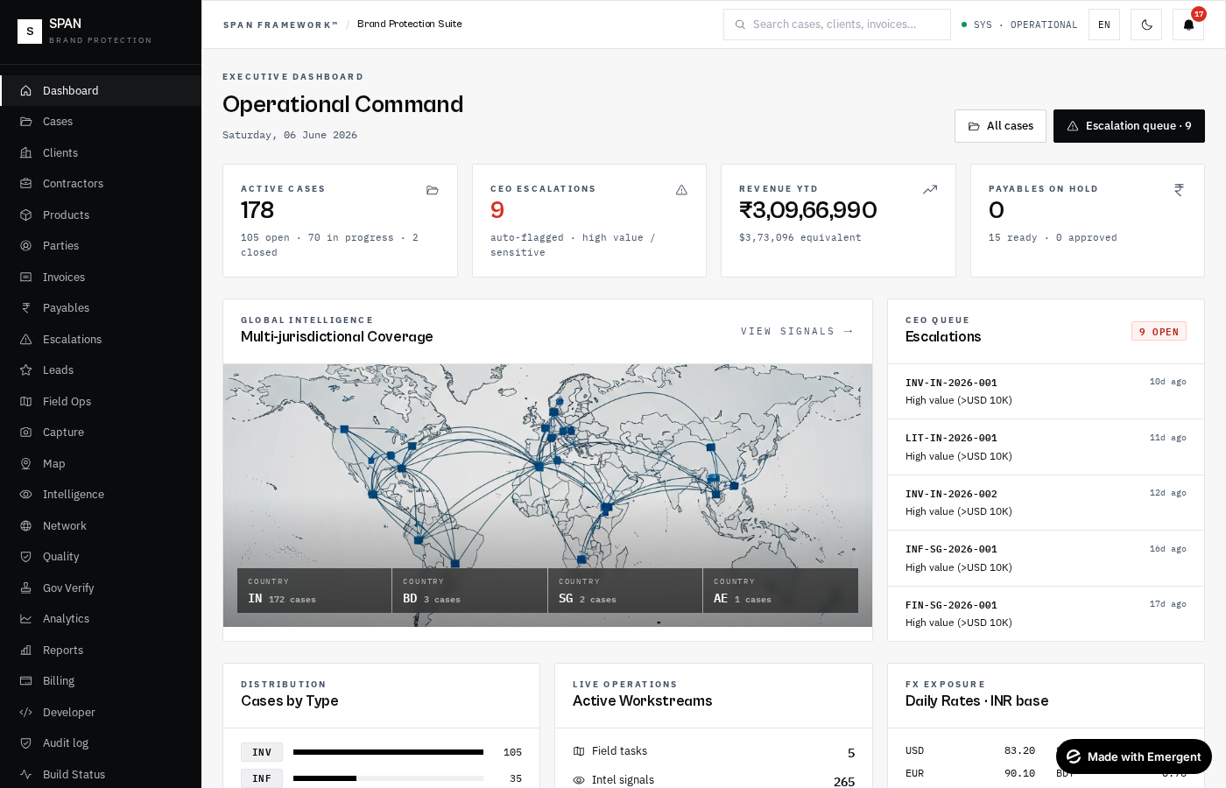
Dashboard — executive KPIs, escalations, OSINT map
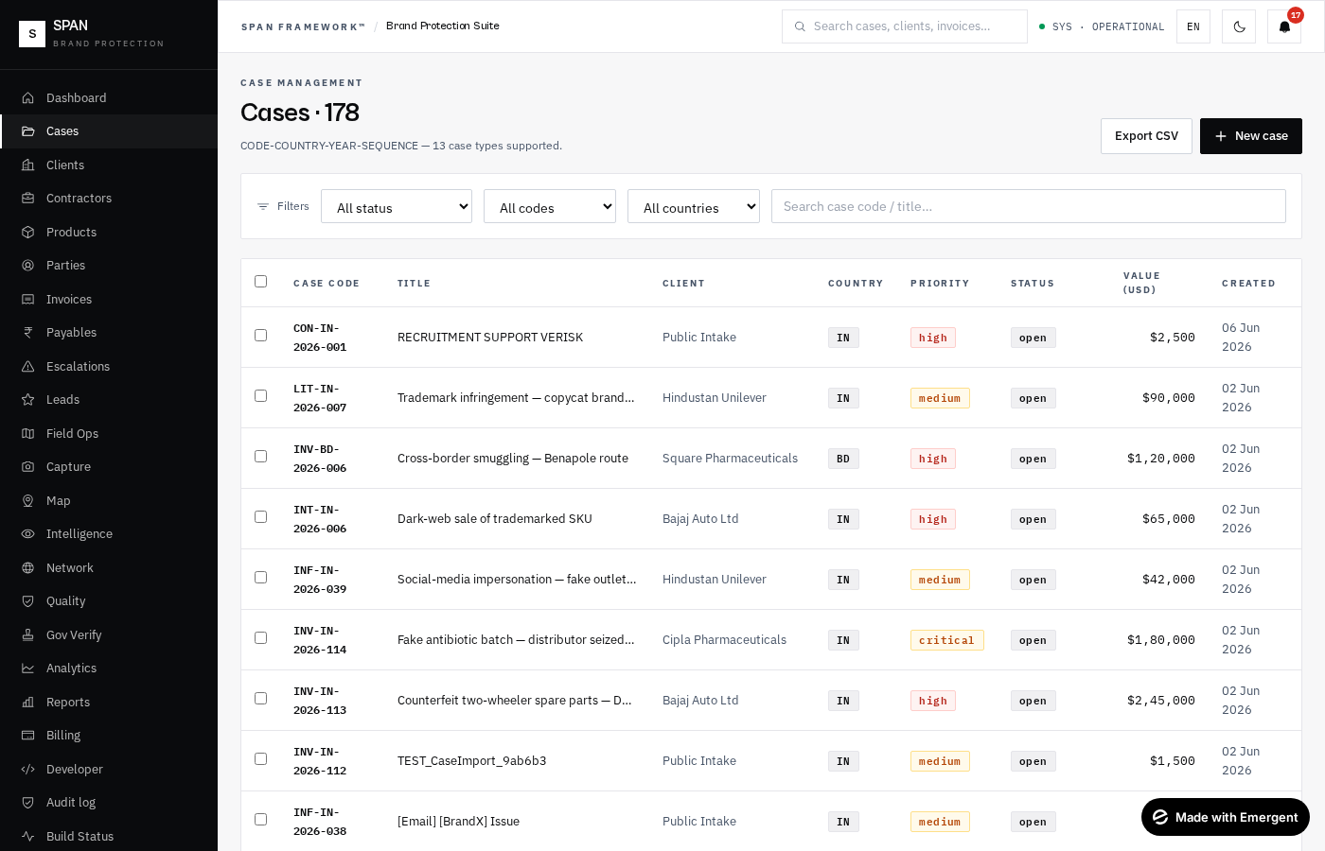
Cases — multi-filter table with case codes & SLA risk
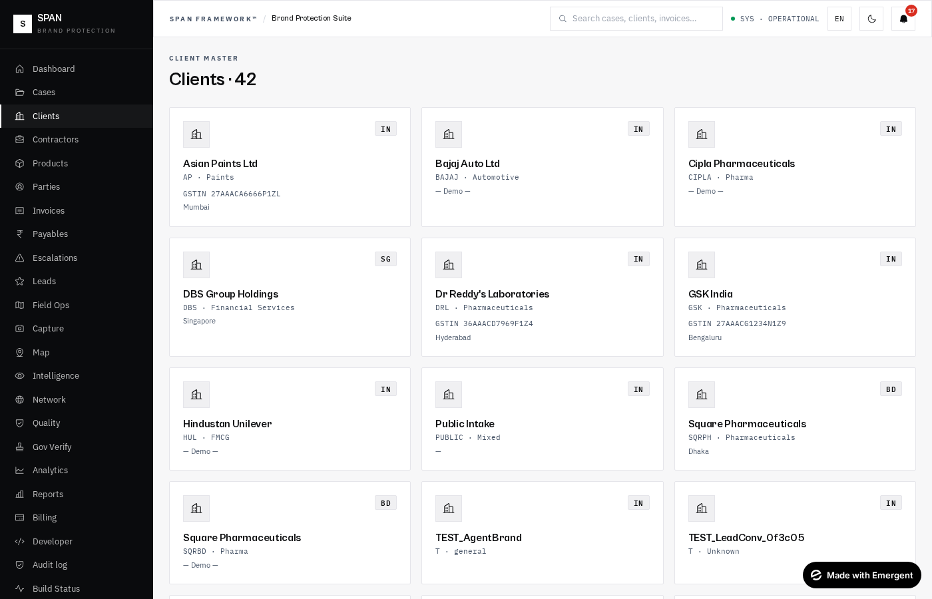
Clients — brand-owner directory with industry & country
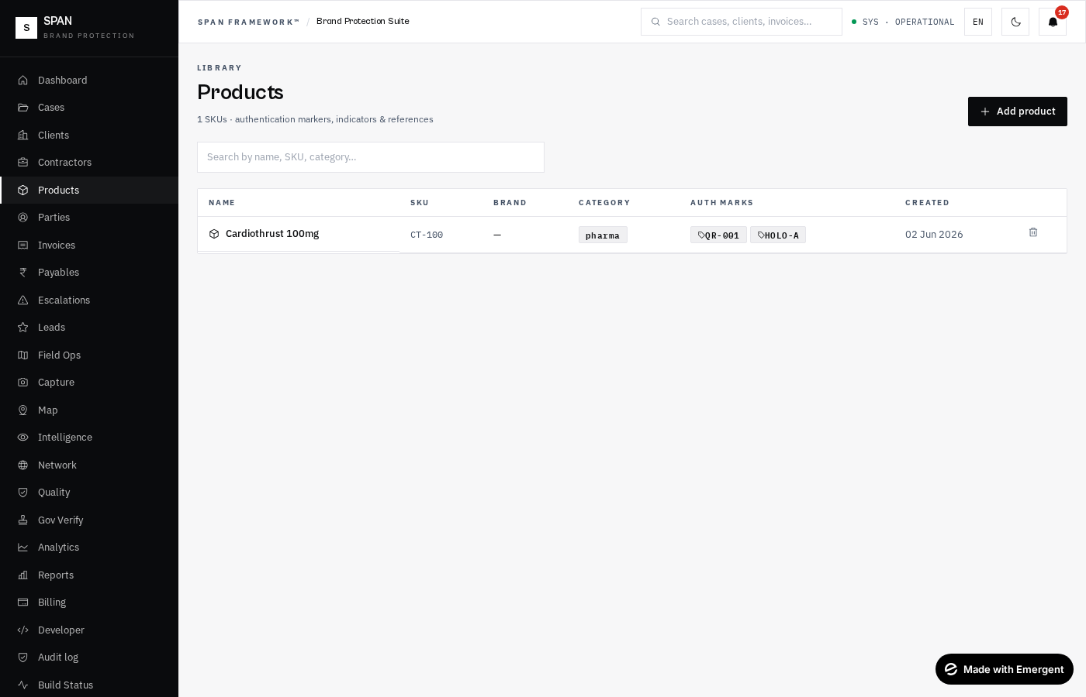
Products library — SKUs, auth marks & category
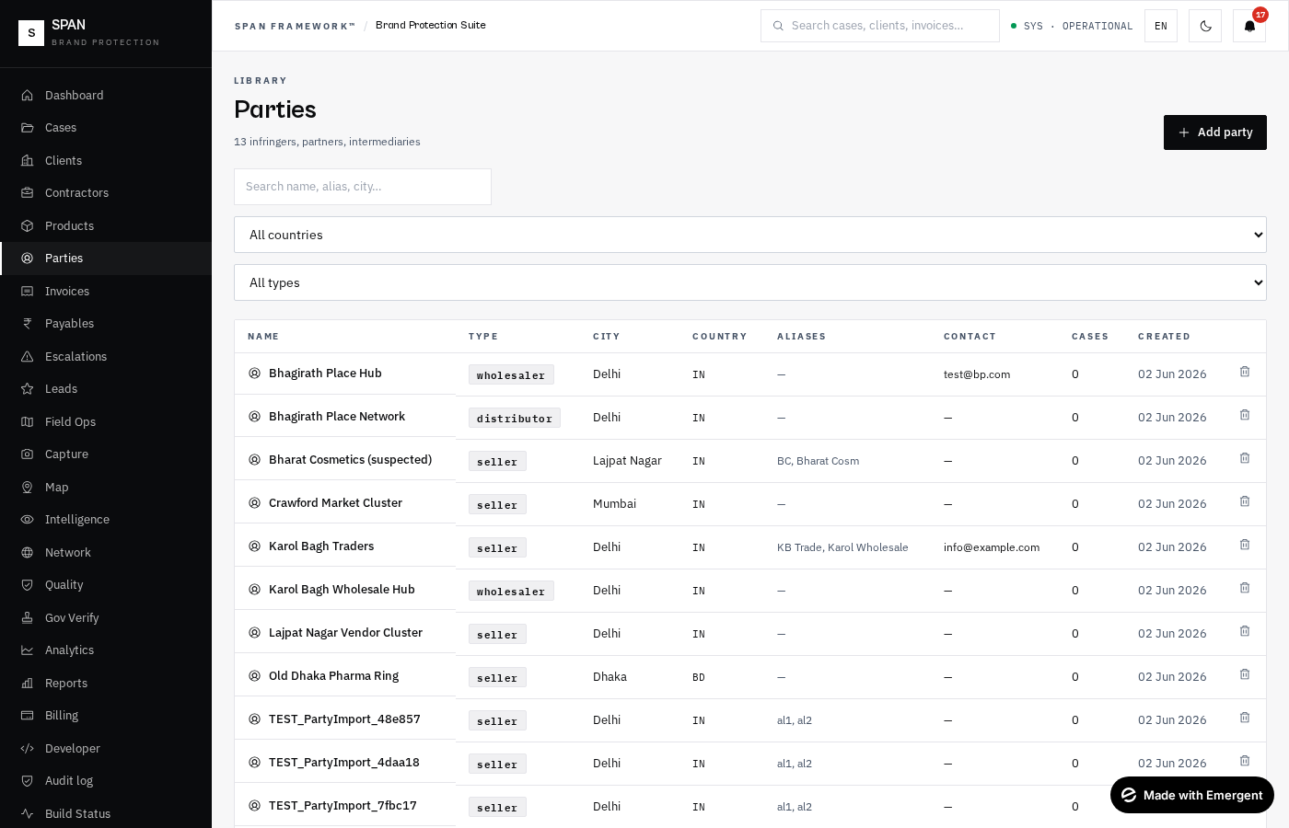
Parties library — sellers, distributors, dark-web vendors
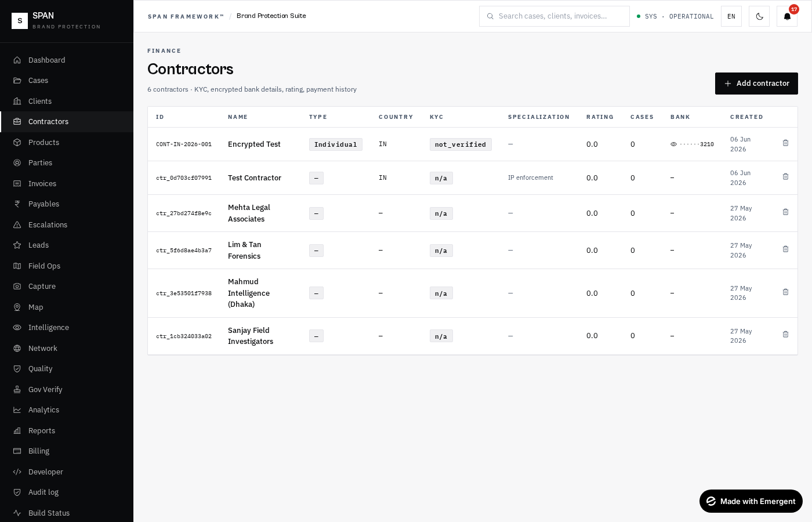
Contractors module — KYC, encrypted bank, rating, payment history
Finance
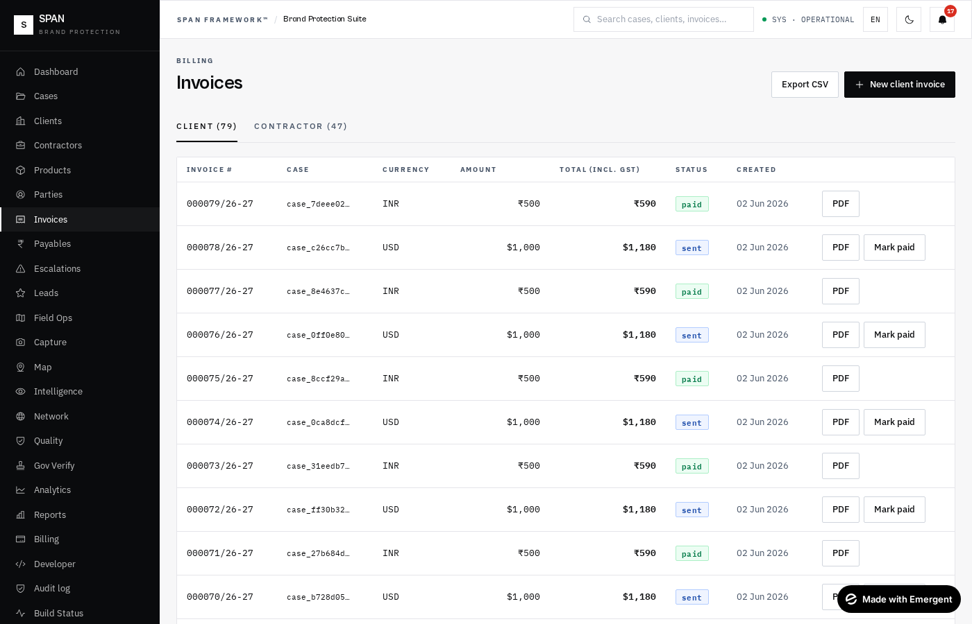
Client invoices — 9 currencies, GST, PDF export
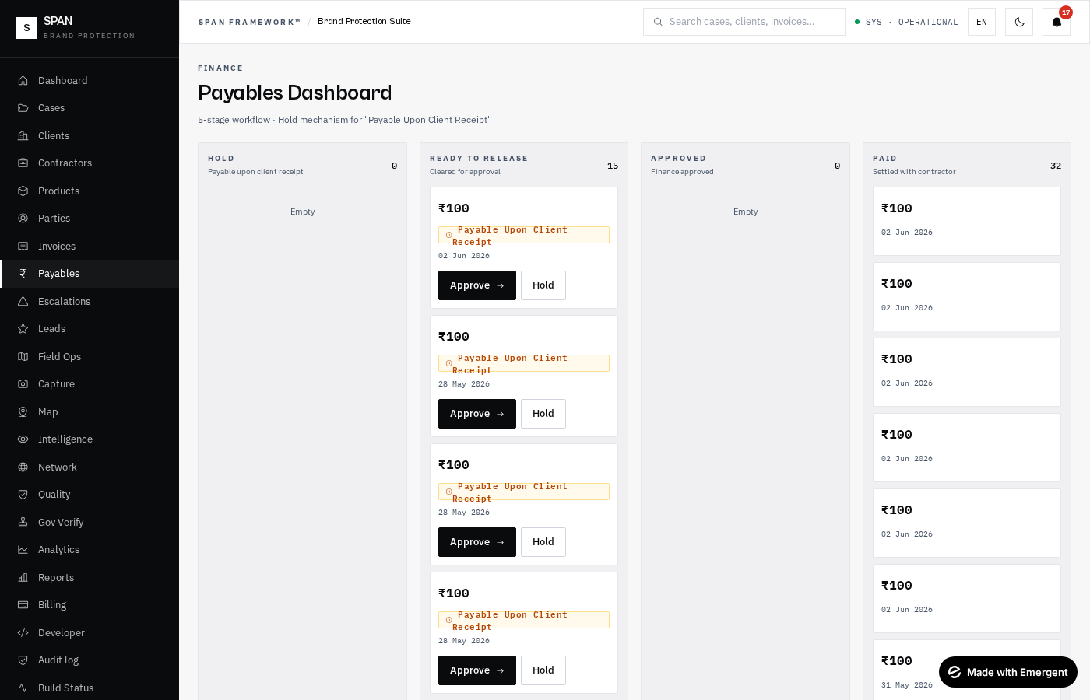
Contractor payables — 5-stage Kanban workflow
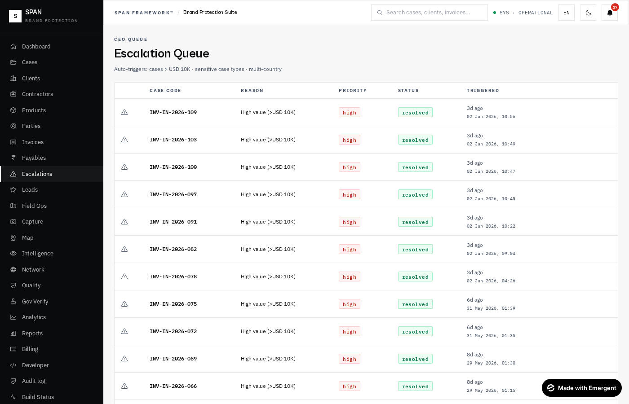
Escalations — CEO queue with auto-triggered rules
Operations
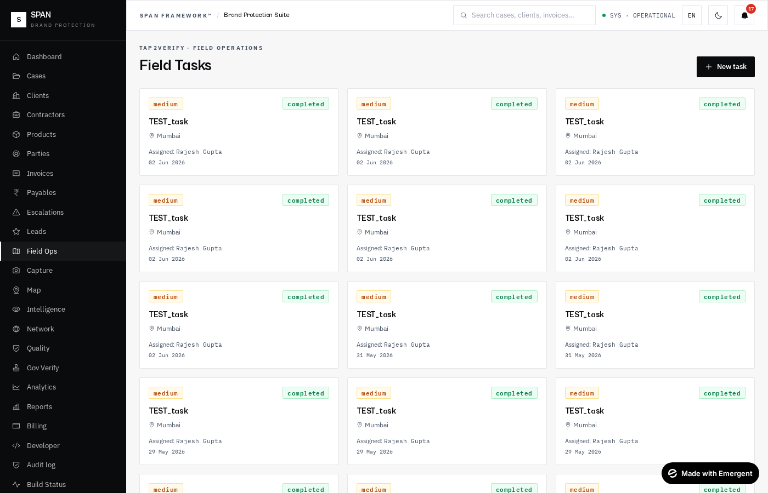
Field ops — officer dispatch & evidence tasks
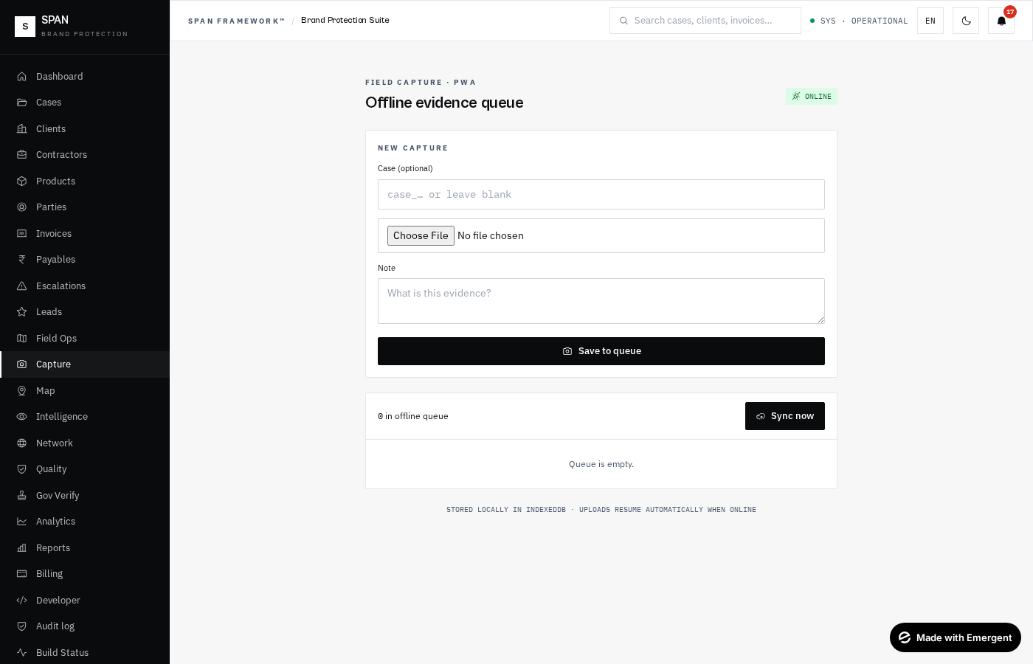
Capture — mobile-first PWA evidence intake (offline-capable)
Intelligence
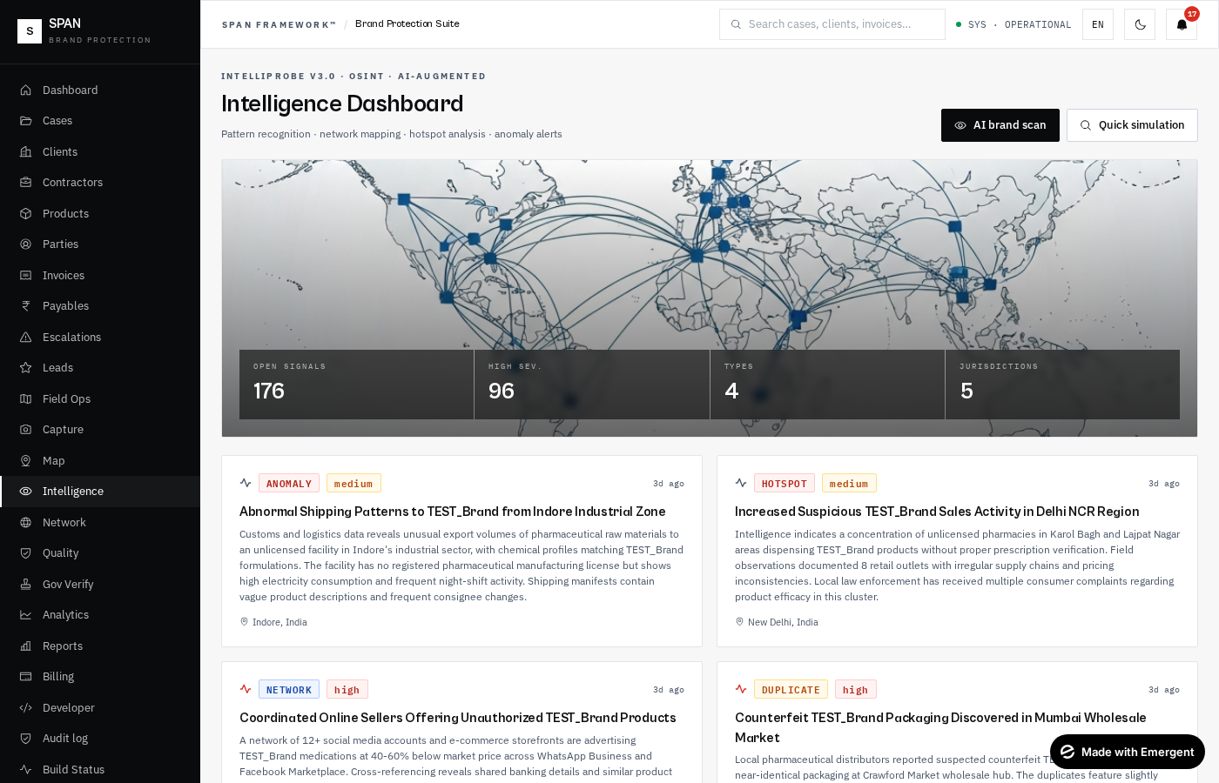
Intelligence — IntelliProbe OSINT dashboard + AI scan
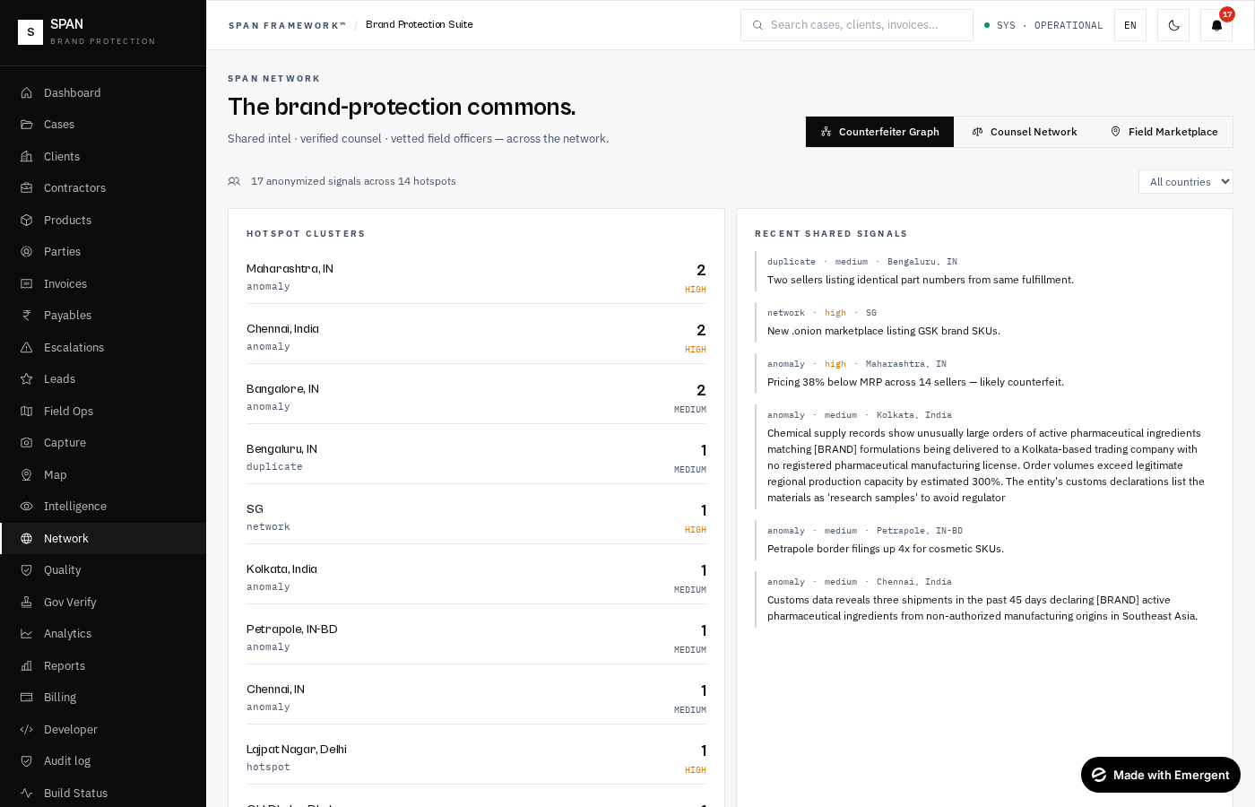
Network — counterfeiter graph + counsel + field marketplace
Compliance
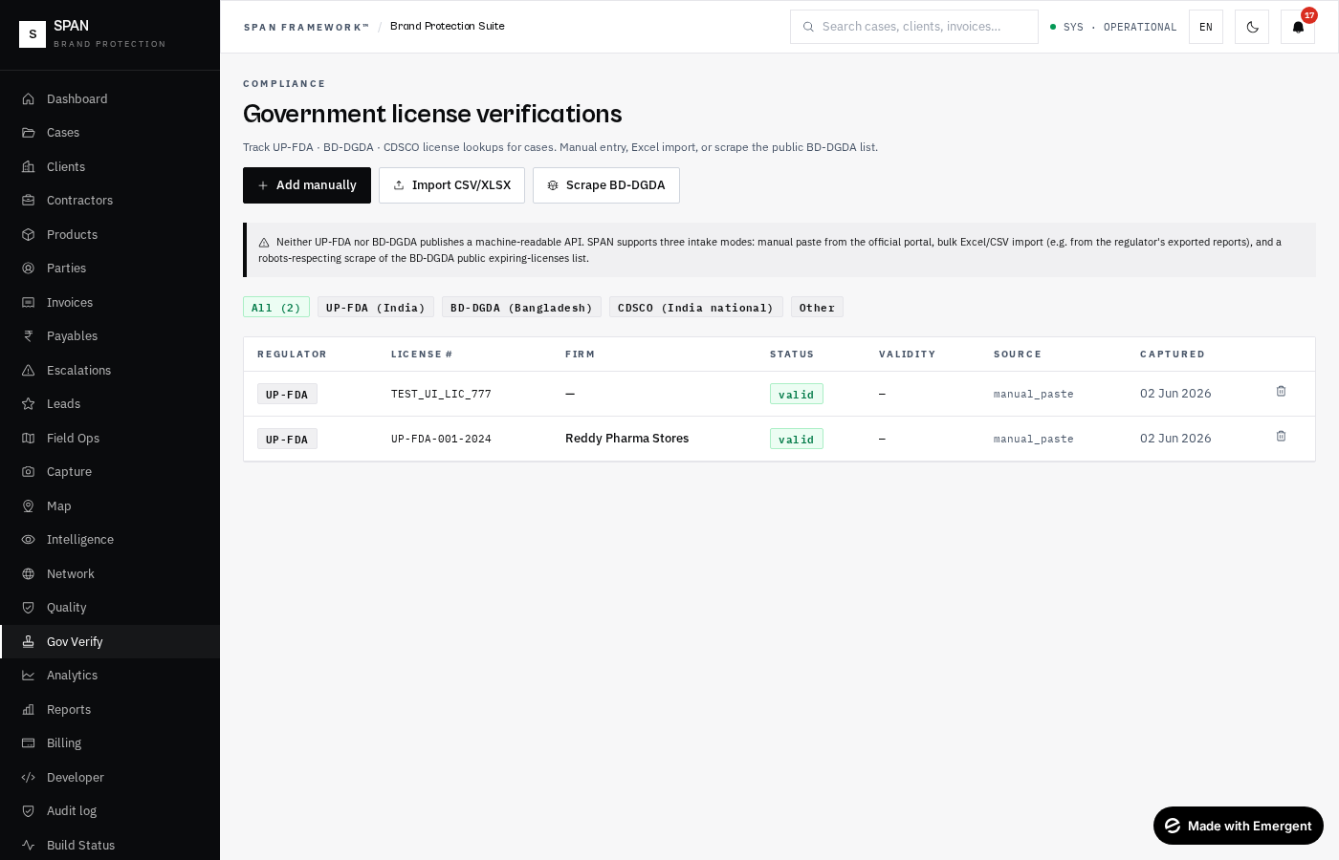
Gov Verify — UP-FDA · BD-DGDA · CDSCO license records
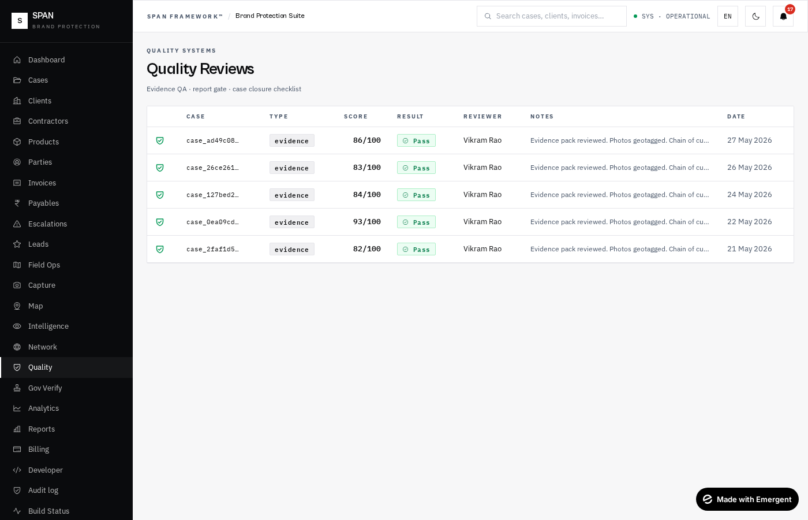
Quality — QA reviews of evidence & investigations
Analytics
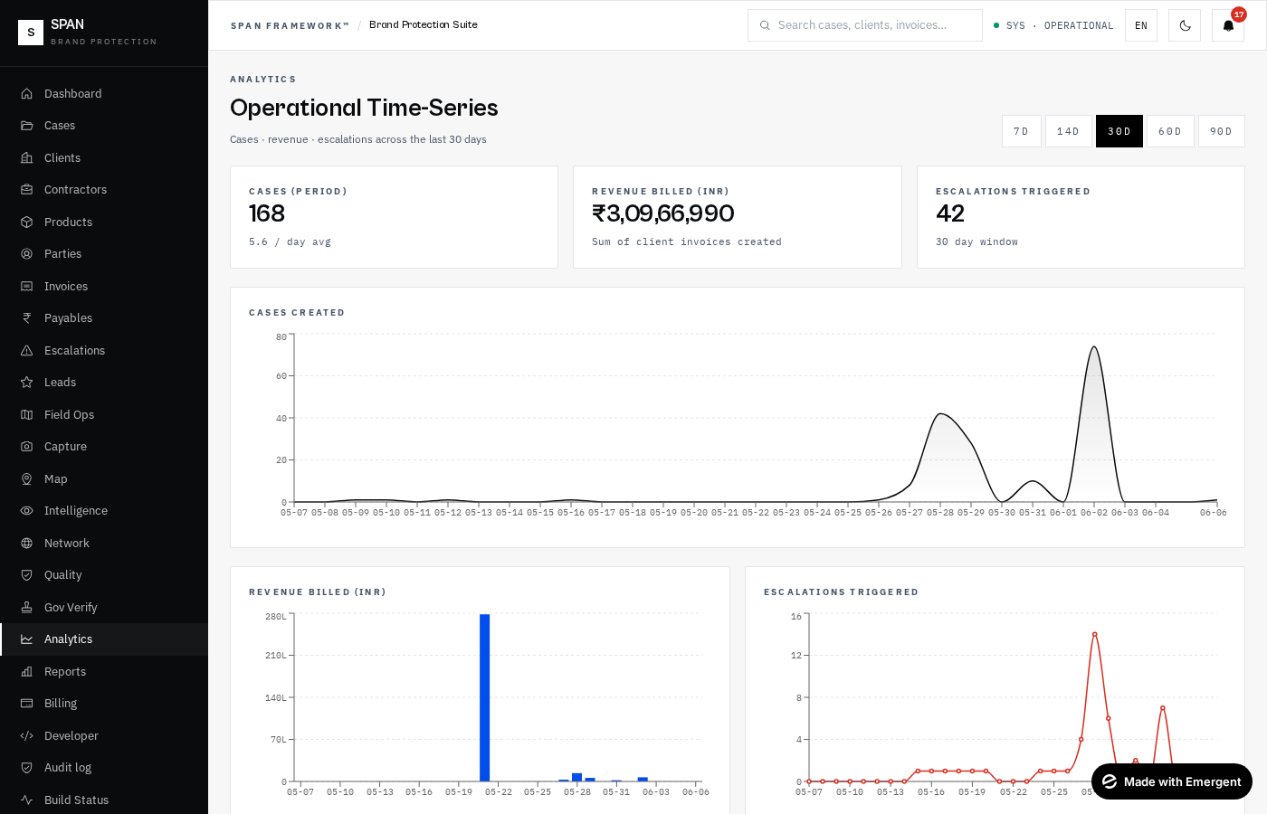
Analytics — time-series Recharts dashboards
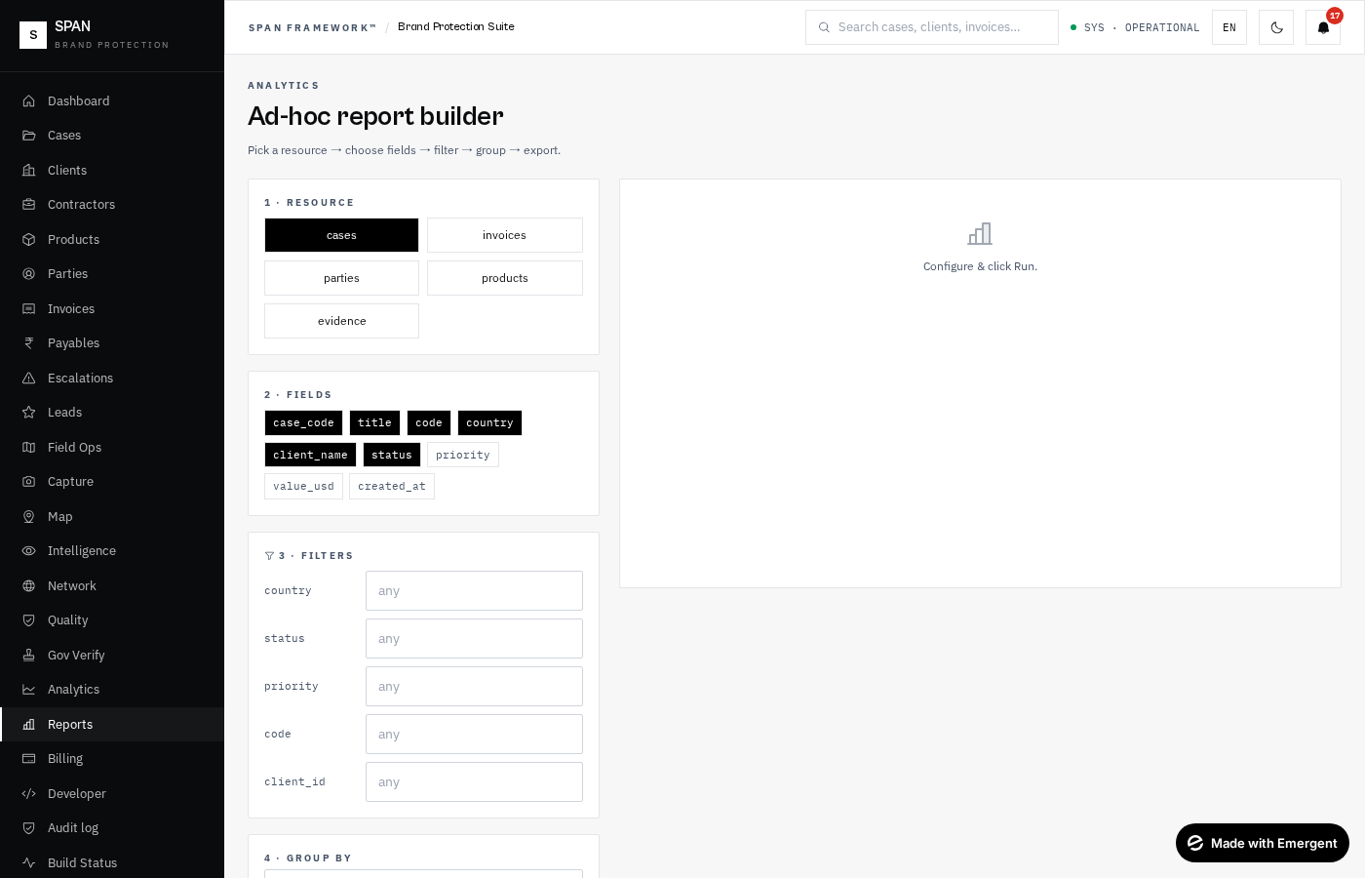
Reports — ad-hoc report builder with filters & group-by
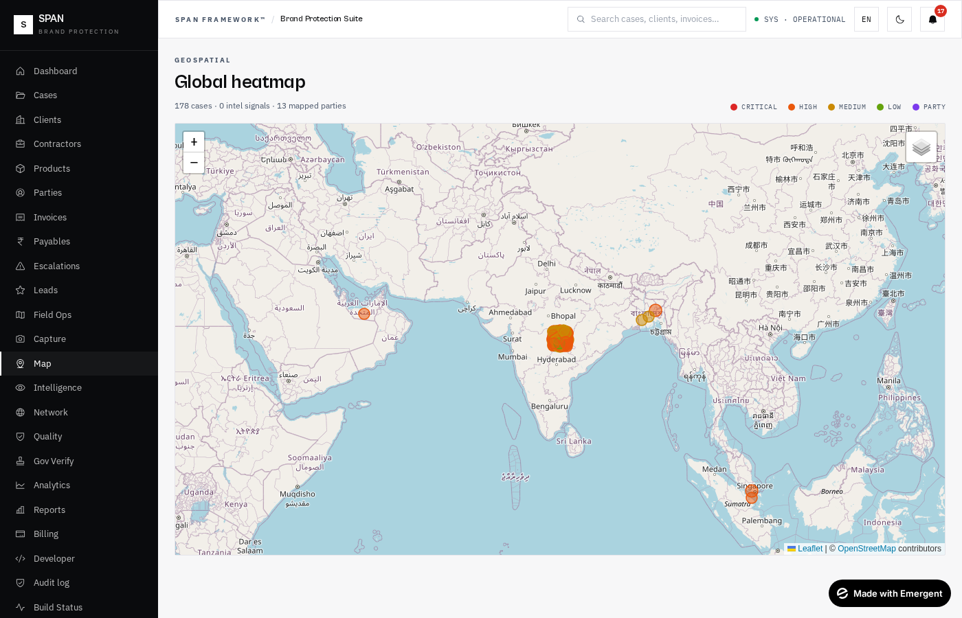
Map — Leaflet heatmap with cases · signals · parties layers
Admin
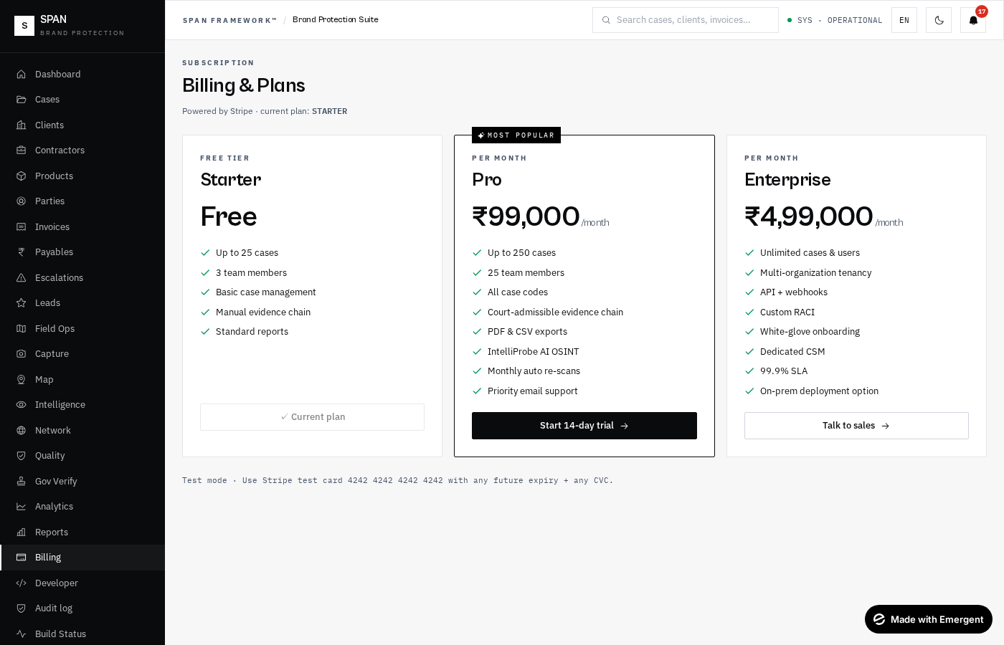
Billing — 3 plans, Stripe checkout, subscription status
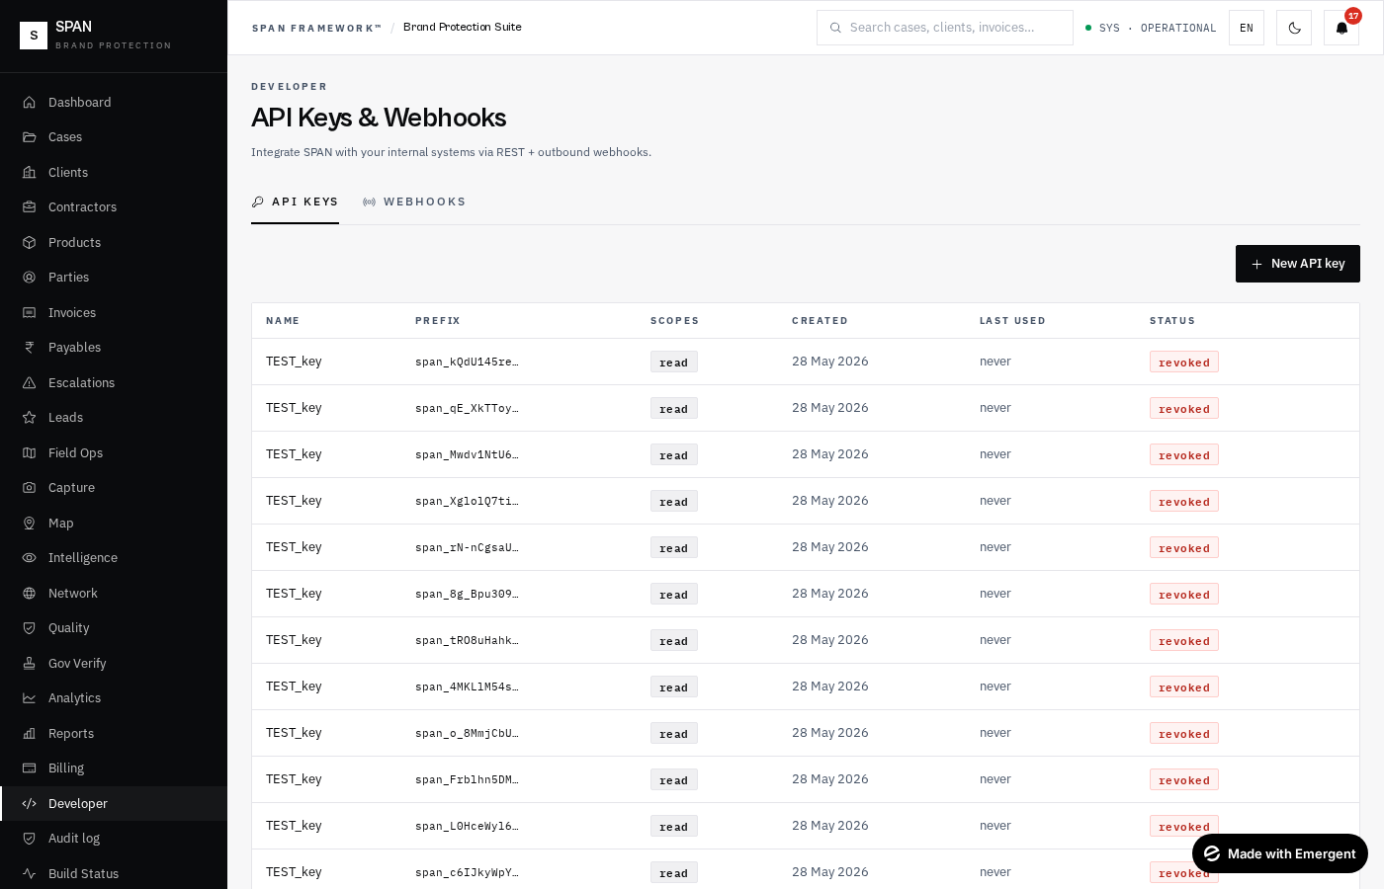
Developer — API keys & outbound webhooks
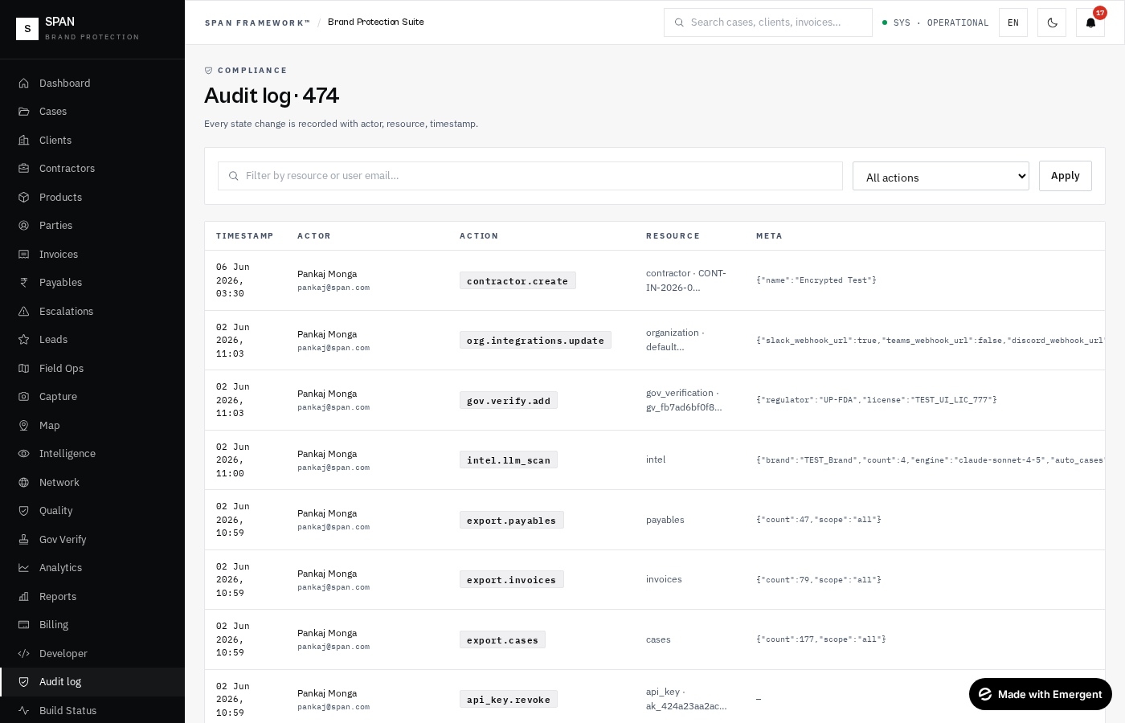
Audit log — every state change with filters
Oversight
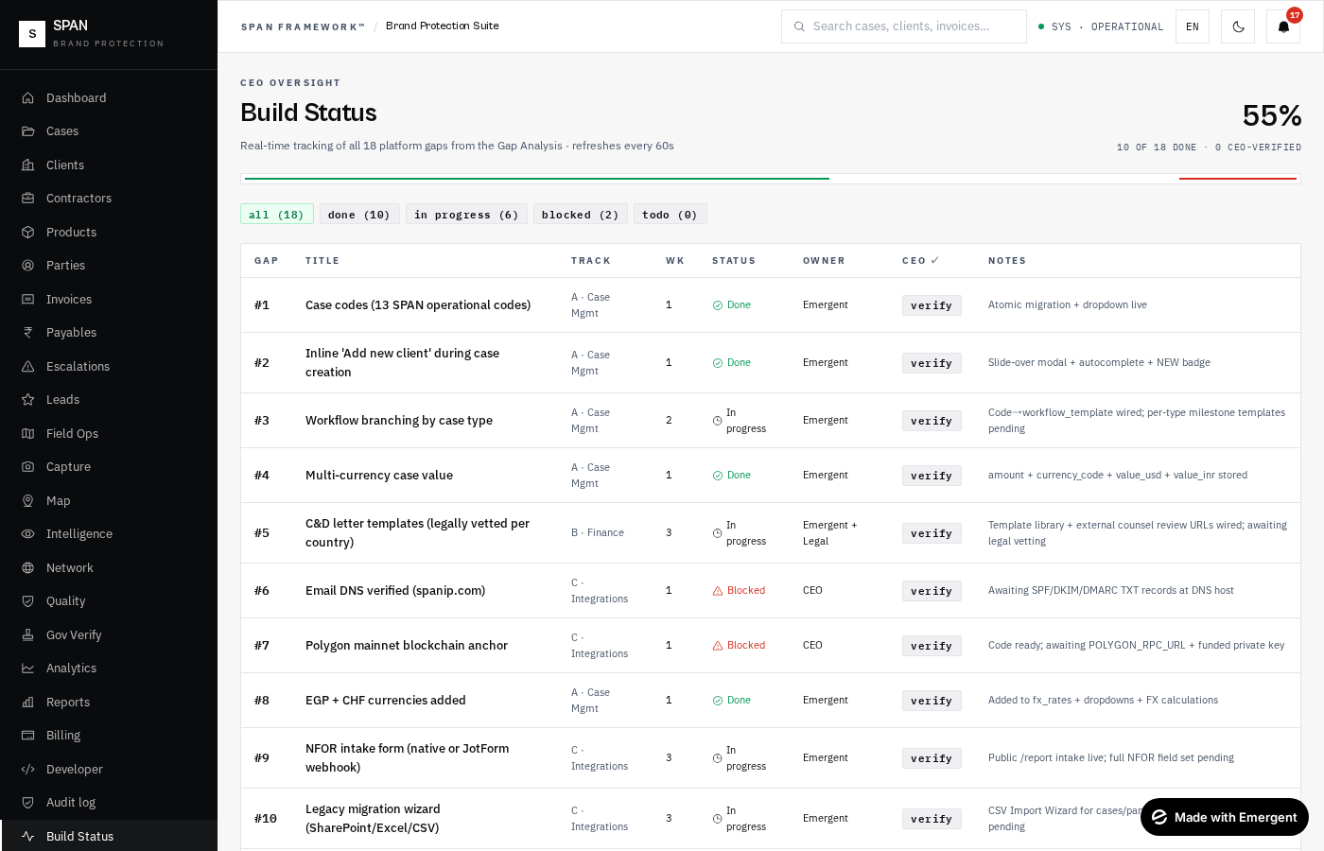
Build Status — CEO oversight dashboard · 18-gap tracker · env health
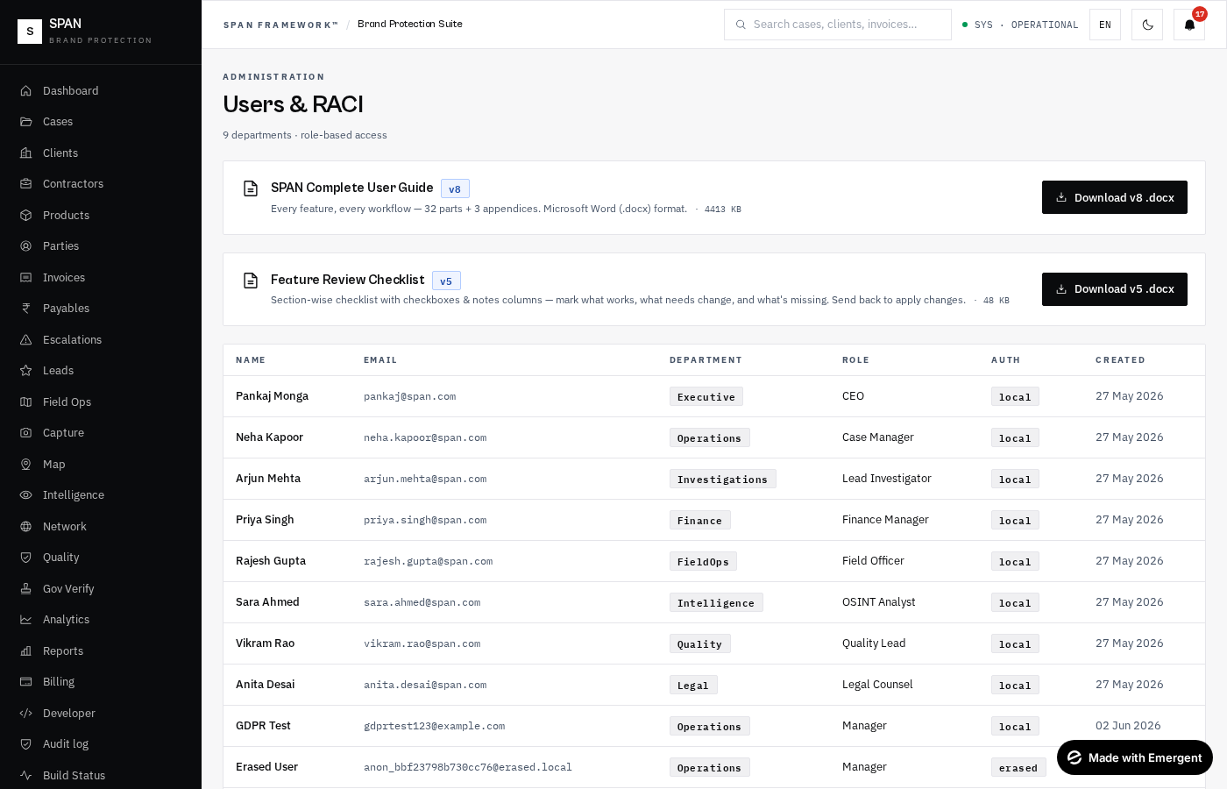
Settings — users, GDPR, integrations, blockchain status
Public-facing pages
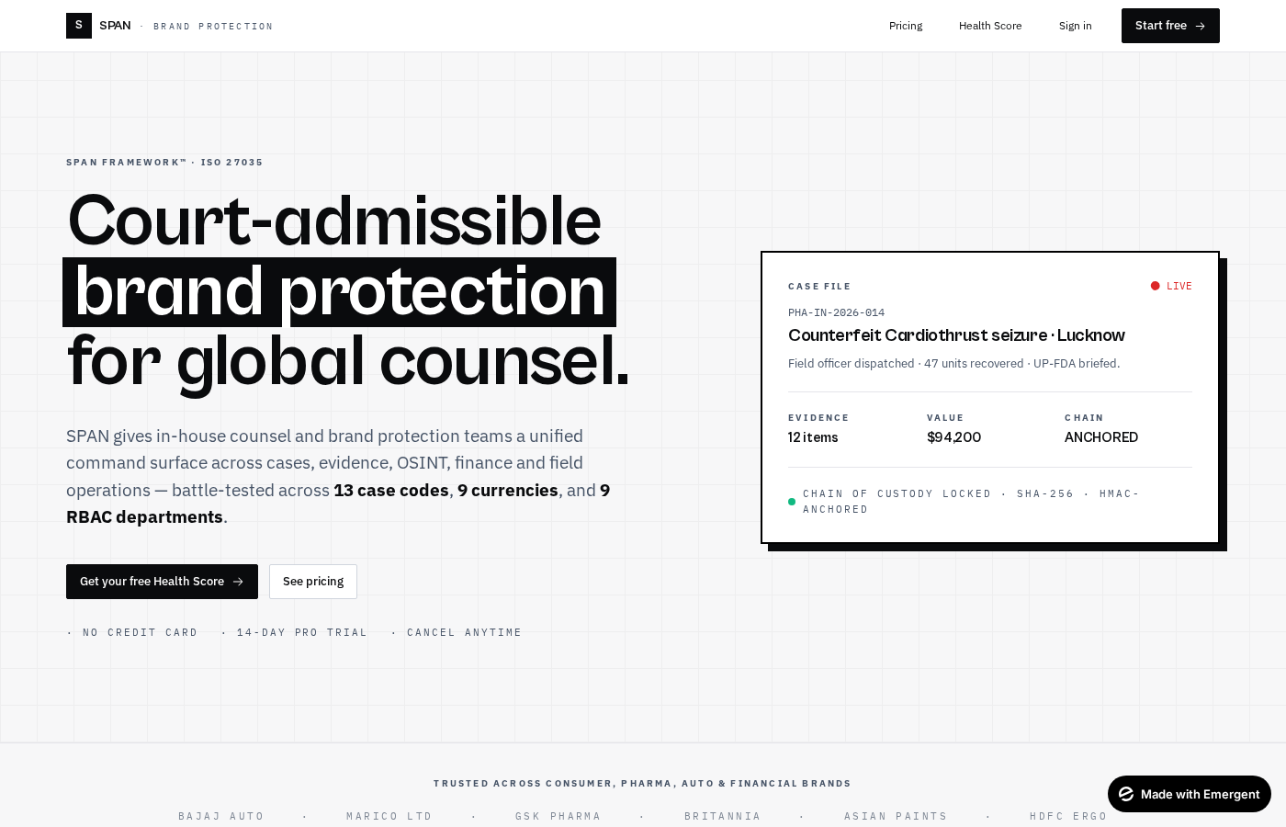
Landing — marketing homepage
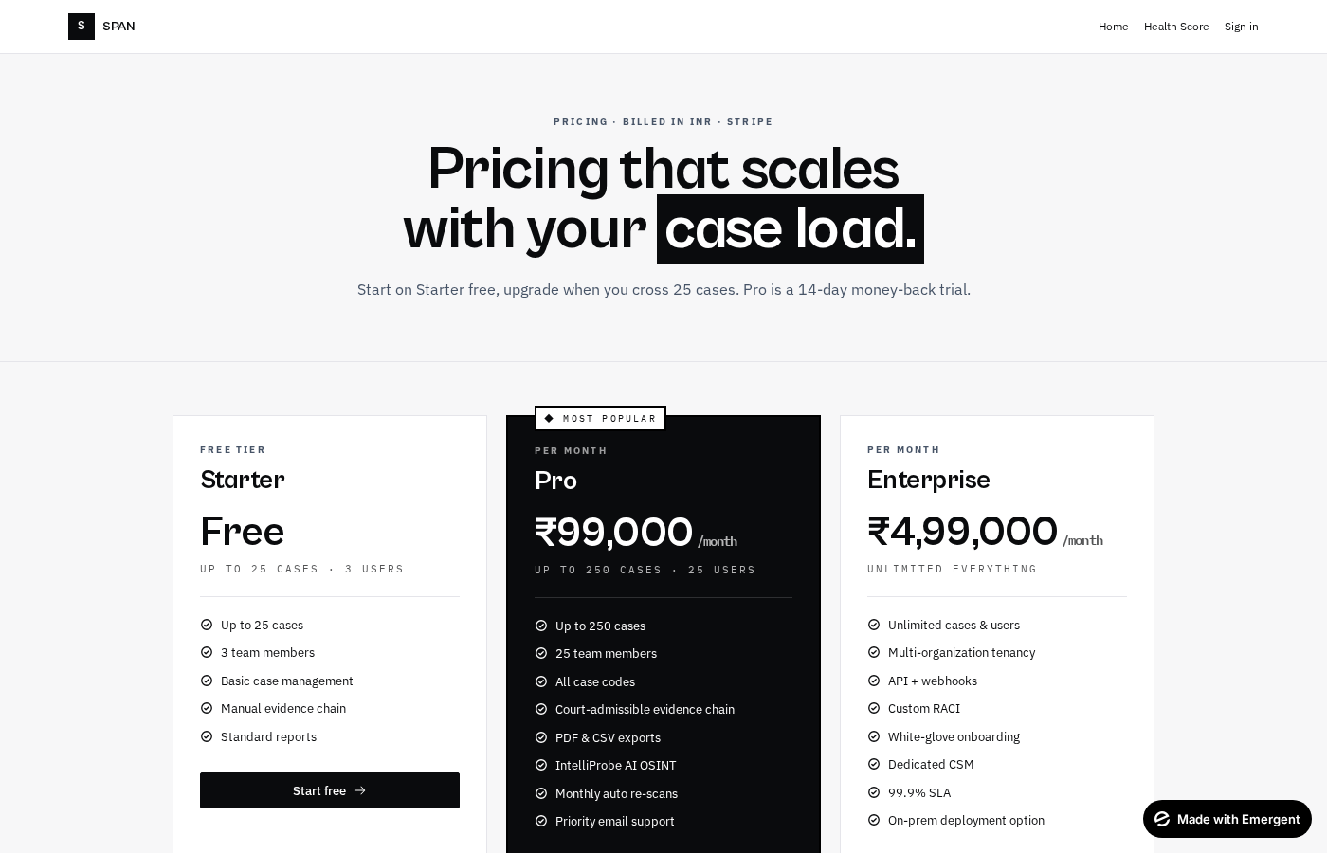
Pricing — three plan tiers
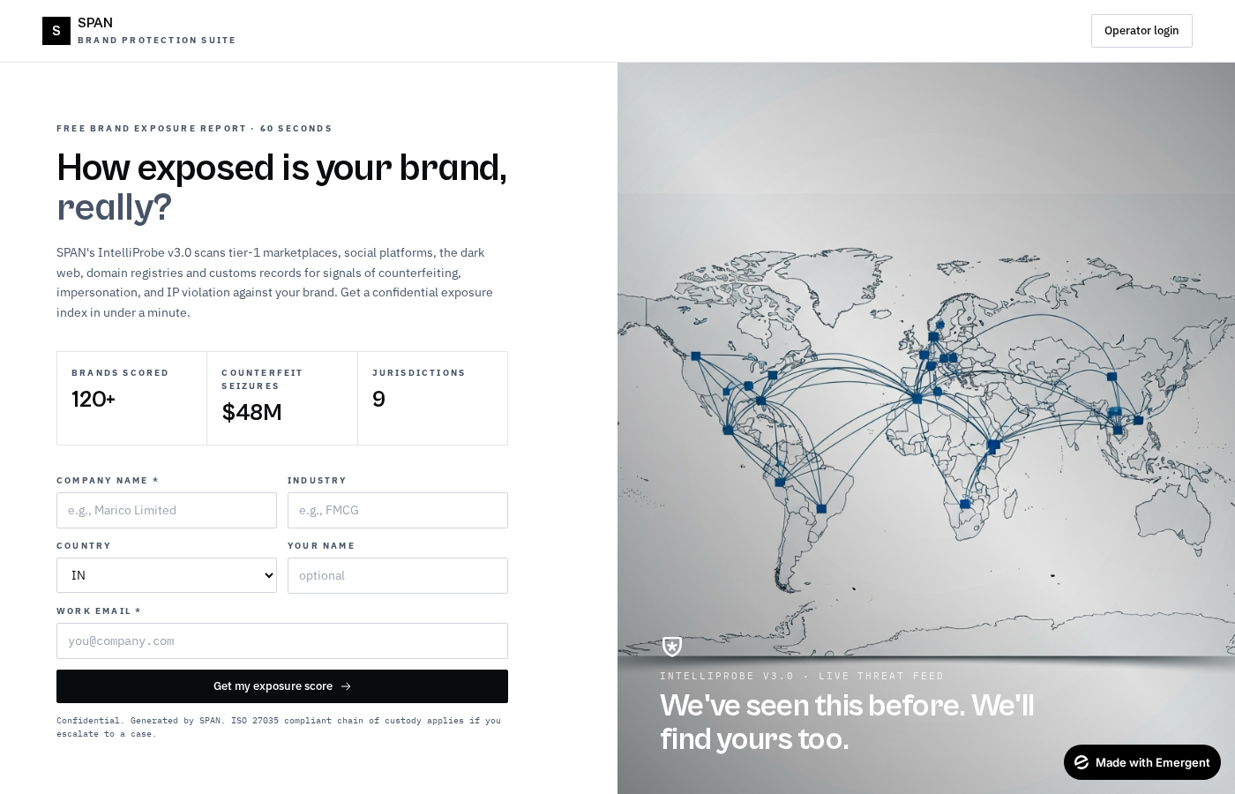
Health Score — public brand-protection risk calculator
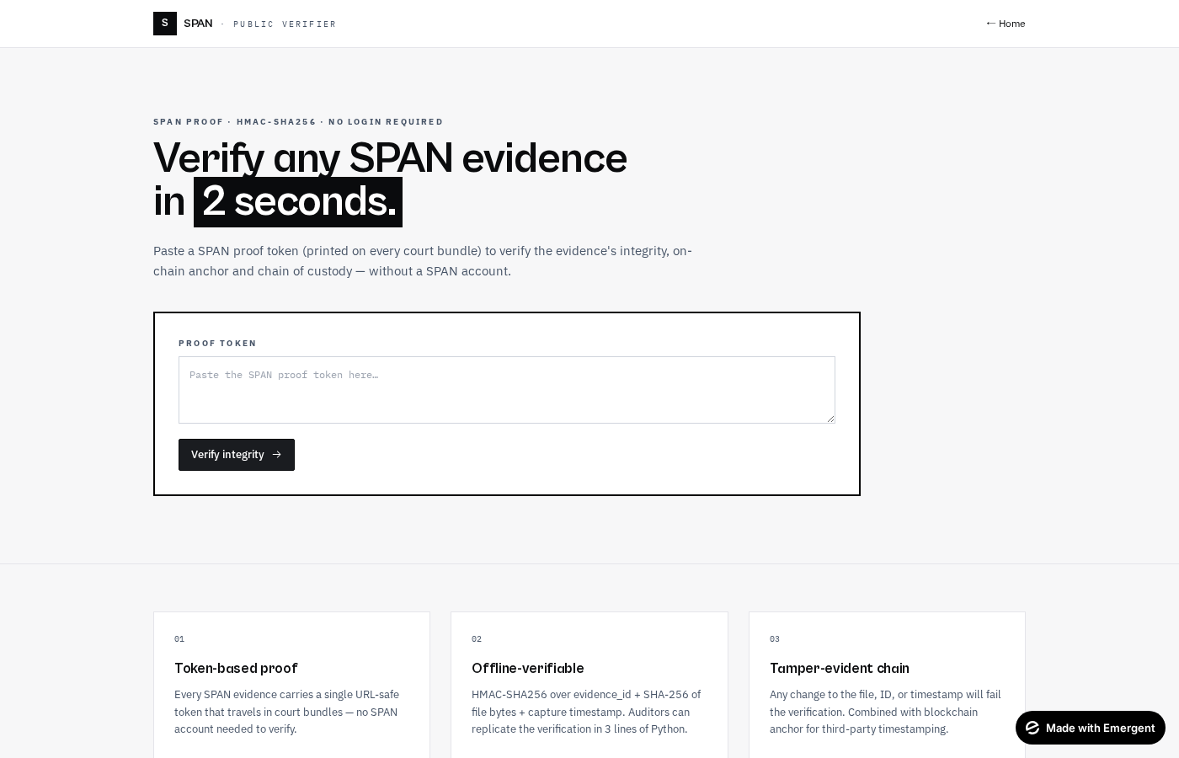
Verify — public evidence-proof verifier
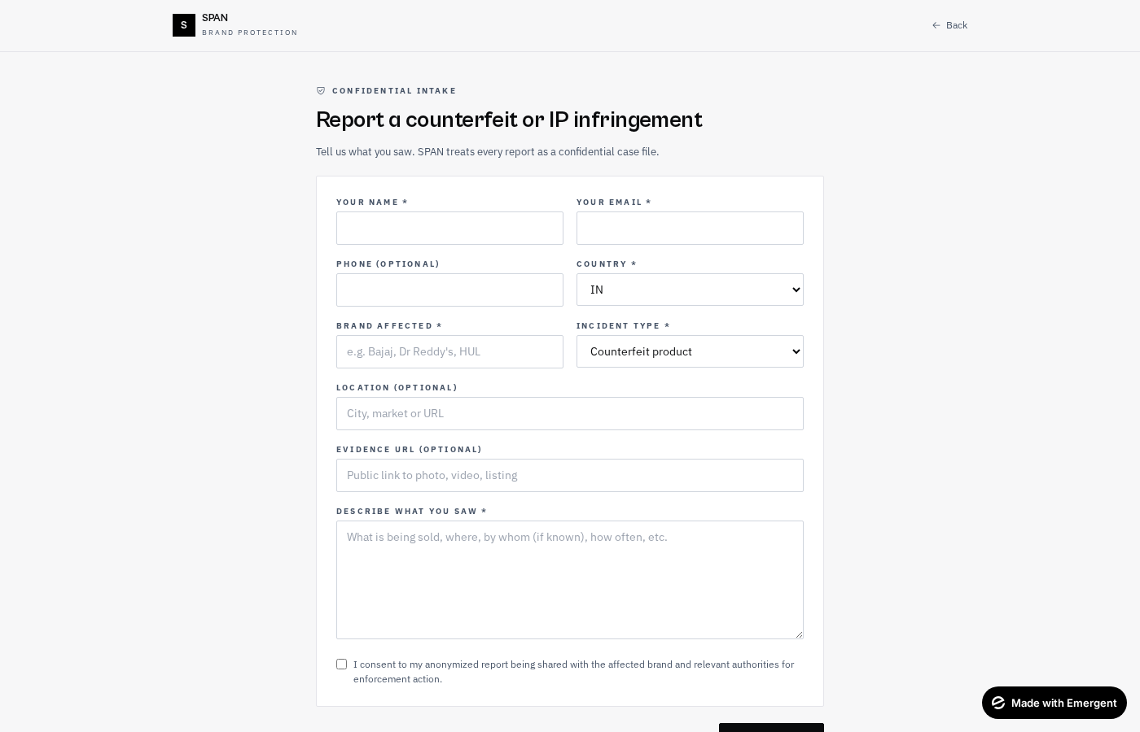
Public report intake — anonymous, rate-limited
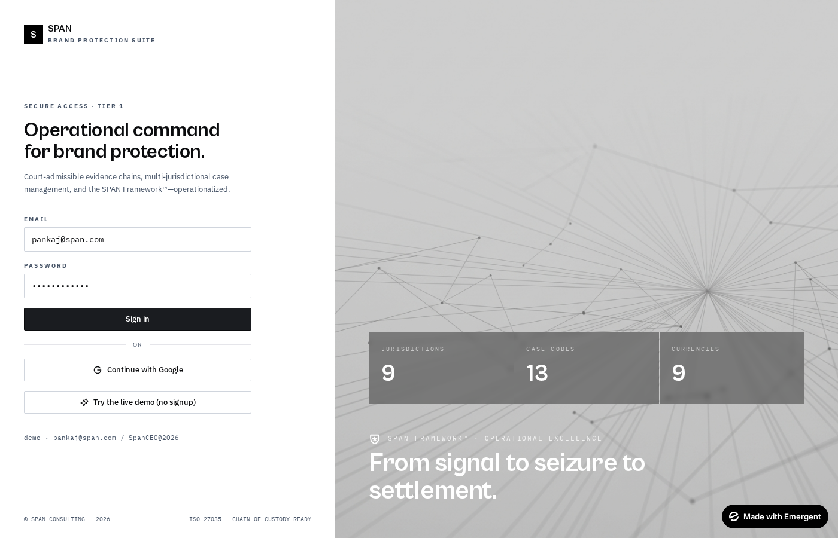
Login — JWT + Google + 'Try the live demo' button

PART 43
Go-Live Hardening + AI/Comms Platform (Phases 16-26)
Following the Production deployment to spancaseprime.com, the platform shipped 11 phases (16 through 26) covering everything from the McKinsey AI engine to the CEO command-center landing page. This part documents every endpoint, page, and admin surface added in Feb 2026.
41.1 Go-Live Hardening (Phase 16 · Track J)
Six production-readiness endpoints, all gated by CEO (ux_tier 5):
- POST /api/admin/reconcile-environments — Preview ↔ Production diff/copy (needs MONGO_URL_PROD env var). dry_run=true returns counts only; confirm='RECONCILE-CONFIRM' actually copies missing records using case_code / invoice_number / client_id / contractor_id / sighting_id / stakeholder_id as identity keys.
- GET /api/admin/backup-status — last verified backup timestamp + size + notes. POST /api/admin/backup-status/mark lets the operator stamp a freshly verified backup.
- GET /api/admin/healthz — PUBLIC lightweight probe (mongo + scheduler + sentry status).
- GET /api/admin/healthz-url — returns the full external healthz URL for copy-paste into uptime monitors.
- Login alias map — pankaj@span.com login attempts now fall back to pm@spanip.com when primary credentials fail. Legacy passwords continue to work (additive only).
- POST /api/admin/polygon/backfill {limit} — re-anchors evidence rows with a SHA-256 but no tx_hash. Requires POLYGON_RPC_URL + POLYGON_PRIVATE_KEY. Uses self-transaction with hash in tx data field (cheapest anchor).
41.2 McKinsey AI Narrative Engine (Phase 17 · Tracks L+Q)
A shared service (backend/services/mckinsey_engine.py) that produces executive-grade SCQA narrative reports across 6 source types and 4 file formats with 2 audience modes.
- Source types: case · sighting · investigation · finance (client) · hr (user) · bd (period)
- Formats: DOCX · PDF · PPTX · XLSX
- Audiences: internal (full detail + evidence IDs + INR figures) vs client (jargon translated, expenses & IDs stripped, framed as 'what we need from you')
- SCQA structure (Situation · Complication · Question · Answer) + Detailed Findings + Recommended Next Steps table (Action · Owner · Impact-if-done · Impact-if-not-done · Due) + References (internal audience only)
- Claude Sonnet 4.5 via the Emergent LLM key. Deterministic fallback if LLM unavailable.
- 30-minute caching per (source_type, source_id, audience) in db.mck_cache — cold call ~40s, warm <2s.
Endpoints (Tier 2+ for case/sighting/investigation; Tier 3+ for finance/hr/bd):
Endpoint | What it returns
GET /api/cases/{case_id}/mckinsey/narrative.{fmt} | Full case brief
GET /api/sightings/{sighting_id}/mckinsey/narrative.{fmt} | Sighting brief
GET /api/investigations/{case_id}/mckinsey/narrative.{fmt} | Investigation brief (case + sightings + intel)
GET /api/finance/clients/{client_id}/mckinsey/narrative.{fmt} | Finance brief — invoices + ageing
GET /api/hr/users/{user_id}/mckinsey/narrative.{fmt} | HR profile — user + direct reports
GET /api/bd/{period}/mckinsey/narrative.{fmt} | BD period — leads + conversion
Frontend payload: McKinseyButton component is wired on Case Detail (header), Sighting Detail (next to PDF), and each Client card. Click reveals an audience toggle and 4 download buttons.
41.3 Feature Toggle / Kill-Switch (Phase 18 · Track K)
Database collection db.feature_flags. Resolution order: User override > Department override > Global state > Default state.
12 seed flags including mckinsey_narrative, recycle_bin, force_delete, stakeholder_bulk_send, holiday_scheduler, polygon_anchor, ai_brief, weekly_intel_digest, monthly_invoice_cron, tap2verify_public, custom_fields, feature_toggles_ui.
- GET /api/feature-flags — list (T4+)
- GET /api/feature-flags/effective — current user's effective on/off map (frontend uses this to show/hide UI)
- POST /api/feature-flags — create custom flag (CEO only)
- PUT /api/feature-flags/{flag_key} — patch global_state / department_overrides / user_overrides (CEO only)
- DELETE /api/feature-flags/{flag_key} — soft-archive; re-POST revives
Admin page: /settings/admin/feature-toggles (T4+). Each flag row shows label, description, category, default-state pill, global-state pill, effective state for the caller, and (for CEO) a 3-segment switch to set global on/default/off.
41.4 Universal Multi-Format Exports (Phase 19 · Track M)
One unified endpoint covering 10 resources × 4 formats:
- Resources: cases · sightings · invoices · expenses · clients · suppliers · receivables · audit-log · legal-holds · analytics-ceo
- Formats: csv · xlsx · docx · pdf (analytics-ceo only supports xlsx and pdf)
- Filename pattern: span_{resource}.{fmt}
- Tier 3+ required (FM/COO/CEO). Tier 1 → 403. Invalid fmt → 400. Invalid resource → 404.
Endpoint: GET /api/reports/{resource}.{fmt}. Registered before the legacy _p12 export router so all surfaces flow through one path.
41.5 Admin UI Completion (Phase 20 · Track N)
Six admin pages went from placeholder to fully wired:
Page | Path | What you can do | Min tier
My Profile | /settings/profile | Edit name, phone, designation, bio. Upload avatar (≤ 3 MB). | 1
Org Branding | /settings/admin/branding | Upload logo (≤ 5 MB), set primary/accent hex colors (validated), set footer legal text. | 5 (CEO)
Departments | /settings/admin/departments | List with member-count, create, rename, soft-delete (730-day TTL). | 5 (CEO)
Invite User | /settings/admin/invite-user | Create user + auto-send Resend welcome email with temp password. Force rotation on first login. | 4 (COO)
Audit Retention | (/settings/admin/* config) | Set audit-log retention 30-18250 days (default 7 years). | 5 to set
Custom Fields | /settings/custom-fields | Already shipped in Phase 14d — schema-builder for case extension fields. | 4
41.6 Case Lifecycle Library (Phase 21 · Track R)
CEO/COO-editable library of step sequences for each of the 13 case-type codes (INV, LIT, CON, INF, GEN, ADM, INT, FIR, CoC, FIN, FoR, BD, PERS). Each step has name, description, owner_tier, due_offset_days, channel, optional. Add/rename/reorder steps without a code deploy.
Page: /settings/admin/lifecycles (T4+ to save).
- GET /api/lifecycles — list all 13
- PUT /api/lifecycles/{code} — replace steps array (T4+)
- POST /api/lifecycles/{code}/steps — append (T4+)
- PUT /api/lifecycles/{code}/steps/{step_id} — patch (T4+)
- DELETE /api/lifecycles/{code}/steps/{step_id} — archive (T4+)
41.7 Case Updates + Today's Update Quick-Action (Phase 22 · Track P)
Updates are now a first-class entity tracked in db.case_updates with 6 channel tags (in_app · email · whatsapp · phone · field_visit · client_meeting).
- POST /api/cases/{case_id}/updates {text, channel} — post (T2+)
- GET /api/cases/{case_id}/updates — reverse-chrono with date grouping
- PUT /api/cases/{case_id}/updates/{update_id} — author can edit within 24h
- DELETE — author or CEO
- POST /api/tracker/today-update {case_id, text} — shortcut from the Investigation Tracker row
Frontend: a new 'Updates' tab on Case Detail (between Activity and Evidence). Reverse-chrono, grouped by date, author avatar + channel pill + edited badge.
41.8 Product Registry + Sighting Validation (Phase 24 · Track S)
db.products_registry stores genuine product specs (brand · name · sku · weight_g · dimensions_mm · security_features · packaging_hash · msrp · country_of_origin · image_url). Sightings can validate against the registry to flag discrepancies automatically.
- GET /api/products — list with ?q= and ?brand= filters
- POST /api/products — create (T3+)
- PUT /api/products/{product_id} — patch (T3+)
- DELETE /api/products/{product_id} — soft-delete to recycle_bin (T4+)
- POST /api/sightings/{sighting_id}/validate-product {product_id, observed_*} — sets sighting.product_match.{is_genuine, discrepancies}
Validation rules: weight has 5% tolerance or 1 g (whichever larger); dimensions and packaging_hash are exact-match; security_features uses set comparison and reports which expected marks are missing.
41.9 Org Chart Editor (Phase 23 · Track V)
GET /api/org-chart/tree builds the manager tree from db.users.reports_to. The drawer on each node now contains a 'Reassign manager' dropdown. The endpoint POST /api/org-chart/validate previews the change; PUT /api/org-chart/users/{user_id}/manager applies it after walking the candidate manager's chain to detect circular reporting.
41.10 Visual System (Phase 19 frontend · Track O)
frontend/src/styles/tokens.css introduces semantic CSS variables (--brand-primary, --surface*, --text-*, --border*, --status-* and --tier-*) plus full dark-mode overrides under [data-theme='dark']. Convenience utility classes (.bg-surface, .text-brand, .status-success-pill, etc.) compose the tokens. Strictly non-layout-changing — only color/contrast/accessibility tweaks.
41.11 Comms Extras (Phase 25)
Five closely-related deliverables that complete the email platform:
(a) Drip Campaign Builder
3-touch sequences targeting any stakeholder tag.
- POST /api/drip-campaigns {name, tag, touches:[{day_offset, subject, html_body}]} — create (T3+)
- POST /api/drip-campaigns/{id}/run — enroll all stakeholders matching tag, schedule sends
- APScheduler cron _flush_drip runs every 15 min — dispatches pending sends via Resend, respects suppression list, increments sent_count
- Frontend: /stakeholders/drip — inline 3-touch builder with defaults D0/D7/D21
(b) Resend Webhook + Analytics
POST /api/webhooks/resend (PUBLIC, optional RESEND_WEBHOOK_SECRET HMAC verify) ingests email.delivered/opened/clicked/bounced/complained events into db.email_events. Bounces and complaints auto-add to suppression. GET /api/analytics/email returns open/click/bounce rates.
(c) Unsubscribe + Suppression
HMAC-signed per-email tokens. GET /api/unsubscribe/{token}?email= renders a SPAN-branded HTML landing page with a single 'Unsubscribe now' button. POST .../confirm adds to db.email_suppression. GET /api/email-suppression lists all suppressed addresses (T3+). Drip cron honours the suppression list at send time.
(d) Email Templates (HTML wrapper)
db.email_templates stores reusable HTML wrappers with a {{body}} placeholder. POST validates the placeholder; PUT updates; DELETE archives (T4+).
41.12 CEO Command Center + Audit Trail (Phase 26)
Single-screen executive overview at /admin (CEO only):
- System health row — 7 services with status dots (mongo, sentry, scheduler, resend, polygon, storage, ux_tier)
- 8 count tiles — cases · clients · invoices · stakeholders · users · evidence · sightings · recycle bin
- Backup widget — last_verified_at + by + total verified
- Feature flags widget — N on / M total + link to manage
- Email widget — events last 30 days + drip running + suppressed total
- Top 5 active cases (by last_activity_at) — each with inline McKinsey 'AI' button
- Last 10 deletion requests — color-coded approved (green) / rejected (red) / pending (amber)
- Last 10 invited users — pending-rotation indicator for users yet to change temp password
- Branding preview — logo + primary/accent color swatches + footer legal
Audit-Trail Dashboard (/admin/audit-trail) — CEO-only deep dive into deletion requests with horizontal bars per tier/department/status/resource-type, 12-month vertical bar chart, median approval-cycle hours, and the most-recent-25 table. Window selector: 30d / 90d / 180d / 365d.
41.13 CEO-only Password Reset
POST /api/admin/reset-password/{email} (CEO only) — sets a new password and forces rotation on first login. Writes audit row. Used to recover hk@spanip.com and jm@spanip.com whose passwords had been rotated. Both now use SpanReset@2026 (must change on first login).
41.14 Real Master Data Import on Production (Phase 15c)
POST /api/admin/data-import/upload (multipart with 4 xlsx files), then POST /api/admin/data-import/preview {confirmation:'DRY-RUN'} to see counts, then POST /api/admin/data-import/execute {confirmation:'IMPORT-REAL-DATA-CONFIRM'} to actually import. Reconciliation + ESF→ESG typo fix run automatically. All CEO-only.
41.15 Resend Email Sender
SENDER_EMAIL is set to admin@spancaseprime.com (verified domain on Resend, id b3c286a8-dcb9-4ba5-a179-6af7b4dc4a01 confirmed delivered). All 5 outbound surfaces (invoice email · weekly intel digest · 72h follow-up · monthly auto-invoice cron · stakeholder bulk + drip campaigns) now send real emails.
41.16 Deferred items (require dedicated sessions)
- Backend file consolidation (_p1 … _p26 → domain folders) — touches 29 modules and ~434 pytests. Refactor risk requires a dedicated session.
- Native iOS/Android via Capacitor — needs separate build pipeline (Xcode + Android Studio + App Store / Play Store accounts + push-notification certs).

PART 42
Phase 27 — Production Closeout (v22)
Phase 27 closes the final 15-point production-grade audit. All endpoints below ship under the `/api` prefix and respect the 5-tier RBAC matrix.
42.1 Case-Type taxonomy (5 values)
Cases now carry an explicit `case_type` field, restricted to the canonical 5-value taxonomy:
- Counterfeit — fake / unauthorised reproduction of a SPAN client's product.
- Diversion — parallel imports / grey-market diversion across territories.
- Tampering — alteration of seals, batch codes, packaging or contents.
- Infringement — trademark, copyright or design-right infringement.
- Other — for anomalies that don't fit the four canonical buckets.
Endpoints: GET /api/case-types · PUT /api/cases/{case_id}/case-type. The Cases page (All Cases) exposes a `filter-case-type` dropdown that wires through to the cases list query.
42.2 Case Update attachments
Daily Updates (Tracker → Update button → slideover) now accept multiple file attachments. Allowed extensions: PNG, JPG, JPEG, WEBP, GIF, PDF, XLSX, XLS, CSV, DOCX, DOC, PPTX, TXT, MP4, MOV. Max size 20 MB per file. Files are stored under /app/backend/uploads/case_updates/ and served read-only via /api/uploads/case_updates/{filename}.
Endpoints: POST /api/cases/{case_id}/updates/{update_id}/attach (multipart/form-data; field `file`) · DELETE /api/cases/{case_id}/updates/{update_id}/attachments/{attachment_id}.
42.3 Sighting impact calculator
POST /api/sightings/{sighting_id}/calculate-impact accepts `units_seen`, `unit_price_inr`, `market_share_pct`, `category_severity` (low|medium|high|critical) and returns a structured impact object: financial (revenue_lost_inr · annualised · net_loss_without_action), reputational (severity_index · headline_risk), trust (trust_drop_pct · recovery_months) and narrative_summary. Stored on the sighting record under `impact_analysis`.
42.4 McKinsey narrative sharing
Every McKinsey narrative button now exposes two extra actions next to the 4 format downloads (DOCX · PDF · PPTX · XLSX):
- Share via Email — opens a modal that POSTs /api/share/email (`to[]`, `subject`, `body_html`). Backed by Resend (admin@spancaseprime.com sender). Skipped recipients (unsubscribed / suppressed) are returned in the response.
- Share via WhatsApp — opens a modal that opens https://wa.me/{E164}?text=… in a new browser tab for each recipient (no Twilio creds required for the deep-link path). Backend also queues the share request to db.whatsapp_queue for audit. When Twilio creds are added (TWILIO_ACCOUNT_SID + TWILIO_AUTH_TOKEN + TWILIO_WHATSAPP_FROM env vars), the queue auto-delivers.
42.5 Finance Dashboard
New page at /finance/dashboard (Finance group sidebar). Renders 4 KPI tiles (Revenue YTD, GST 18% collected, TDS 194J estimate, Receivables outstanding), the Receivables Aging bucket summary (0-30 · 31-60 · 61-90 · 90+ days), the Invoices-by-status table, and the Saturday payout drill. Multi-format export buttons (CSV/XLSX/PDF/DOCX) for Invoices, Receivables, and Expenses are exposed at the top-right.
42.6 Universal multi-format exports (Reports → Quick Exports)
The Reports page now opens with a Quick Exports panel listing all 11 export-ready resources in a 3-column grid:
- Cases · Sightings · Invoices · Expenses · Clients · Suppliers · Receivables · Stakeholders · Audit log · Legal holds · CEO snapshot.
- Formats: CSV · XLSX · DOCX · PDF — plus PPTX for Cases / Sightings / Clients / Suppliers / Receivables / CEO snapshot. (CSV is unavailable for analytics-ceo because the snapshot mixes tabular and narrative payloads.)
- All endpoints route through /api/reports/{resource}.{fmt}. Stakeholder PPTX is exposed under /api/reports/stakeholders-ppt to avoid a route-shadowing collision.
42.7 INV lifecycle expanded to 8 steps (Feb 2026)
Per CEO request, the INV (Investigation) lifecycle has been expanded from 5 to 8 steps to reflect the full forensic chain. A migration in seed_lifecycles auto-upgrades any 5-step INV record on backend boot.
- 1. Sighting intake (T2 · day 1)
- 2. Field deployment (T2 · day 5)
- 3. Test purchase (T3 · day 10)
- 4. Evidence collation (T2 · day 15)
- 5. Forensic verification (T3 · day 18)
- 6. Report draft (T3 · day 22)
- 7. Stakeholder review (T4 · day 28)
- 8. Closure / Hand-off (T3 · day 35)
42.8 The 13 SPAN lifecycle codes (canonical list)
All 13 lifecycle codes are seeded into db.lifecycles on backend boot. Each is editable from /settings/admin/lifecycles by COO/CEO. They are:
- INV — Investigation (8 steps · forensic counterfeit / brand-protection investigations)
- LIT — Litigation (6 steps · pre-litigation → suit → judgment → execution)
- CON — Consulting (configurable · brief → research → deliverable)
- INF — Infringement (6 steps · detection → C&D → escalation → settlement / suit)
- GEN — Genuine Verification (4 steps · product authentication / forensic check)
- ADM — Admin / Office Ops (3 steps · premises · contracts · vendor)
- INT — Intelligence / OSINT (4 steps · Tap2Verify → OSINT pivot → intel brief)
- FIR — FIR / Criminal (5 steps · complaint → FIR → investigation → chargesheet → trial)
- CoC — Chain of Custody (4 steps · evidence intake → blockchain anchor → court bundle)
- FIN — Finance & Recovery (5 steps · invoice → receivables → reminders → recovery suit)
- FoR — Forensic Review (4 steps · sample intake → forensic review → opinion drafted → signed)
- BD — Business Development (5 steps · lead → meeting → proposal → negotiation → conversion)
- PERS — Personal Mandate (3 steps · confidential CEO/MD mandate, segregated from main case pool)
42.9 Stakeholder directory — multi-format downloads
The /stakeholders page exposes a new format-picker (`export-all-xlsx` · `-docx` · `-pdf`) next to the existing CSV button. Each downloads the full active-stakeholder set in the chosen format via /api/reports/stakeholders.{fmt}.
42.10 Visual tokens migration (greyscale removal)
All admin pages (CommandCenter, AuditTrailDashboard, FeatureToggles, DripCampaigns, Departments, Lifecycles, Branding, InviteUser, Profile, Team) had their hardcoded Tailwind slate/gray utility classes migrated to CSS custom-properties sourced from /app/frontend/src/styles/tokens.css. The token file also exports backwards-compatible --span-* aliases so legacy markup continues to render correctly while inheriting the new SPAN brand palette.
42.11 Mocked endpoints — pending user-provided credentials
- POST /api/share/whatsapp — Twilio creds not yet provided. Behaviour: queues to db.whatsapp_queue with status='queued_awaiting_twilio_creds'. Browser deep-link via wa.me is the primary delivery path until creds are added.
- POST /api/admin/polygon/backfill — Polygon mainnet RPC URL + Private Key not yet provided. Evidence anchoring records stay on Mumbai testnet until prod RPC is wired.
- Durable evidence storage (S3 / Cloudflare R2) — Bucket + access keys not yet provided. Files currently live on local pod disk under /app/backend/uploads/.

